3-Chymotrypsin-like protease (3CLpro) is a promising drug target for coronavirus disease 2019 and related coronavirus diseases because of the essential role of this protease in pro- cessing viral polyproteins after infection. Understanding the detailed catalytic mechanism of 3CLpro is essential for designing effective inhibitors of infection by severe acute res- piratory syndrome coronavirus 2 (SARS-CoV-2). Molecular dynamics studies have suggested pH-dependent conforma- tional changes of 3CLpro, but experimental pH proﬁles of SARS-CoV-2 3CLpro and analyses of the conserved active-site histidine residues have not been reported. In this work, pH- dependence studies of the kinetic parameters of SARS-CoV-2 3CLpro revealed a bell-shaped pH proﬁle with 2 p*K*a values (6.9 ± 0.1 and 9.4 ± 0.1) attributable to ionization of the cata- lytic dyad His41 and Cys145, respectively. Our investigation of the roles of conserved active-site histidines showed that different amino acid substitutions of His163 produced inactive enzymes, indicating a key role of His163 in maintaining cata- lytically active SARS-CoV-2 3CLpro. By contrast, the H164A and H172A mutants retained 75% and 26% of the activity of WT, respectively. The alternative amino acid substitutions H172K and H172R did not recover the enzymatic activity, whereas H172Y restored activity to a level similar to that of the WT enzyme. The pH proﬁles of H164A, H172A, and H172Y were similar to those of the WT enzyme, with comparable p*K*a values for the catalytic dyad. Taken together, the experimental data support a general base mechanism of SARS-CoV-2 3CLpro and indicate that the neutral states of the catalytic dyad and active-site histidine residues are required for maximum enzyme activity.

Since the advent of the 21st century, the globe has experi- enced three epidemics caused by coronaviruses, the most recent of which is severe acute respiratory syndrome corona- virus 2 (SARS-CoV-2). SARS-CoV-2 ﬁrst emerged among the Chinese population in the city of Wuhan in December 2019 before spreading worldwide at an exceptionally high rate. SARS-CoV-2 is responsible for coronavirus disease 2019

(COVID-19), which is characterized by inﬂuenza-like symp- toms, such as fever, fatigue, diarrhea, dry cough, and shortness of breath. According to the World Health Organization, the global COVID-19 pandemic has resulted in over 600 million cases and six million reported deaths thus far (1, 2). COVID-19 is considered one of the most challenging viral outbreaks in contemporary times. Fortunately, the development of effective vaccines against SARS-CoV-2 has contributed to reducing viral transmission and preserving public health (3). However, as we continue into the third year of COVID-19 pandemic, additional effective antiviral treatments are urgently needed to combat current and newly emerging SARS-CoV-2 variants as well as future coronavirus outbreaks.

A coronavirus is a small spherical assembly with club- shaped protrusions composed of structural spike proteins that enable host cell entry (4). Once inside host cells, the coronavirus releases a single-stranded positive-sense RNA genome with 14 ORFs that encode 27 structural and nonstructural proteins (nsps) (2, 5). The 2 largest ORFs (ORF1a/b) are immediately translated by the host cell ma- chinery into 2 overlapping polyproteins, pp1a and pp1ab, which encode nsps that are essential for the viral replication/ transcription cycles (6, 7). These polyproteins are then cleaved by the highly conserved viral cysteine proteases, 3-chymotrypsin-like protease (3CLpro) and papain-like pro- tease (PLpro). First, 3CLpro (nsp5) catalyzes its own cleavage at its N and C termini before liberating the other 11 nsps (nsp4–11/16) from the polyproteins. The remaining nsps (nsp1–4) are cleaved by PLpro (nsp3), which ﬁrst autopro- cesses its own cleavage (5, 8–10). The 2 cysteine proteases, 3CLpro and PLpro, are highly conserved among coronaviruses, including severe acute respiratory syndrome coronavirus (SARS-CoV) and Middle East respiratory syndrome corona- virus, which emerged in 2002 and 2012, respectively. Given that 3CLpro catalyzes the release of the majority of the nsps, this enzyme represents an attractive drug target for the development of effective and safe antivirals against COVID-19 and other coronavirus diseases (2, 11).

Previous studies have shown that homodimer formation is required for 3CLpro catalytic activity (12–18). However, we recently showed that dimerization does not necessarily guar- antee a functional 3CLpro enzyme, as some mutations lead to

)

complete inactivation of the enzyme without disrupting the dimer conformation (19). The crystal structure of 3CLpro revealed that the monomeric subunit comprises 3 domains, where domain I (residues 10–96) and domain II (residues 102–180) form a ﬁve-stranded antiparallel *β*-barrel structure with a chymotrypsin-like folding scaffold (20). The C-terminal domain III (residues 200–303) is a cluster of ﬁve *α*-helices linked to domain II by a long loop (residues 181–199). In the 3CLpro of SARS-CoV, domain III reportedly controls the dimerization and formation of the active enzyme (21).

The 3CLpro active site is located at the interface between domains I and II (22). In contrast to the Ser–His–Asp triad of chymotrypsin, SARS-CoV-2 3CLpro contains a catalytic His– Cys dyad in which the catalytic residue, Cys145, is located

2.5 Å from the carbonyl carbon of the conserved glutamine of the peptide substrate. The side chains of His41 and Cys145 of the catalytic dyad, which are part of domains I and II, respectively, form H-bond at 3.6 Å. The enzyme catalyzes the cleavage of the 11 nsps by targeting a highly conserved sequence comprising glutamine at P1 and leucine/phenylala- nine/valine at P2 (*i.e.*, (L/F/V)Q↓(S, A or G), where ↓ deﬁnes the cleavage site) (12). Substrate binding to the active site of 3CLpro is highly speciﬁc, with a well-deﬁned binding site consisting of four pockets (S1–S4) (23). Recent high-resolution crystal structures of 3CLpro complexed with nine substrate peptides and six cleavage products revealed a network of conserved hydrogen bonding interactions between the active- site residues of 3CLpro and the peptide substrate (24). Spe- ciﬁcally, the side chain of the conserved glutamine at P1 of the peptide substrate forms hydrogen bonds with the side chains of His163 and Glu166 in the active site of 3CLpro and the backbone of Phe140. This network of hydrogen bonds is further stabilized by Asn142 (both side and main chains) and Ser1 from one monomer, which interact with Phe140 and Glu166 of the other monomer. The substrate-binding pocket in 3CLpro has 3 conserved histidine residues that affect enzyme activity depending on their protonation states, as demonstrated by molecular dynamics (MD) studies (Fig. 1) (25–27).

Crystallographic, biochemical, and MD studies have shown that the conformational ﬂexibility and stability of 3CLpro are pH dependent. The potential effect of pH on SARS-CoV 3CLpro activity was ﬁrst suggested by the signiﬁcant differ- ences in conformation between 3CLpro crystals grown at pH

6.0 and those grown at pH 7.6 or pH 8.0 (25). SARS-CoV 3CLpro exhibits a bell-shaped pH proﬁle of proteolytic activity, with a peak at pH 7.0 to 7.4 (21, 25). However, no study has reported experimental pH proﬁle data on SARS- CoV-2 3CLpro or examined the effects of the conserved histidine residues near the catalytic dyad on the pH depen- dence of its catalytic activity. Here, we performed site- directed mutagenesis to assess the effects of the conserved histidine residues in the substrate-binding sites (His163, His162, and His172) on the catalytic activity of SARS-COV-2 3CLpro. Importantly, elucidation of the pH proﬁle of SARS- CoV-2 3CLpro enabled the proposal of a chemical mecha- nism for this protease.

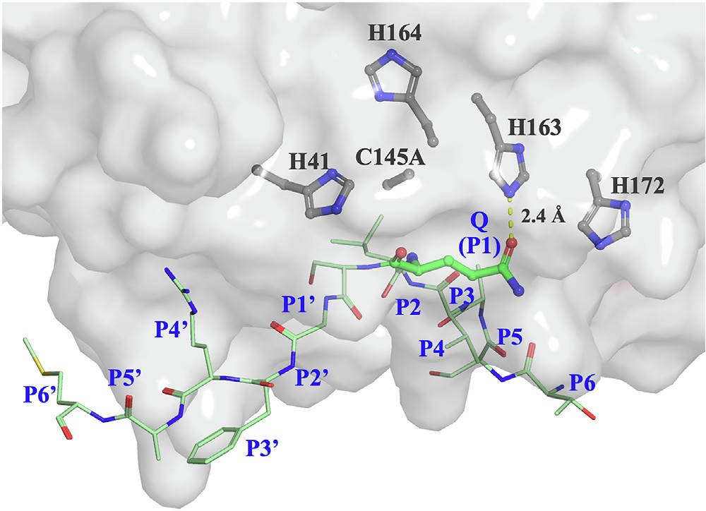

Figure 1. Surface representation of the active site of SARS-CoV-2 3CLpro. Protein Data Bank (ID: 7T70) was used to generate the ﬁgure. The catalytic residue Cys145 was mutated to Ala to prevent cleavage of the peptide substrate (24). The side chains of the catalytic dyad residues (His41

and Cys145) and the conserved active-site histidine residues (H163, H164, and H172) are depicted as *dark gray sticks*. The 12-mer substrate peptide (TSAVLQ↓SGFRKM) is colored in *green*. The conserved glutamine at P1 of the peptide substrate forms a hydrogen bond at 2.4 Å with the side chain of His163. The ﬁgure was generated using PyMol (Schrodinger LLC). 3CLpro, 3-

chymotrypsin-like protease; SARS-CoV-2, severe acute respiratory syndrome

coronavirus 2.

# Results

*pH pro*ﬁ*le of WT SARS-CoV-2 3CLpro*

The pH dependence of the kinetic parameters of WT 3CLpro from SARS-CoV-2, including the turnover number (*k*cat) and catalytic efﬁciency (*k*cat/*Km*), was determined over the pH range of 5.5 to 10.0 (Fig. 2). The proteolytic activity of WT 3CLpro was assayed continuously by monitoring the cleavage of the ﬂuo- rescent peptide substrate using a highly sensitive FRET-based enzymatic assay (12, 22, 28–30). Initial velocity studies were

performed at 30 ◦C in 20 mM Hepes (pH 7.0), 100 mM NaCl, 1 mM EDTA, 1 mM Tris(2-carboxyethyl)phosphine (TCEP),

and 20% (v/v) dimethyl sulfoxide (DMSO) to acquire the kinetic parameters of the WT enzyme. The peptide substrate was varied from 20 to 500 *μ*M at a ﬁxed enzyme concentration, and the proteolytic cleavage rate was ﬁt to Michaelis–Menten equation. The pH proﬁle of *k*cat had a half-bell shape with maximum

*k*cat values at pH >7.5 as shown in Figure 2*A*. Fitting the *k*cat

pH proﬁle using Equation 1 resulted in a single p*K*a value of

6.7 ± 0.1. By contrast, the pH proﬁle of *k*cat/*Km* was bell sha- ped, with a maximum *k*cat/*Km* value at pH 8.0 (Fig. 2*B*). Fitting the data to a double-titration bell-shaped model (Equation 2) resulted in p*K*a values of 6.9 ± 0.1 and 9.4 ± 0.1. Despite similar *k*cat values, *k*cat/*Km* values were lower at pH 9.0 to 9.5 than at pH 7.5 to 8.5. This observation is due to an increase in *Km* values (Table S1), which implies that substrate binding is reduced at high pH. Experimentally, we also observed aggre- gation and precipitation of the peptide substrate at pH ≥10.

*Enzymatic activity and initial velocity studies of histidine mutants of SARS-CoV-2 3CLpro*

Crystal structure analysis revealed network of bonding in- teractions with the peptide substrate in the active site of

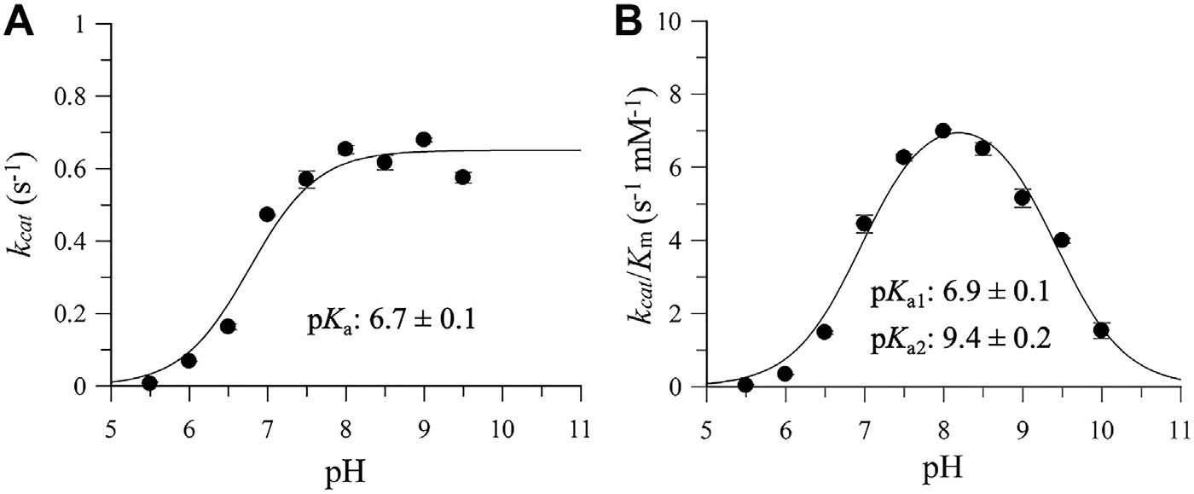

Figure 2. pH proﬁles of WT SARS-CoV-2 3CLpro. *A*, pH proﬁle of *k*cat showing dependence on a single ionizable group with a p*K*a of 6.7 ± 0.1. *B*, pH proﬁle of *k*cat/*Km* showing dependence on 2 ionizable groups with p*K*a values of 6.9 ± 0.1 and 9.4 ± 0.2. The *lines* represent the best ﬁt of the experimental data to half-bell (*k*cat) and bell-shaped (*k*cat/*Km*) models using GraFit 5.0 software (Erithacus Software Ltd). All reactions were performed at 30 ◦C with (DABCYL) KTSAVLQ↓SGFRKME(EDANS)-NH2 as the substrate. Data points are means ± SD of triplicate measurements. 3CLpro, 3-chymotrypsin-like protease; SARS-

CoV-2, severe acute respiratory syndrome coronavirus 2.

3CLpro including 3 histidine residues (Fig. 1). To determine the roles of the conserved histidine residues in the substrate- binding site of SARS-CoV-2 3CLpro, we introduced alanine mutations at H163, H164, and H172. The proteolytic activity of the histidine mutants was compared with the WT 3CLpro, where the rate was measured at a ﬁxed peptide substrate concentration of 60 *μ*M, whereas the enzyme concentration was varied from 0.5 to 5.0 *μ*M (Fig. 3). Increasing the enzyme concentration was important for activity detection, as the mutants were expected to have low activity.

Alanine substitution at His163 (H163A) completely inacti- vated the enzymatic activity of 3CLpro (Fig. 3*A*). By contrast, H164A and H172A retained 75% and 26% of the enzymatic activity of WT 3CLpro, respectively (Fig. 3*D*). These results suggested that H163 and H172 are important for maintaining the catalytic activity of SARS-CoV-2 3CLpro. In addition to alanine substitutions, we introduced lysine, arginine, and tyrosine at H163 and H172. None of the amino acid sub- stitutions of His163, that is, H163K, H163R, and H163Y, recovered the enzymatic activity of 3CLpro, further supporting the importance of His163 in the catalytic mechanism of 3CLpro (Fig. 3*B*). However, tyrosine substitution at His172 resulted in full recovery of enzymatic activity to WT levels (Fig. 3, *C* and *D*).

Next, initial velocity studies were performed to acquire the kinetic parameters of the H164A, H172A, and H172Y mutants, which had partial or full catalytic activity compared with the WT enzyme (Fig. 4). Compared with WT 3CLpro, H164A and H172A exhibited 22% and 80% reductions in *k*cat, respectively, whereas the *k*cat of H172Y was nearly identical to the WT enzyme (Fig. 4*A*). All tested mutations increased the *Km* of 3CLpro compared with WT, which had a *Km* of 67 ± 3 mM; the *Km* values of H164A, H172A, and H172Y were 103 ± 6 mM, 89 ± 1 mM, and 80 ± 2 mM, respectively (Fig. 4*B*). These effects indicate that the histidine residues play impor- tant roles in peptide substrate binding. Overall, the WT and H172Y enzymes had the highest and similar catalytic efﬁ- ciencies (Fig. 4*C*), whereas H164A and H172A exhibited decreases in *k*cat/*Km* of 49% and 85%, respectively.

*Thermodynamic stability of histidine mutants of SARS-CoV-2 3CLpro*

The effects of the histidine mutations (H163A, H164A, H172A, and H172Y) on the thermodynamic stability of 3CLpro were examined using differential scanning calorimetry (DSC). DSC thermograms of each enzyme were acquired in 20 mM Hepes (pH 7.4), 100 mM NaCl, and 0.5 mM TCEP, and

the temperature was ramped from 15 to 75 ◦C at a scan rate of 1 ◦C/min to acquire the thermal unfolding transitions (Fig. 5).

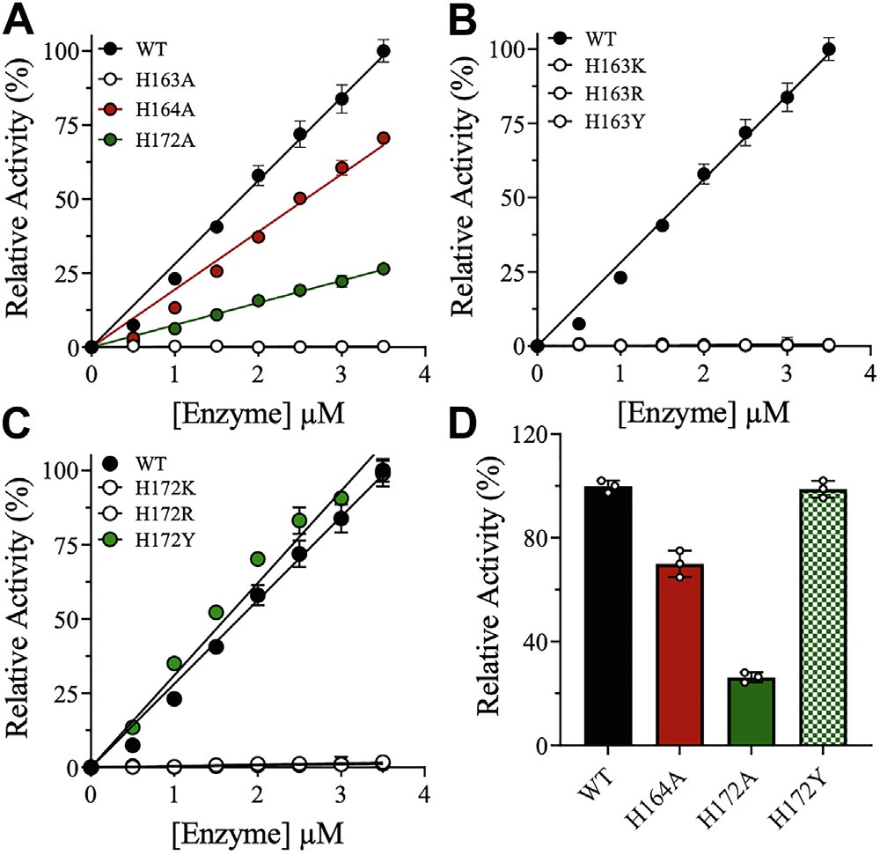

Figure 3. Effects of 3CLpro histidine (H163, H164, and H172) mutants on activity relative to WT. *A*–*C*, relative activities of the active-site histidine mutants of 3CLpro at increasing enzyme concentrations (0.0–3.5 μM) and a ﬁxed peptide substrate concentration of 60 μM. The proteolytic cleavage rates of each mutant were normalized to the rate of 3CLpro WT to obtain

the percent relative enzymatic activity. Enzymatically active mutants are represented by ﬁ*lled colored circles*, whereas enzymatically inactive mutants are represented by *open black circles*. *D*, bar plot of the relative activity of WT 3CLpro and the enzymatically active mutants (H164A, H172A, and H172Y). Data are presented as the mean ± SD, n = 3. 3CLpro,

3-chymotrypsin-like protease.

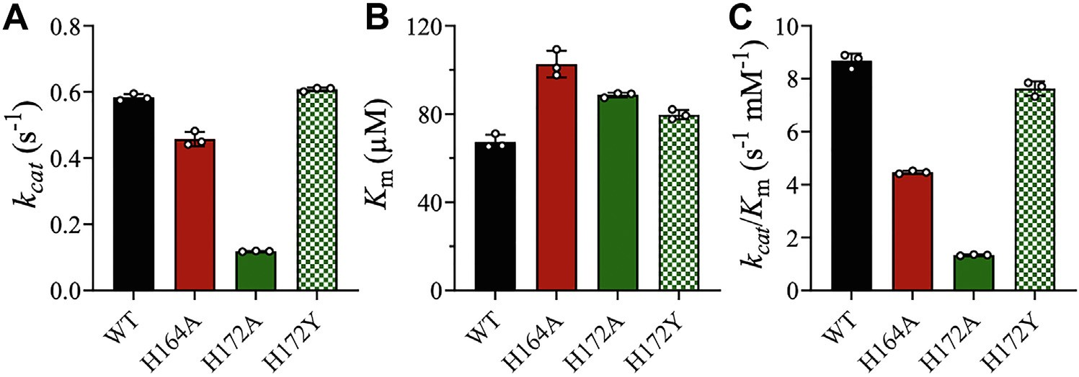

Figure 4. Effects of 3CLpro histidine mutants on the kinetic parameters. (*A*) *k*cat, (*B*) *Km*, and (*C*) *k*cat/*Km* of 3CLpro compared with WT enzyme. Data points are the means ± SD of triplicate measurements. 3CLpro, 3-chymotrypsin-like protease.

The WT and mutant enzymes exhibited a single transition with an early shoulder peak (Fig. 5*A*). The melting temperature (*T*m) was determined from the apex of the thermogram peak, where the WT enzyme had a *T*m of 52.9 ± 0.1 ◦C, consistent with previously reported values (22, 31). The alanine sub- stitutions at H163 and H172 decreased the *T*m slightly to

50.3 ± 0.1 ◦C and 50.8 ± 0.6 ◦C, respectively, whereas H172Y had a *T*m of 53.0 ± 0.2 ◦C, similar to the WT enzyme (Fig. 5*B*). The calorimetric enthalpy (*ΔH*cal) values determined from the

area under the thermographic peak were similar for all vari- ants: 185 ± 3 kJ/mol for WT, 194 ± 17 kJ/mol for H163A,

186 ± 8 kJ/mol for H164A, 209 ± 10 kJ/mol for H172A, and 187 ± 16 kJ/mol for H172Y (Fig. 5*C*).

*pH pro*ﬁ*les of the histidine mutants of SARS-CoV-2 3CLpro*

Given its complete loss of enzymatic activity, the pH proﬁles of H163 mutants of 3CLpro could not be determined. The pH proﬁles of the catalytically active histidine mutants H164A, H172A, and H172Y were similar to those of the WT enzyme (Fig. 6). The *k*cat pH proﬁles exhibited a half-bell shape with one ionizable residue with a p*K*a value of 6.8 ± 0.1, 6.2 ± 0.1, or

6.1 ± 0.2 for H164A, H172A, and H172Y, respectively (Fig. 6, *A*, *C* and *E*). The *k*cat/*Km* pH proﬁles exhibited a bell shape with 2 ionizable groups with p*K*a values similar to those of the WT enzyme (6.9 ± 0.1 and 9.4 ± 0.2): H164A (7.1 ± 0.1 and 9.4 ± 0.2), H172A (6.5 ± 0.1 and 9.6 ± 0.2), and H172Y (6.4 ±

0.1 and 9.4 ± 0.3) (Fig. 6, *B*, *D* and *F*). For H172A and H172Y, the ﬁrst p*K*a was slightly lower than that of WT. Importantly, the overall kinetic parameters of H172A were lower than those of WT at all tested pH values.

# Discussion

The cysteine protease 3CLpro is highly conserved in all coronaviruses because of its essential role in processing viral polyproteins (5, 8–10). MD and crystallographic studies have indicated that coronavirus 3CLpro enzymes undergo pH- dependent conformational changes (23, 25, 32). This confor- mational dependence on pH is due to the high ﬂexibility of 3CLpro enzymes and is physiologically relevant: 3CLpro is assembled in late endosomes, where the low pH environment maintains the enzyme in an inactive state to prevent auto- proteolysis of the viral polyproteins (33). Crystal structures of SARS-CoV 3CLpro have been determined in different pH environments (34). The dimeric structures of 3CLpro at pH 7.6 and 8.0 are in the fully active conformations, whereas at pH 6.0, 3CLpro undergoes substantial conformational changes that lead to complete inactivation of one protomer. These initial crystallographic data were later supported by several pH proﬁles of SARS-CoV 3CLpro, which revealed a bell-shaped curve with maximum activity at pH 7.0 to 8.5 (21, 25, 34).

In the present study, we identiﬁed key residues in the active site of SARS-CoV-2 3CLpro that interact with the substrate, in

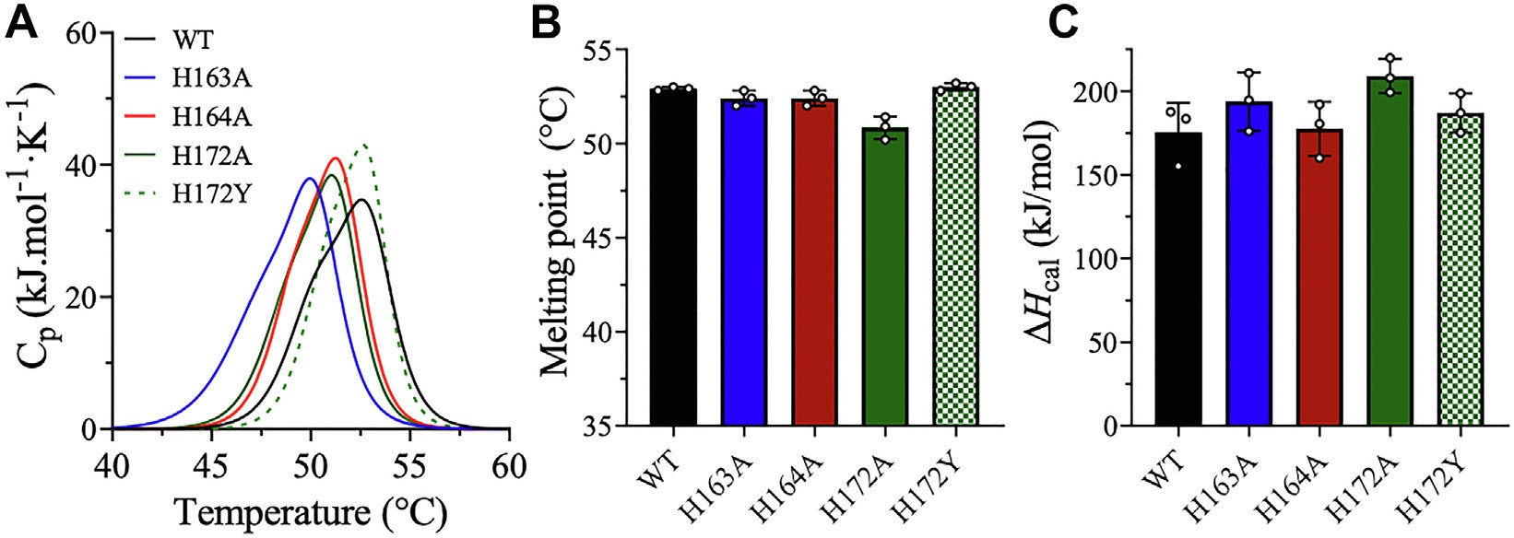

Figure 5. DSC thermal scans of WT and mutant 3CLpro. *A*, DSC thermal scans of WT and mutant 3CLpro (H163A, H164A, H172A, and H172Y) were acquired at a heating rate of 1.0 ◦C/min. *B*, bar plot of *T*m calculated at the apex of the thermographic peak. *C*, bar plot of Δ*H*cal calculated from the area under the DSC thermal peak. Data are presented as the mean ± SD, n = 3. 3CLpro, 3-chymotrypsin-like protease; DSC, differential scanning calorimetry.

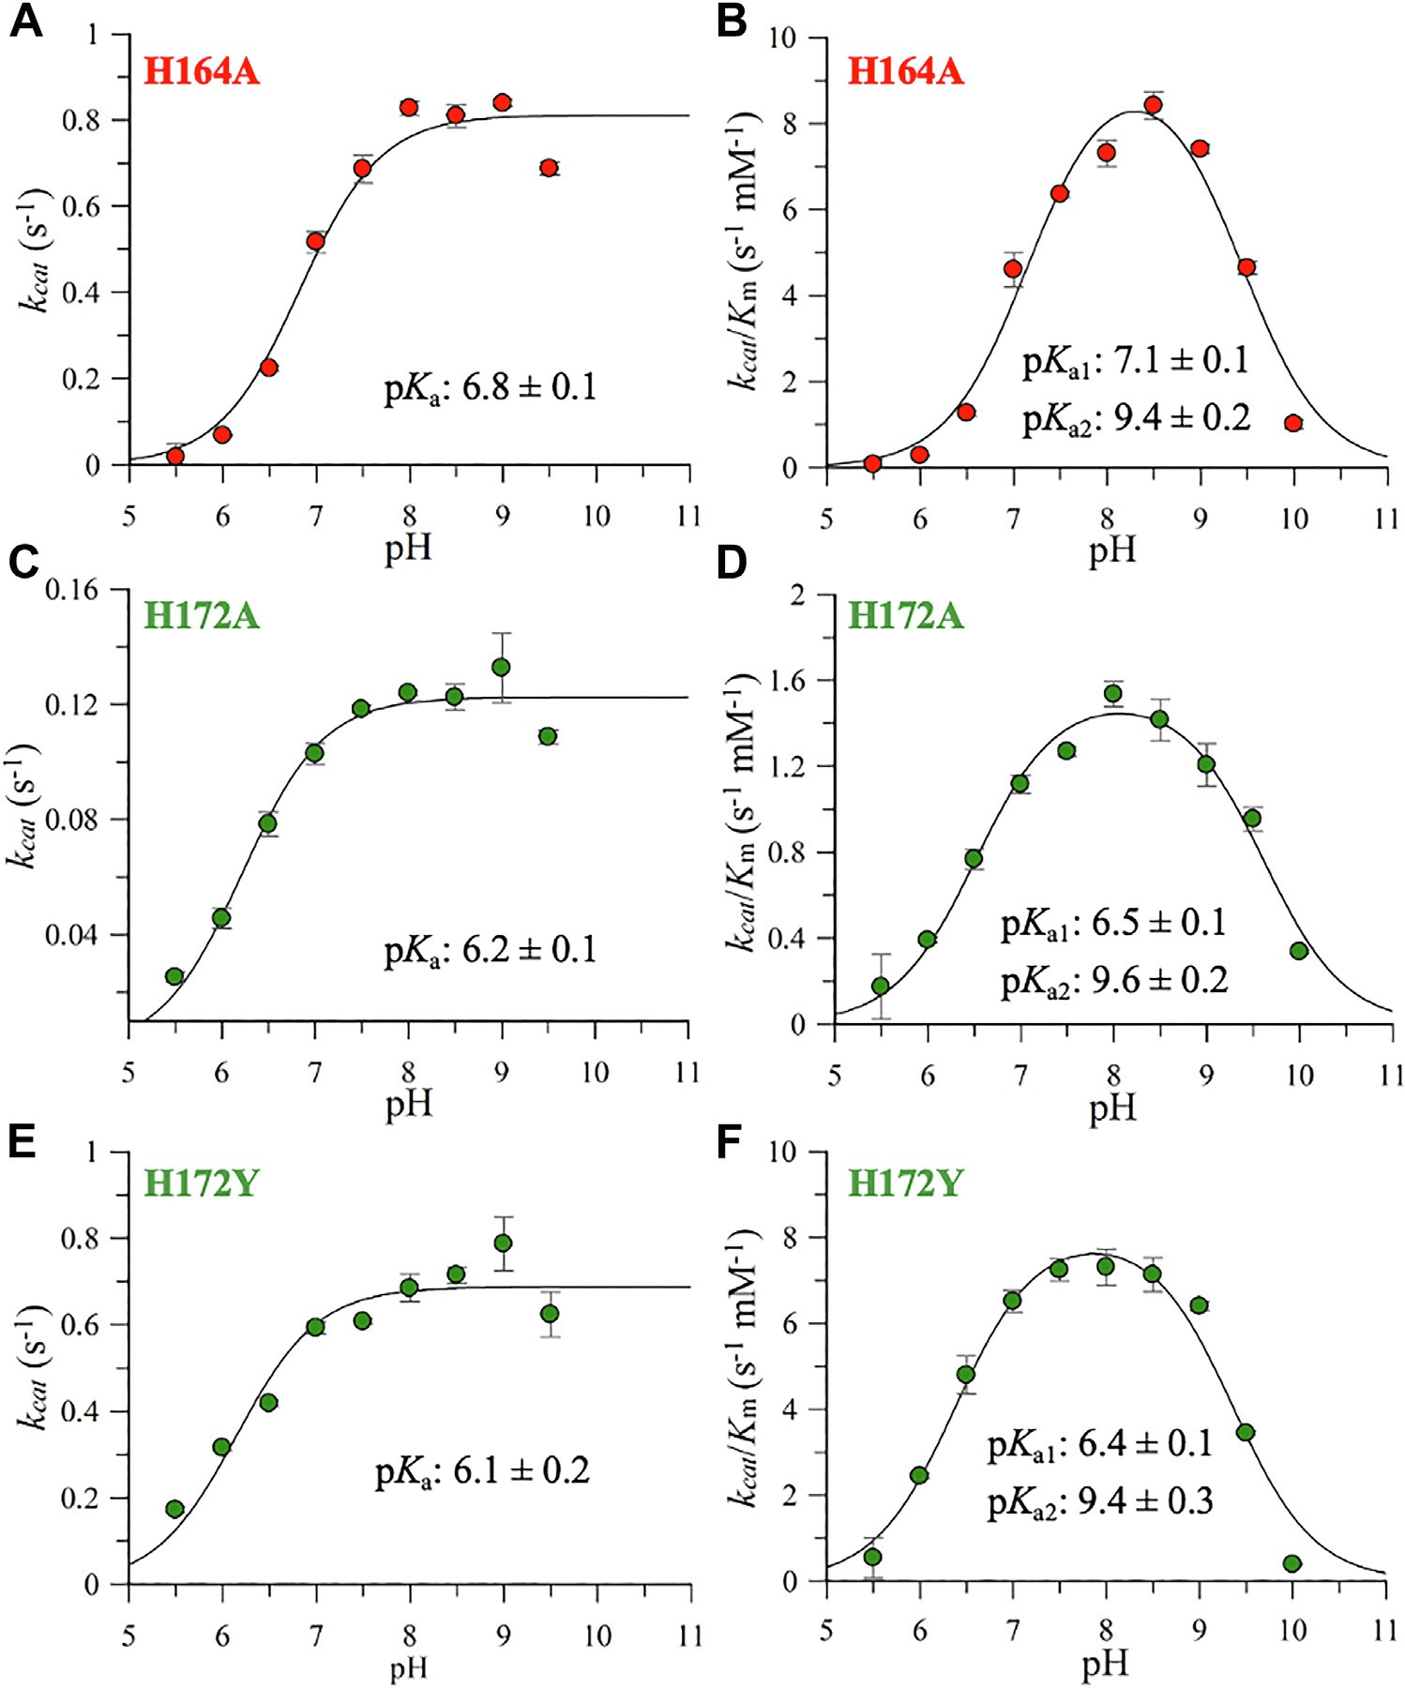

Figure 6. pH proﬁles of SARS-CoV-2 3CLpro histidine mutants. *A*, *C*, and *E*, pH proﬁles of *k*cat for H164A, H172A, and H172Y showing dependence on a single ionizable group with one p*K*a value. *B*, *D*, and *F*, pH proﬁles of *k*cat/*Km* for H164A, H172A, and H172Y showing dependence on 2 ionizable groups with 2 p*K*a values. The *lines* represent the best ﬁt of the experimental data to half-bell (*k*cat) and bell-shaped (*k*cat/*Km*) models using GraFit 5.0 software (Erithacus Software Ltd). Data points are means ± SD of triplicate measurements. 3CLpro, 3-chymotrypsin-like protease; SARS-CoV-2, severe acute respiratory syn-

drome coronavirus 2.

addition to the catalytic dyad His41 and Cys145. Among these residues, His163, His164, and His172 play important roles in binding the peptide substrate and ensuring its proper orien- tation for catalysis. Within the peptide substrate, the Gln residue has the largest number of binding interactions with the protease. The S1 pocket of the active site of 3CLpro is mainly formed by residues Phe140, Leu141, Asn142, Glu166, His163, and His172 from one monomer and Ser1 of the other monomer (35). The ionizable groups in the active site of an enzyme must adopt the proper orientation to ensure substrate binding and functional catalysis. Although previous MD and crystallographic studies have discussed the pH-dependent conformational changes of 3CLpro of SARS-CoV and SARS- CoV-2, this study is the ﬁrst to report experimental pH pro- ﬁles of the kinetic parameters of the WT enzyme and variants

with mutations of key histidine residues at the substrate- binding site of SARS-CoV-2 3CLpro.

The pH proﬁle of *k*cat/*Km* of SARS-CoV-2 3CLpro is bell shaped with p*K*a values of 6.9 ± 0.1 and 9.4 ± 0.1 (Fig. 2), which are likely attributable to the ionizable side chains of the cata- lytic dyad His41 and Cys145, respectively. The pH proﬁles of *k*cat and *k*cat/*Km* of H164A, H172A, and H172Y are similar in shape to those of the WT enzyme, with comparable p*K*a values (Fig. 6). The similar shapes of the pH proﬁles and calculated p*K*a values of the mutants and the WT enzyme further indicate that the estimated p*K*a values correspond to the catalytic dyad His41 and Cys145. Our ﬁndings are in agreement with previ- ous MD studies proposing a general base mechanism of 3CLpro in which the catalytic residues are neutral at physio- logical pH (*i.e.*, non–ion-pair mechanism), with p*K*a values of

6.4 and 8.3 for the catalytic dyad His41 and Cys145, respec- tively (21, 26, 27, 35–37). A comprehensive MD study of the neutral and zwitterionic states of the catalytic dyad of SARS- CoV-2 3CLpro found enhanced binding and stability of the peptide substrate in the proper mode for catalysis when the catalytic residues were in the neutral form (27). By contrast, the zwitterionic state of 3CLpro disturbed domain I of the active site and impaired substrate binding (27). Our experi- mental pH proﬁles of *k*cat/*Km* support the need for a neutral state of the catalytic dyad to ensure proper substrate binding (*i.e.*, low *Km* values) and maximal enzyme catalysis (high *k*cat values). However, the pH proﬁle of *k*cat yielded only one titratable group, the imidazole side chain of His41, needed for optimal enzyme catalysis, with a p*K*a of 6.7 ± 0.1.

In addition to the active-site residues, computational studies of the protonation states of conserved histidine residues in the substrate-binding site have reported that H163 and H172 have p*K*a values of <5.0 and 6.6, respectively, and thus exist in their neutral states under physiological conditions (26, 36). At physiological pH, the neutral (singly protonated Nε) state of

His163 facilitates polar and nonpolar contacts to maintain a

stable S1-binding pocket. In fact, a structural analysis of the 3CLpro substrate-binding site found that an H-bond forms between His163 (at Nε) and the highly conserved Gln sub-

strate residue (at its side-chain carbonyl oxygen); this inter-

action requires a neutral His163 to ensure the absolute speciﬁcity of 3CLpro for Gln at P1 of the peptide substrate (34).

Our work demonstrates that hydrogen bonding interactions between His163 (at Nε) with the side-chain carbonyl oxygen of P1 Gln of the peptide substrate at a 2.4 Å is crucial for the activity of 3CLpro of SARS-CoV-2 (Fig. 1). Hence, different amino acid substitutions of H163 including substitution of

arginine (H163R), lysine (H164K), and tyrosine (H163Y) could not recover the activity of 3CLpro. Even though, arginine, lysine, and tyrosine are able to form hydrogen bonding inter- action; however, the large size of their side chains did not facilitate the required H-bonding distances with the peptide substrate. Overall, H-bond with speciﬁc distance between His163 and P1 of the peptide substrate is crucial to facilitate proper peptide substrate orientation for optimum activities of 3CLpro of SARS-CoV-2.

In addition, His163 participates in aromatic stacking with Phe140 to support the neutral state of His163 and ensure its optimal interaction with the substrate Gln (26, 34). The neutral side chain of His163 (at N*δ*) also acts as an H-bond acceptor in an H-bond interaction with the side chain of the donor Tyr161 (38). MD simulations further revealed that full protonation of H163 results in the spontaneous collapse of the binding pocket and inactivation of 3CLpro (25, 38).

The estimated p*K*a of H172 was 6.6; thus, this residue is also neutral in the optimum pH range (7.5–8.5) of WT 3CLpro (26, 36). In fact, MD simulations have indicated that proton- ation of His172 at pH 6.0 results in collapse of the oxyanion hole, leading to conformational deactivation of the S1 pocket (23, 26). The imidazole side chain of the neutral H172 forms a conserved H-bond with the side chain of Glu166, a key

interaction that is lost upon H172 protonation (19, 25, 34). In addition, a computational analysis demonstrated that proton- ation of His172 abolishes its interaction with Ser1 in the N-ﬁnger domain of the opposite monomer, whereas this interaction is maintained when H172 is in the neutral state (26).

Consequently, our results provide experimental evidence of the important roles of H163 and H172 in maintaining the catalytic activity of 3CLpro. Alanine substitution of H163 resulted in complete loss of enzymatic activity, and substitu- tion with other amino acids did not recover 3CLpro activity (Fig. 3, *A* and *B*). Our data provide experimental proof of the

reported interaction between the imidazole of His163 (at Nε2) and the highly conserved Gln residue of the peptide substrate

(38). Alanine substitution of H172 reduced the catalytic ac- tivity and kinetic parameters of 3CLpro by 80% compared with WT (Figs. 3 and 4). These reductions may be due to the loss of the H-bond interaction between the side chains of His172 and Glu166, which was previously reported to be critical for sta- bilizing the oxyanion hole and hence activating enzyme function (19, 23). We experimentally veriﬁed the neutral state of His172 by introducing lysine, arginine, and tyrosine muta- tions and assessing the activity and pH proﬁles of the resulting mutants (Figs. 3, 4 and 6). H172K and H172R were inactive, and only H172Y resulted in full recovery of activity similar to that of WT 3CLpro (Fig. 3*D*).

In light of these ﬁndings, a catalytic mechanism of 3CLpro can be proposed (Fig. 7). Catalysis begins with the deproto- nation of the thiol side chain of Cys145 by His41 to facilitate nucleophilic attack of Cys145 on the carbonyl carbon of glutamine in the polyprotein backbone and the formation of a covalent thioester bond. The resulting tetrahedral thio- hemiacetal intermediate contains an oxyanion group that is stabilized by hydrogen bonding with the amides of the main- chain residues Ser139–Leu141. Subsequent collapse of the thiohemiacetal complex releases the C-terminal segment of the polypeptide substrate (20, 21, 39), and hydrolysis of the thioester linkage by a water molecule displaces Cys145 and releases the N-terminal part of the polypeptide substrate.

In summary, our experimental data and previous MD studies support a general base mechanism of SARS-CoV-2 3CLpro in which the neutral states of the catalytic dyad resi- dues and conserved active-site histidine residues are required for catalysis. In addition, we highlight the importance of the neutral states of His163 and His172 for achieving a fully active enzyme state.

# Experimental procedures

*Expression and puri*ﬁ*cation of WT and mutant 3CLpro*

The recombinant genes for WT and mutant 3CLpro were introduced into pET28b(+) bacterial expression vectors by GenScript, Inc. The vectors were used to transform *Escher- ichia coli* BL21-CodonPlus-RIL (Stratagene) for protein

expression as previously described (31). The inoculated culture (1 l) was grown in terriﬁc broth medium at 30 ◦C in the presence of 100 mg/l kanamycin and 50 mg/l chloramphenicol

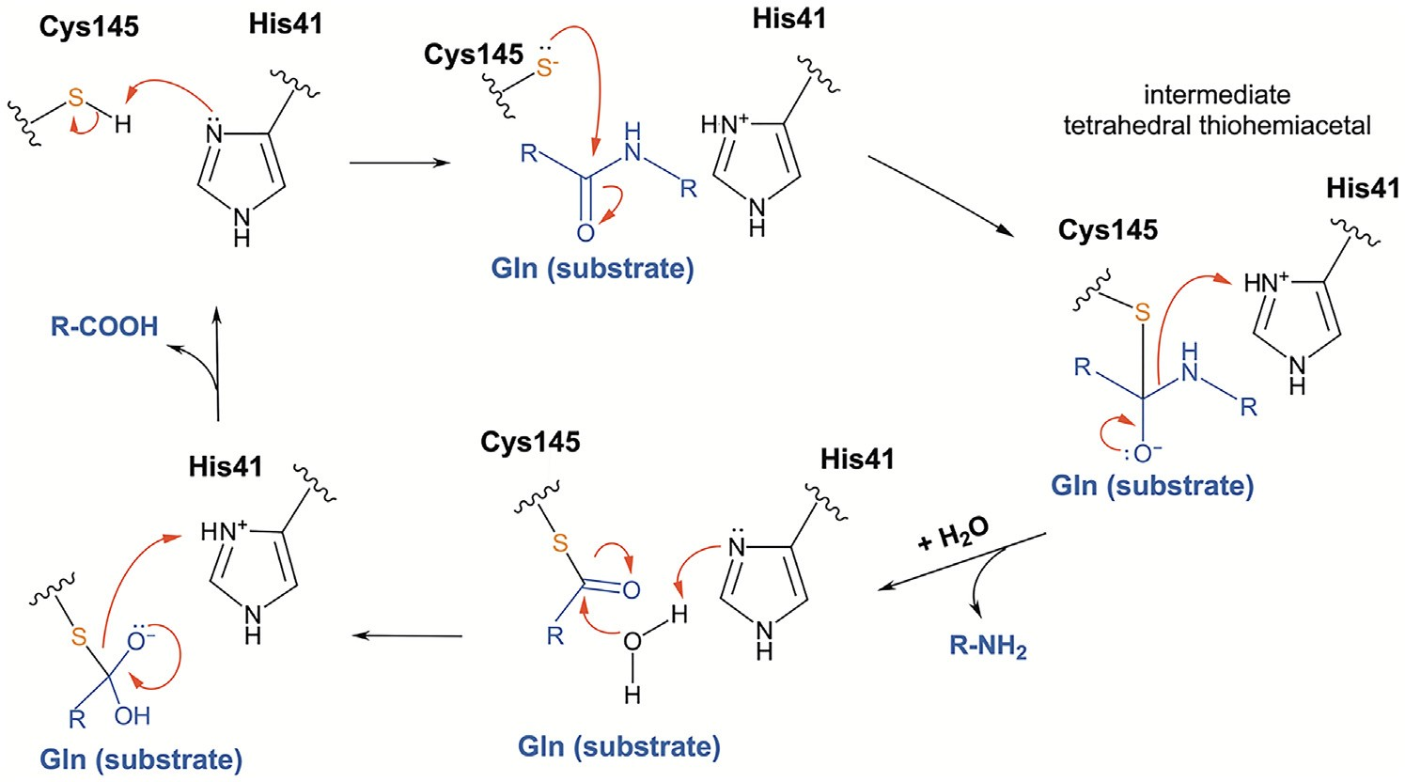

Figure 7. Proposed chemical mechanism of 3CLpro SARS-CoV-2. 3CLpro, 3-chymotrypsin-like protease; SARS-CoV-2, severe acute respiratory syndrome coronavirus 2.

until the absorbance at 600 nm reached 0.8. The temperature was then lowered to 15 ◦C, and protein expression was induced overnight with 0.5 mM IPTG. The cells were har- vested by centrifugation at 8000 rpm and 4 ◦C for 10 min in an Avanti J26-XPI centrifuge (Beckman Coulter, Inc). The cells

were homogenized in lysis buffer containing 20 mM Tris (pH 7.5), 150 mM NaCl, 5 mM imidazole, 3 mM *β*-mercaptoe- thanol (*β*-ME), and 0.1% protease inhibitor cocktail (Sigma– Aldrich; catalog no.: P8849). The cell lysates were sonicated on ice before centrifugation at 40,000*g* for 45 min at 4 ◦C.

The supernatant was loaded onto a ProBond nickel- chelating column (Life Technologies) previously equilibrated with binding buffer containing 20 mM Tris (pH 7.5), 150 mM NaCl, 5 mM imidazole, and 3 mM *β*-ME at 4 ◦C. The column was washed with binding buffer followed by washing buffer

containing 20 mM Tris (pH 7.5), 150 mM NaCl, 25 mM imidazole, and 3 mM *β*-ME. The Hisx6-tagged 3CLpro enzyme was eluted with 20 mM Tris (pH 7.5), 150 mM NaCl, 300 mM imidazole, and 3 mM *β*ME. Finally, the fractions containing 3CLpro were loaded onto a HiLoad 16/600 Superdex 200 size-exclusion column (GE Healthcare) on an ÄKTA pure 25 chromatography system (Cytiva). The gel ﬁltration column was pre-equilibrated with 20 mM Hepes (pH 7.5), 100 mM NaCl, and 0.5 mM TCEP. The ﬁnal protein was collected and concentrated to 55 *μ*M as determined by the Bradford assay, and the protein purity was assessed *via* SDS- PAGE.

*Enzymatic activity analysis*

The enzymatic activities of WT 3CLpro and the histidine mutants were assessed by an FRET-based assay using the 14-amino-acid ﬂuorogenic peptide substrate (DABCYL) KTSAVLQ↓SGFRKME(EDANS)-NH2 (GenScript, Inc) as

described previously (12, 19, 28, 29, 40–42). The reaction was initiated by adding WT or mutant 3CLpro to the peptide substrate in 20 mM Hepes, pH 7.0, 100 mM NaCl, 1 mM

EDTA, and 1 mM TCEP. The assay buffer contained 20% (v/v) DMSO to reduce the aggregation of the peptide substrate and enhance its stability (22). The reaction rate was measured for

10 min at 30 ◦C in a thermostatically controlled cell

compartment. The catalytic rates were determined from the cleavage of the ﬂuorogenic substrate, which was monitored by the increase in the ﬂuorescence signal upon release of the EDANS group in a 96-well plate assay format in a Cytation 5 multimode microplate reader (Biotek Instruments). The ﬂuo- rescence signal was monitored at *λ*excitation of 360 nm and *λ*emission of 500 nm.

To account for the inner ﬁlter effect in the FRET enzymatic assay, ﬁrst, the excitation coefﬁcient of free EDANS was determined in the absence of the peptide substrate by varying the concentration of free EDANS, *f*0 (EDANS). Next, the correction factor (Corr%) required to correct for the decrease in the emission signal of the ﬂuorogenic substrate in the presence of the quencher (DABCYL) was calculated (22, 40, 41, 43, 44). To calculate Corr%, the ﬂuorescence of a ﬁxed concentration (50 *μ*M) of free EDANS was measured in the absence, f(S), and presence, f(S + EDANS), of various con- centrations of the peptide substrate (from 20 to 500 *μ*M):

*fs* ðEDANSÞ¼ fðS þ EDANSÞ−fðSÞ

To determine Corr%, the emission reduction of free EDANS at a speciﬁc substrate concentration, *f*s (EDANS), was compared with that of EDANS in the absence of peptide substrate, *f*o (EDANS).

Corr *fs* ðEDANSÞ

¼

*f*0 ðEDANSÞ

The values of Corr% calculated at different peptide sub- strate concentrations were taken into consideration when measuring the cleavage rate of 3CLpro. The effect of histidine mutations on the catalytic rate of 3CLpro was determined by

measuring enzymatic activity at different enzyme concentra- tions ranging from 0.5 to 5.0 *μ*M and a ﬁxed peptide substrate concentration of 60 *μ*M. The relative activity of each mutant was obtained from the slope of the straight line for each mutant.

*Initial velocity studies and pH dependence of kinetic parameters*

Next, initial velocity studies were performed to determine the kinetic parameters *k*cat and *Km* for the WT enzyme and the histidines’ catalytically active histidine mutants. The concen- tration of the peptide substrate was varied from 20 to 500 *μ*M at a ﬁxed enzyme concentration. Three independent experi- ments were performed with triplicate measurement each to obtain the cleavage rate data that were ﬁtted to the Michaelis– Menten equation using the global ﬁtting analysis function in the kinetics module of SigmaPlot (Systat Software, Inc). The kinetic parameters, *k*cat and *Km*, were obtained, and the stan- dard error bars were calculated from triplicate measurements of each reaction using GraphPad Prism 9.0 software (Graph- Pad Software, Inc). The results are presented as the mean ± SD.

The pH proﬁles of WT 3CLpro and the catalytically active mutants H164A, H172A, and H172Y were measured using the FRET enzymatic assay by varying the concentration of the peptide substrate from 20 to 500 *μ*M at a ﬁxed enzyme con- centration. The reaction buffers were prepared over a pH range of 5.5 to 10 using 20 mM Mes for pH 5.5 to 6.5, 20 mM

Hepes for pH 7.0 to 8.0, and 20 mM Ches for pH 8.5 to 10.0. All reaction buffers contained 100 mM NaCl, 1 mM EDTA, 1 mM TCEP, and 20% (v/v) DMSO. Initial velocity studies were performed to determine the kinetic parameters *k*cat and *k*cat/*Km* as a function of pH. GraFit 5.0 software (Erithacus Software Ltd) was used to determine the p*K*a values. Equa- tion 1 was used to ﬁt the pH proﬁle data of *k*cat with a single ionizable group resulting in a half-bell curve with zero activity at low pH and an activity plateau at high pH. Equation 2 was used to ﬁt the pH proﬁle data of *k*cat/*Km* with 2 ionizable groups resulting in a bell-shaped curve with zero activity at low and high pH.

10*pH*−*pKa*

*k* ¼ *k*ð*limit*Þ10*pH*−*pKa* þ 1 (1)

*DSC*

The effects of mutations on the thermodynamic stability of 3CLpro were assessed by DSC in a Nano-DSC instrument (TA Instruments). A ﬁxed enzyme concentration of 25 *μ*M was used in buffer containing 20 mM Hepes (pH 7.4), 100 mM NaCl, and 0.5 mM TCEP. All samples were scanned from 15 to

75 ◦C at a temperature ramp rate of 1 ◦C/min. The buffer was

used as a reference, and the protein samples were degassed for 10 min prior to the start of each analysis run. The DSC scans were acquired by ramping up the temperature twice to obtain

2 thermograms; the second scan was used as the buffer background for each sample. The lack of signal in the second ramp-up temperature scan conﬁrmed that the melting tran- sitions of all 3CLpro variants were irreversible. The DSC scans were normalized for protein concentration and baseline cor- rected by subtracting the corresponding buffer baseline. The data were then converted to plots of excess heat capacity (Cp) as a function of temperature. The *T*m of 3CLpro was deter- mined from the temperature at the apex of the thermal tran- sition, and the calorimetric enthalpy (*ΔH*cal) of the transition was estimated from the area under the thermal transition curve using NanoAnalyze Software, version 3.11.0 (TA Instruments).

# Data availability

The authors declare that all data that support the ﬁndings of this study are available within this article and its accompanying ﬁles.

*Supporting information*—This article contains supporting information.

*Acknowledgments*—This research was partially carried out using the Core Technology Platforms resources at New York University Abu Dhabi.

*Author contributions*—K. A. A., J. C. F., S. F., and W. M. R. meth-

odology; K. A. A., J. C. F., and S. F. formal analysis; K. A. A., J. C. F., and S. F. investigation; K. A. A. and W. M. R. writing–original draft;

K. A. A. and W. M. R. supervision.

*Funding and additional information*—This work was supported by New York University Abu Dhabi through research funds provided to the laboratory of Prof Rabeh in addition to the COVID-19 Facilitator Research Fund (grant number: ADC05).

*k* ¼ *k*

ð*limit*Þ

1 (2)

1 þ 10*pK* 1−*pH* þ 10*pH*−*pK* 2

*Con*ﬂ*ict of interest*—The authors declare that they have no conﬂicts of interest with the contents of this article.

In Equation 1, *k* is *k*cat, *k*(limit) corresponds to the maximum limit of *k*cat, and p*K*a is the dissociation constant of the single ionizable group. In Equation 2, *k* is *k*cat/*Km*, *k*(limit) corresponds to the maximum limit of *k*cat/*Km*, and p*K*a1 and p*K*a2 are the dissociation constants of the ﬁrst and second ionizable groups. The 3 independent pH proﬁle measurements were analyzed using GraFit 5.0 software that provided the p*K*a values and standard errors.

*Abbreviations*—The abbreviations used are: 3CLpro, 3- chymotrypsin-like protease; DMSO, dimethyl sulfoxide; DSC, dif- ferential scanning calorimetry; MD, molecular dynamics; *β*-ME, *β*-mercaptoethanol; nsp, nonstructural protein; PLpro, papain-like protease; SARS-CoV, severe acute respiratory syndrome coronavirus; SARS-CoV-2, severe acute respiratory syndrome coronavirus 2; TCEP, Tris(2-carboxyethyl)phosphine.

References

1. [Ciotti, M., Angeletti, S., Minieri, M., Giovannetti, M., Benvenuto, D.,](http://refhub.elsevier.com/S0021-9258(22)01233-9/sref1) [Pascarella, S., *et al*. (2019) COVID-19 outbreak: an overview. *Chemo-*](http://refhub.elsevier.com/S0021-9258(22)01233-9/sref1)[*therapy* 64, 215–223](http://refhub.elsevier.com/S0021-9258(22)01233-9/sref1)
2. [Wu, Y. C., Cflen, C. S., and Cflan, Y. J. (2020) Tfle outbreak of COVID-19:](http://refhub.elsevier.com/S0021-9258(22)01233-9/sref2) [an overview. *J. Chin Med. Assoc.* 83, 217–220](http://refhub.elsevier.com/S0021-9258(22)01233-9/sref2)
3. [Pascual-Iglesias, A., Canton, J., Ortega-Prieto, A. M., Jimenez-Guardeño,](http://refhub.elsevier.com/S0021-9258(22)01233-9/sref3)

[J. M., and Regla-Nava, J. A. (2021) An overview of vaccines against SARS-](http://refhub.elsevier.com/S0021-9258(22)01233-9/sref3) [CoV-2 in tfle COVID-19 pandemic era. *Pathogens* 10](http://refhub.elsevier.com/S0021-9258(22)01233-9/sref3)

1. [Cflen, Y., Guo, Y., Pan, Y., and Zflao, Z. J. (2020) Structure analysis of tfle](http://refhub.elsevier.com/S0021-9258(22)01233-9/sref4) [receptor binding of 2019-nCoV. *Biochem. Biophys. Res. Commun.* 525,](http://refhub.elsevier.com/S0021-9258(22)01233-9/sref4) [135–140](http://refhub.elsevier.com/S0021-9258(22)01233-9/sref4)
2. [Kricflel, B., Falke, S., Hilgenfeld, R., Redecke, L., and Uetrecflt, C. (2020)](http://refhub.elsevier.com/S0021-9258(22)01233-9/sref5) [Processing of tfle SARS-CoV pp1a/ab nsp7-10 region. *Biochem. J.* 477,](http://refhub.elsevier.com/S0021-9258(22)01233-9/sref5) [1009–1019](http://refhub.elsevier.com/S0021-9258(22)01233-9/sref5)
3. [Rawson, J. M. O., Ducflon, A., Nikolaitcflik, O. A., Patflak, V. K., and Hu,](http://refhub.elsevier.com/S0021-9258(22)01233-9/sref6)

[W. S. (2021) Development of a cell-based luciferase complementation](http://refhub.elsevier.com/S0021-9258(22)01233-9/sref6) [assay for identiﬁcation of SARS-CoV-2 3CL(pro) inflibitors. *Viruses* 13,](http://refhub.elsevier.com/S0021-9258(22)01233-9/sref6) [173](http://refhub.elsevier.com/S0021-9258(22)01233-9/sref6)

1. [V’Kovski, P., Kratzel, A., Steiner, S., Stalder, H., and Tfliel, V. (2021)](http://refhub.elsevier.com/S0021-9258(22)01233-9/sref7) [Coronavirus biology and replication: Implications for SARS-CoV-2. *Nat.*](http://refhub.elsevier.com/S0021-9258(22)01233-9/sref7)[*Rev. Microbiol.* 19, 155–170](http://refhub.elsevier.com/S0021-9258(22)01233-9/sref7)
2. [Anand, K., Palm, G. J., Mesters, J. R., Siddell, S. G., Ziebuflr, J., and Hil-](http://refhub.elsevier.com/S0021-9258(22)01233-9/sref8) [genfeld, R. (2002) Structure of coronavirus main proteinase reveals](http://refhub.elsevier.com/S0021-9258(22)01233-9/sref8) [combination of a cflymotrypsin fold witfl an extra alpfla-flelical domain.](http://refhub.elsevier.com/S0021-9258(22)01233-9/sref8) [*EMBO J.* 21, 3213–3224](http://refhub.elsevier.com/S0021-9258(22)01233-9/sref8)
3. [Kumar, R., Verma, H., Singflvi, N., Sood, U., Gupta, V., Singfl, M., *et al*.](http://refhub.elsevier.com/S0021-9258(22)01233-9/sref9) [(2020) Comparative genomic analysis of rapidly evolving SARS-CoV-2](http://refhub.elsevier.com/S0021-9258(22)01233-9/sref9) [reveals mosaic pattern of pflylogeograpflical distribution. *mSystems* 5,](http://refhub.elsevier.com/S0021-9258(22)01233-9/sref9) [e00505](http://refhub.elsevier.com/S0021-9258(22)01233-9/sref9)
4. [Ratflnayake, A. D., Zfleng, J., Kim, Y., Perera, K. D., Mackin, S., Meyer-](http://refhub.elsevier.com/S0021-9258(22)01233-9/sref10) [flolz, D. K., *et al*. (2020) 3C-like protease inflibitors block coronavirus](http://refhub.elsevier.com/S0021-9258(22)01233-9/sref10) [replication *in vitro* and improve survival in MERS-CoV-infected mice. *Sci.*](http://refhub.elsevier.com/S0021-9258(22)01233-9/sref10)[*Transl Med.* 12, eabc5332](http://refhub.elsevier.com/S0021-9258(22)01233-9/sref10)
5. [Helmy, Y. A., Fawzy, M., Elaswad, A., Sobiefl, A., Kenney, S. P., and](http://refhub.elsevier.com/S0021-9258(22)01233-9/sref11) [Sfleflata, A. A. (2020) Tfle COVID-19 pandemic: a compreflensive review](http://refhub.elsevier.com/S0021-9258(22)01233-9/sref11) [of taxonomy, genetics, epidemiology, diagnosis, treatment, and control. *J.*](http://refhub.elsevier.com/S0021-9258(22)01233-9/sref11)[*Clin. Med.* 9, 1225](http://refhub.elsevier.com/S0021-9258(22)01233-9/sref11)
6. [Anand, K., Ziebuflr, J., Wadflwani, P., Mesters, J. R., and Hilgenfeld, R.](http://refhub.elsevier.com/S0021-9258(22)01233-9/sref12) [(2003) Coronavirus main proteinase (3CLpro) structure: Basis for design](http://refhub.elsevier.com/S0021-9258(22)01233-9/sref12) [of anti-SARS drugs. *Science* 300, 1763–1767](http://refhub.elsevier.com/S0021-9258(22)01233-9/sref12)
7. [Sfli, J., and Song, J. (2006) Tfle catalysis of tfle SARS 3C-like protease is](http://refhub.elsevier.com/S0021-9258(22)01233-9/sref13) [under extensive regulation by its extra domain. *FEBS J.* 273, 1035–1045](http://refhub.elsevier.com/S0021-9258(22)01233-9/sref13)
8. [Barrila, J., Bacfla, U., and Freire, E. (2006) Long-range cooperative in-](http://refhub.elsevier.com/S0021-9258(22)01233-9/sref14) [teractions modulate dimerization in SARS 3CLpro. *Biochemistry* 45,](http://refhub.elsevier.com/S0021-9258(22)01233-9/sref14) [14908–14916](http://refhub.elsevier.com/S0021-9258(22)01233-9/sref14)
9. [Sfli, J., Sivaraman, J., and Song, J. (2008) Mecflanism for controlling tfle](http://refhub.elsevier.com/S0021-9258(22)01233-9/sref15) [dimer-monomer switcfl and coupling dimerization to catalysis of tfle](http://refhub.elsevier.com/S0021-9258(22)01233-9/sref15) [severe acute respiratory syndrome coronavirus 3C-like protease. *J. Virol.*](http://refhub.elsevier.com/S0021-9258(22)01233-9/sref15)[82, 4620–4629](http://refhub.elsevier.com/S0021-9258(22)01233-9/sref15)
10. [Barrila, J., Gabelli, S. B., Bacfla, U., Amzel, L. M., and Freire, E. (2010)](http://refhub.elsevier.com/S0021-9258(22)01233-9/sref16) [Mutation of Asn28 disrupts tfle dimerization and enzymatic activity of](http://refhub.elsevier.com/S0021-9258(22)01233-9/sref16) [SARS 3CL(pro). *Biochemistry* 49, 4308–4317](http://refhub.elsevier.com/S0021-9258(22)01233-9/sref16)
11. [Tomar, S., Joflnston, M. L., St Jofln, S. E., Osswald, H. L., Nyalapatla, P. R.,](http://refhub.elsevier.com/S0021-9258(22)01233-9/sref17) [Paul, L. N., *et al*. (2015) Ligand-induced dimerization of middle east](http://refhub.elsevier.com/S0021-9258(22)01233-9/sref17) [respiratory syndrome (MERS) coronavirus nsp5 protease (3CLpro): Im-](http://refhub.elsevier.com/S0021-9258(22)01233-9/sref17) [plications for nsp5 regulation and tfle development of antivirals. *J. Biol.*](http://refhub.elsevier.com/S0021-9258(22)01233-9/sref17)[*Chem.* 290, 19403–19422](http://refhub.elsevier.com/S0021-9258(22)01233-9/sref17)
12. [Ye, G., Deng, F., Sflen, Z., Luo, R., Zflao, L., Xiao, S., *et al*. (2016) Structural](http://refhub.elsevier.com/S0021-9258(22)01233-9/sref18) [basis for tfle dimerization and substrate recognition speciﬁcity of porcine](http://refhub.elsevier.com/S0021-9258(22)01233-9/sref18) [epidemic diarrflea virus 3C-like protease. *Virology* 494, 225–235](http://refhub.elsevier.com/S0021-9258(22)01233-9/sref18)
13. [Ferreira, J. C., Fadl, S., and Rabefl, W. M. (2022) Key dimer interface](http://refhub.elsevier.com/S0021-9258(22)01233-9/sref19) [residues impact tfle catalytic activity of 3CLpro, tfle main protease of](http://refhub.elsevier.com/S0021-9258(22)01233-9/sref19) [SARS-CoV-2. *J. Biol. Chem.* 298, 102023](http://refhub.elsevier.com/S0021-9258(22)01233-9/sref19)
14. [Zflang, L., Lin, D., Sun, X., Curtfl, U., Drosten, C., Sauerflering, L., *et al*.](http://refhub.elsevier.com/S0021-9258(22)01233-9/sref20) [(2020) Crystal structure of SARS-CoV-2 main protease provides a basis](http://refhub.elsevier.com/S0021-9258(22)01233-9/sref20) [for design of improved *α*-ketoamide inflibitors. *Science* 368, 409–412](http://refhub.elsevier.com/S0021-9258(22)01233-9/sref20)
15. [Huang, C., Wei, P., Fan, K., Liu, Y., and Lai, L. (2004) 3C-like proteinase](http://refhub.elsevier.com/S0021-9258(22)01233-9/sref21) [from SARS coronavirus catalyzes substrate flydrolysis by a general base](http://refhub.elsevier.com/S0021-9258(22)01233-9/sref21) [mecflanism. *Biochemistry* 43, 4568–4574](http://refhub.elsevier.com/S0021-9258(22)01233-9/sref21)
16. [Ferreira, J. C., Fadl, S., Ilter, M., Pekel, H., Rezgui, R., Sensoy, O., *et al*.](http://refhub.elsevier.com/S0021-9258(22)01233-9/sref22) [(2021) Dimetflyl sulfoxide reduces tfle stability but enflances catalytic](http://refhub.elsevier.com/S0021-9258(22)01233-9/sref22) [activity of tfle main SARS-CoV-2 protease 3CLpro. *Faseb J.* 35, e21774](http://refhub.elsevier.com/S0021-9258(22)01233-9/sref22)
17. [Jaffrelot Inizan, T., Célerse, F., Adjoua, O., El Afldab, D., Jolly, L.-H., Liu,](http://refhub.elsevier.com/S0021-9258(22)01233-9/sref23) [C., *et al*. (2021) Higfl-resolution mining of tfle SARS-CoV-2 main pro-](http://refhub.elsevier.com/S0021-9258(22)01233-9/sref23) [tease conformational space: Supercomputer-driven unsupervised adaptive](http://refhub.elsevier.com/S0021-9258(22)01233-9/sref23) [sampling. *Chem. Sci.* 12, 4889–4907](http://refhub.elsevier.com/S0021-9258(22)01233-9/sref23)
18. [Sflaqra, A. M., Zvornicanin, S. N., Huang, Q. Y. J., Lockbaum, G. J.,](http://refhub.elsevier.com/S0021-9258(22)01233-9/sref24) [Knapp, M., Tandeske, L., *et al*. (2022) Deﬁning tfle substrate envelope of](http://refhub.elsevier.com/S0021-9258(22)01233-9/sref24) [SARS-CoV-2 main protease to predict and avoid drug resistance. *Nat.*](http://refhub.elsevier.com/S0021-9258(22)01233-9/sref24)[*Commun.* 13, 3556](http://refhub.elsevier.com/S0021-9258(22)01233-9/sref24)
19. [Tan, J., Verscflueren, K. H. G., Anand, K., Sflen, J., Yang, M., Xu, Y., *et al*.](http://refhub.elsevier.com/S0021-9258(22)01233-9/sref25) [(2005) pH-dependent conformational ﬂexibility of tfle SARS-CoV main](http://refhub.elsevier.com/S0021-9258(22)01233-9/sref25) [proteinase (mpro) dimer: molecular dynamics simulations and multiple](http://refhub.elsevier.com/S0021-9258(22)01233-9/sref25) [X-ray structure analyses. *J. Mol. Bio* 354, 25–40](http://refhub.elsevier.com/S0021-9258(22)01233-9/sref25)
20. [Verma, N., Henderson, J. A., and Sflen, J. (2020) Proton-coupled](http://refhub.elsevier.com/S0021-9258(22)01233-9/sref26) [conformational activation of SARS coronavirus main proteases and op-](http://refhub.elsevier.com/S0021-9258(22)01233-9/sref26) [portunity for designing small-molecule broad-spectrum targeted covalent](http://refhub.elsevier.com/S0021-9258(22)01233-9/sref26) [inflibitors. *J. Am. Chem. Soc.* 142, 21883–21890](http://refhub.elsevier.com/S0021-9258(22)01233-9/sref26)
21. [Díaz, N., and Suárez, D. (2021) Inﬂuence of cflarge conﬁguration on](http://refhub.elsevier.com/S0021-9258(22)01233-9/sref27) [substrate binding to SARS-CoV-2 main protease. *Chem. Commun.*](http://refhub.elsevier.com/S0021-9258(22)01233-9/sref27)[*(Camb)* 57, 5314–5317](http://refhub.elsevier.com/S0021-9258(22)01233-9/sref27)
22. [Kao, R. Y., To, A. P., Ng, L. W., Tsui, W. H., Lee, T. S., Tsoi, H. W., *et al*.](http://refhub.elsevier.com/S0021-9258(22)01233-9/sref28) [(2004) Cflaracterization of SARS-CoV main protease and identiﬁcation of](http://refhub.elsevier.com/S0021-9258(22)01233-9/sref28) [biologically active small molecule inflibitors using a continuous](http://refhub.elsevier.com/S0021-9258(22)01233-9/sref28) [ﬂuorescence-based assay. *FEBS Lett.* 576, 325–330](http://refhub.elsevier.com/S0021-9258(22)01233-9/sref28)
23. [Hilgenfeld, R. (2014) From SARS to MERS: Crystallograpflic studies on](http://refhub.elsevier.com/S0021-9258(22)01233-9/sref29) [coronaviral proteases enable antiviral drug design. *FEBS J.* 281,](http://refhub.elsevier.com/S0021-9258(22)01233-9/sref29) [4085–4096](http://refhub.elsevier.com/S0021-9258(22)01233-9/sref29)
24. [Gioia, M., Ciaccio, C., Calligari, P., De Simone, G., Sbardella, D., Tundo,](http://refhub.elsevier.com/S0021-9258(22)01233-9/sref30) [G., *et al*. (2020) Role of proteolytic enzymes in tfle COVID-19 infection](http://refhub.elsevier.com/S0021-9258(22)01233-9/sref30) [and promising tflerapeutic approacfles. *Biochem. Pharmacol.* 182, 114225](http://refhub.elsevier.com/S0021-9258(22)01233-9/sref30)
25. [Ferreira, J. C., and Rabefl, W. M. (2020) Biocflemical and biopflysical](http://refhub.elsevier.com/S0021-9258(22)01233-9/sref31) [cflaracterization of tfle main protease, 3-cflymotrypsin-like protease](http://refhub.elsevier.com/S0021-9258(22)01233-9/sref31) [(3CLpro) from tfle novel coronavirus SARS-CoV 2. *Sci. Rep.* 10, 22200](http://refhub.elsevier.com/S0021-9258(22)01233-9/sref31)
26. [Kawase, M., Sflirato, K., Matsuyama, S., and Tagucfli, F. (2009) Protease-](http://refhub.elsevier.com/S0021-9258(22)01233-9/sref32) [mediated entry via tfle endosome of fluman coronavirus 229E. *J. Gen.*](http://refhub.elsevier.com/S0021-9258(22)01233-9/sref32)[*Virol.* 83, 712–721](http://refhub.elsevier.com/S0021-9258(22)01233-9/sref32)
27. [Hilgenfeld, R., Anand, K., Mesters, J. R., Rao, Z., Sflen, X., Jiang, H., *et al*.](http://refhub.elsevier.com/S0021-9258(22)01233-9/sref33) [(2006) *Structure and Dynamics of Sars Coronavirus Main Proteinase*](http://refhub.elsevier.com/S0021-9258(22)01233-9/sref33)[*(MPRO)*, Springer US, Boston, MA](http://refhub.elsevier.com/S0021-9258(22)01233-9/sref33)
28. [Yang, H., Yang, M., Ding, Y., Liu, Y., Lou, Z., Zflou, Z., *et al*. (2003) Tfle](http://refhub.elsevier.com/S0021-9258(22)01233-9/sref34) [crystal structures of severe acute respiratory syndrome virus main pro-](http://refhub.elsevier.com/S0021-9258(22)01233-9/sref34) [tease and its complex witfl an inflibitor. *Proc. Natl. Acad. Sci. U. S. A.* 100,](http://refhub.elsevier.com/S0021-9258(22)01233-9/sref34) [13190–13195](http://refhub.elsevier.com/S0021-9258(22)01233-9/sref34)
29. ´S[widerek, K., and Moliner, V. (2020) Revealing tfle molecular mecfla-](http://refhub.elsevier.com/S0021-9258(22)01233-9/sref35)

[nisms of proteolysis of SARS-CoV-2 Mpro by QM/MM computational](http://refhub.elsevier.com/S0021-9258(22)01233-9/sref35) [metflods. *Chem. Sci.* 11, 10626–10630](http://refhub.elsevier.com/S0021-9258(22)01233-9/sref35)

1. [Suárez, D., and Díaz, N. (2020) SARS-CoV-2 main protease: a molecular](http://refhub.elsevier.com/S0021-9258(22)01233-9/sref36) [dynamics study. *J. Chem. Inf. Model* 60, 5815–5831](http://refhub.elsevier.com/S0021-9258(22)01233-9/sref36)
2. [Ramos-Guzmán, C. A., Ruiz-Pernía, J. J., and Tuñón, I. (2020) Unraveling](http://refhub.elsevier.com/S0021-9258(22)01233-9/sref37) [tfle SARS-CoV-2 main protease mecflanism using multiscale metflods.](http://refhub.elsevier.com/S0021-9258(22)01233-9/sref37) [*ACS Catal.* 10, 12544–12554](http://refhub.elsevier.com/S0021-9258(22)01233-9/sref37)
3. [Pavlova, A., Lyncfl, D. L., Daidone, I., Zanetti-Polzi, L., Smitfl, M. D.,](http://refhub.elsevier.com/S0021-9258(22)01233-9/sref38) [Cflipot, C., *et al*. (2021) Inflibitor binding inﬂuences tfle protonation](http://refhub.elsevier.com/S0021-9258(22)01233-9/sref38) [states of flistidines in SARS-CoV-2 main protease. *Chem. Sci.* 12,](http://refhub.elsevier.com/S0021-9258(22)01233-9/sref38) [1513–1527](http://refhub.elsevier.com/S0021-9258(22)01233-9/sref38)
4. [Ratia, K., Saikatendu, K. S., Santarsiero, B. D., Barretto, N., Baker, S. C.,](http://refhub.elsevier.com/S0021-9258(22)01233-9/sref39) [Stevens, R. C., *et al*. (2006) Severe acute respiratory syndrome corona-](http://refhub.elsevier.com/S0021-9258(22)01233-9/sref39) [virus papain-like protease: Structure of a viral deubiquitinating enzyme.](http://refhub.elsevier.com/S0021-9258(22)01233-9/sref39) [*Proc. Natl. Acad. Sci. U. S. A.* 103, 5717–5722](http://refhub.elsevier.com/S0021-9258(22)01233-9/sref39)
5. [Kuo, C. J., Cfli, Y. H., Hsu, J. T., and Liang, P. H. (2004) Cflaracterization](http://refhub.elsevier.com/S0021-9258(22)01233-9/sref40) [of SARS main protease and inflibitor assay using a ﬂuorogenic substrate.](http://refhub.elsevier.com/S0021-9258(22)01233-9/sref40) [*Biochem. Biophys. Res. Commun.* 318, 862–867](http://refhub.elsevier.com/S0021-9258(22)01233-9/sref40)
6. [Xue, X., Yang, H., Sflen, W., Zflao, Q., Li, J., Yang, K., *et al*. (2007)](http://refhub.elsevier.com/S0021-9258(22)01233-9/sref41) [Production of autflentic SARS-CoV M(pro) witfl enflanced activity:](http://refhub.elsevier.com/S0021-9258(22)01233-9/sref41) [Application as a novel tag-cleavage endopeptidase for protein over-](http://refhub.elsevier.com/S0021-9258(22)01233-9/sref41) [production. *J. Mol. Biol.* 366, 965–975](http://refhub.elsevier.com/S0021-9258(22)01233-9/sref41)
7. [Ferreira, J. C., Fadl, S., Villanueva, A. J., and Rabefl, W. M.](http://refhub.elsevier.com/S0021-9258(22)01233-9/sref42) [(2021) Catalytic dyad residues His41 and Cys145 impact tfle](http://refhub.elsevier.com/S0021-9258(22)01233-9/sref42) [catalytic activity and overall conformational fold of tfle main](http://refhub.elsevier.com/S0021-9258(22)01233-9/sref42)

[SARS-CoV-2 protease 3-cflymotrypsin-like protease. *Front.*](http://refhub.elsevier.com/S0021-9258(22)01233-9/sref42)[*Chem.* 9, 692168](http://refhub.elsevier.com/S0021-9258(22)01233-9/sref42)

1. [Aggarwal, M., Sflarma, R., Kumar, P., Parida, M., and Tomar, S. (2015) Kinetic](http://refhub.elsevier.com/S0021-9258(22)01233-9/sref43) [cflaracterization of trans-proteolytic activity of Cflikungunya virus capsid](http://refhub.elsevier.com/S0021-9258(22)01233-9/sref43) [protease and development of a FRET-based HTS assay. *Sci. Rep.* 5, 14753](http://refhub.elsevier.com/S0021-9258(22)01233-9/sref43)
2. [McCartney, C. E., and Davies, P. L. (2019) FRET-based assays to deter-](http://refhub.elsevier.com/S0021-9258(22)01233-9/sref44) [mine calpain activity. *Methods Mol. Biol.* 1915, 39–55](http://refhub.elsevier.com/S0021-9258(22)01233-9/sref44)