# Chapter 1 Introduction

### Introduction to Diabetes

Diabetes mellitus (DM) is a non-contagious chronic metabolic endocrine syndrome, caused by malfunctioning of insulin leading to hyperglycemia while upsetting the metabolism of carbohydrates, fat and protein (Association, 2014; Mitra *et al.*, 2007; Zimmet, 1999). It has proved to be a costly factor in the health budget of many countries. It has also been seen that diabetes is in itself not as much dangerous; but it can lead to many dangerous complications including both microvascular and macrovascular disorders, which can ultimately lead to neuropathy, retinopathy, nephropathy, cardiovascular disorders, diabetic stroke, dementia, sexual dysfunction, depression and lower limb amputation (Forbes *et al.*, 2013; Group, 2014; Guariguata *et al.*, 2014; Inzucchi *et al.*, 2015; Organization, 1999). The main spurs for the worldwide increase in diabetes are said to be unhealthy life styles, urbanization and aging (Hu, 2011; Ichida *et al.*, 2012; Ramachandran *et al.*, 2012).

According to WHO, based on pathogenesis, diabetes has been categorized into three different types, diabetes mellitus type 1 (T1DM), which is caused by an autoimmune process and /or *α*-cell destruction. Type 2 diabetes mellitus (T2DM), a very common form, is caused by dysfunction in insulin secretion or resistance (DeFronzo *et al.*, 2015; Hannon *et al.*, 2015). Gestational diabetes mellitus (GDM) is started temporarily during pregnancy and resolve with delivery. The gestational diabetes mellitus is about 35% worldwide; while in Pakistan it is up to 14%, the main reason being for it is malnutrition, physical inactivity and improper diet (Barros, Ferreira*, et**al.*, 2007; Colagiuri *et al.*, 2005; Metzger *et al.*, 1998). T1DM has the classic

symptoms of polyuria (frequent urination), polyphagia (excessive hunger) or polydipsia (excessive thirst). Insulin is the key hormone involved in the binding on plasma membrane through a series of intracellular protein phosphorylation and accounts for 90–95% of T2DM around the world (Brewer, 2011; Kahn *et al.*, 1993; Reaven *et al.*, 1988). The inadequate secretion of insulin to maintain glucose concentration in the blood accompanied with other factors such as obesity, over eating, sedentary lifestyle and stress can lead to T2DM (Kahn *et al.*, 2014; Kahn *et**al.*, 1993; Kaku *et al.*, 2013; Triplitt *et al.*, 2014). The most common symptom of T2DM is fatigue followed by nocturia because these symptoms occur more slowly (Dziuba *et al.*, 2014).

The global estimate of the past three decades showed an upsetting increase diabetics and is expected to be 592 million by 2035 (IDF, 2013; Wild *et al.*, 2004). The emerging epidemic of diabetes mellitus in Asia, with China and India are the hit areas where Pakistan has been positioned 11th by WHO, where the prevalence is estimated to be from 7.6 to 11%. T2DM is highly prevalent being 85% of all diabetes being the most widespread diabetes of the century (WHO, 2016). Due to this high prevalence, the mortality ratio is the highest in the poor countries where people suffer due to low income. It is expected that the number of diabetics could be 552 million by 2030, because during the development of diabetes, there is a dormant stage during which pathological and functional changes are set in the body due to hyperglycemia leading to complications years before the appearance of clinical symptoms (Narayan *et al.*, 2006; Rahman *et al.*, 2007; Shaw *et al.*, 2010).

### Amylase and Glucosidase as Antidiabetic Drug Target

One of the approaches for the treatment of diabetes is to check the glycemic index related to high calorie food intake. This leads to the formation of high glycation,

which is a non-enzymatic glycosylation known as advanced glycated end Products (AGEs), which modify structure and functions of tissue proteins due to the high blood glucose levels binding with serum proteins, lipids and nucleic acids. AGEs play a key role in diabetic complications including cardiovascular diseases, nephropathy, cataract and neurodegenerative diseases due to their binding on the surface receptors of arteries leading to their blockage (Eshaq *et al.*, 2017; Pasupulati *et al.*, 2016; Pinkas *et**al.*, 2016). Therefore, using the simplest approach of controlling PPHG would help in maintenance of glucose level through the inhibition of enzymes amylase and glucosidase in the small intestinal brush border, which ultimately reduces the absorption of glucose as well as AGEs formation (Rabasa‐Lhoret *et al.*, 2003).

* 1. **Protein Tyrosine Phosphatase 1B a Molecular Anti-diabetic Drug Target** Another key enzyme involved in disease regulation is protein tyrosine phosphatase 1B, belongs to a key regulatory enzymes, protein tyrosine phosphatases (PTPs) that causes dephosphorylation of phosphotyrosine residues in their protein substrates. These phosphatases with their biological counterpart, protein kinases regulate many cellular processes in signal transduction pathways, including cell apoptosis (Tonks., 2006). Phosphatases are the potent therapeutic target in many disease such as diabetes, neurodegenerative, inflammation and cancer. The activity of PTP linked with the tyrosine phosphorylation (negative regulator of insuline), as the inhibition of protein tyrosine phosphatase 1B (PTP1B) removing negative pressure on the insulin regulation pathway. In the treatment of T2DM and obesity, protein tyrosine phosphatase 1B (PTP1B) due to its dual specificity, is considered as an effective target.

To develop potent and selective PTP1B inhibitors, which engage positively charged active-site pocket as well as highly conserved no catalytic sites, is challenging.

### Importance of Minerals in Medicinal Plants

Plants are the main external sources of minerals such as Na, K, Ca, P, Fe, Zn, Co, Cu, which play a vital role in human nutrition and health. However, any nutrient or essential metal when present in excess can be toxic and causes to produce harmful free radicals, enzyme malfunction or inactivation of certain metals (Halliwell *et al.*, 2015). Therefore, there is a great need to standardize and evaluate the medicinal herbs and their products for elemental contents. The current study determined content of some macro and trace elements in the selected medicinal plants and a mushroom.

### The Need of New Multi-targeted Inhibitors to Diabetes Mellitus

Multi-targeted therapy approach involving the combination of phytochemicals or plant extracts with synthetic drugs to treat illnesses such as cancer, AIDS, hypertension, and tuberculosis has been well documented (Hemaiswarya *et al.*, 2008; Manek *et al.*, 2011). Many of the effective phytomedicines available in the market is whole extracts of plants and it is believed that synergistic interaction between the various constituents in the mixture is vital for their therapeutic efficacy (Williamson, 2001). The synthetic clinical drugs commonly used to handle or control diabetes by

lowering the level of blood glucose include insulin, sulfonylureas, biguanide, glucosidase inhibitors, aldose reductase inhibitor, thiazolidinediones, carbamoylmethyl benzoic acid, and insulin-like growth factor (Chakrabarti *et al.*, 2002; Cheng *et al.*, 2005; Inzucchi, 2002). Inhibitors of carbohydrate hydrolyzing enzymes such as acarbose, miglitol, and voglibose used in Pakistan, are reported to have serious side effects of bloating, abdominal discomfort, delayed carbohydrate digestion, prolonged overall carbohydrate digestion time, and blunting the postprandial plasma glucose rise (Cheng & Fantus, 2005(Dineshkumar *et al.*, 2010; Gelato *et al.*, 1992; Tripathi *et al.*, 2006; van de Laar, 2008). Therefore, there is a need for new potent inhibitors from natural source with least side effects. Although, considerable progress has been made in the field of antidiabetic drugs including oral hypoglycemic agents (OHA) and insulin, but their efficacy in glycemic control is only 41% (Agarwal *et al.*, 2014; Nagpal *et al.*, 2006), and no antidiabetic drug could maintain stable blood glucose level and less side effects of weight gain, hypoglycemia and cardiovascular damage (Valerón, 2013; Young *et al.*, 2012). For example, sulfonylureas include hypoglycemia, weight gain, and cardiovascular damage (Pistrosch *et al.*, 2015), metformin causes gastrointestinal discomfort and is limited in diabetic patients with renal impairment, hepatic disease, or cardiopulmonary insufficiency; the use of pioglitazone annexed with increase risks of bladder cancer, edema, distal bone fractures in postmenopausal women (Qiang, 2013; Valerón, 2013). The use of herbal medicine in combination with Western drugs may reduce the adverse effects and improve better efficacies (El-Kaissi *et al.*, 2011; Li *et al.*, 2004) (Chang *et al.*, 2012; Kozarski *et al.*, 2015).

In the current study, *in vitro* assays involving inhibition of carbohydrate hydrolyzing enzymes including α-amylase and α-glucosidase, inhibition of PTP1B enzyme,

anitglycation antioxidant activities for selected medicinal plants selected medicinal plants; *Trillium govaneum*, *Cichorium intybus*, *Trigonella foenum-graecum*, *Saussarea lappa*, *Lipidium satiuvm*, *Nigella sativa*, their formulations, and a novel mushroom; *Morchella conica* collected from Khyber Pakhtunkhwa were performed. Phytoactive secondary metabolites; flavonoids, phenols and tannins were also quantified for all selected samples. Active samples were evaluated for *in vivo* experiments using streptozotocin induced diabetic mouse model, and cytotoxic activity using MTT assays on CCRF-CEMvcr100 cell lines. Furthermore, liquid chromatography-mass spectrometry (LC-MS) analysis of active samples to provide compound profile of active samples was also performed. The study also include determination of content of some macro and trace elements such as aluminium (Al), calcium (Ca), iron (Fe), potassium (K), magnesium sodium (Na), phosphorus (P), sulphur (S), nickel (Ni), copper (Cu), zinc (Zn), and vanadium (V).

### Operational Objectives

The operational objectives of study were as follows:

* + 1. To evaluate the *α-*amylase inhibitory potential of various selected medicinal plants.
    2. To determine the antioxidant and antiglycation potential of medicinal plants.
    3. To explore the molecular aspects of T2DM with emphasis on role of PTP1B.
    4. To relate the above mentioned therapeutic properties of selected medicinal plants with specific class of phytochemicals including phenols and flavonoids.
    5. To assess the expression of protein tyrosine phosphatase 1B enzyme in animal model before and after treatment.

# Chapter 2 Methodology

## Sample Collection

Plants were selected using ethnomedicinal approach and are listed in Table 2.1. They were purchased from the local market and authenticated by Dr. Mohib Shah Assistant Professor, Department of Botany. The specimens were deposited in the herbarium of Botany Department, Abdul Wali Khan University, Mardan. Two polyherbal formulations S11 and S12 were developed by different combinations of these enlisted plants.

Table 2.2. List of selected individual plants and their parts used in the current study

|  |  |  |
| --- | --- | --- |
| **Sample** | **Name** | **Part used** |
| S3 | *Cichorium intybus* | Seed |
| S5 | *Trigonella* | Seed |
| S6 | *Saussarea lappa* | Root |
| S7 | *Lipidium satiuvm* | Seed |
| S8 | *Nigella satiuvm* | Seed |
| S10 | *Morchella conica* | Whole |
| S11 | *C. intybus+N. sativa* (1:3) |  |
| S12 | *C. intybus+T. foenum-graecum+S. lappa+L. sativum+N. sativa* (1:1:1:1:3) | |

### Samples Preparation

Shed dried whole plants and seeds were ground to fine powder and soaked in methanol (1:10) for three consecutive days. All samples were then filtered, centrifuged (25oC), and residues were collected for second round of extraction. The extraction process was repeated for three times, and extracts were obtained and stored at 4°C for further analysis.

### Bio Assays

### *α-*Amylase Inhibition Assay

Screening of crude methanol extracts of individual plants as well as formulations (S11 and S12) were carried out according to Xiao *et al.,* (2006) with slight modifications (Xiao *et al.*, 2006). The total reaction volume was 1200 µL that contained sodium phosphate buffer (0.02 M) having pH 6.9 (containing 6 mM sodium chloride), pancreatic *α-*amylase (PA) solution (1.5 mL, 3 units/mL) and plant extracts at concentration from 30-1000 µg/mL. The reaction mixture was incubated at 37°C for 10 min followed by the addition of soluble starch (1%, w/v). The mixture was again incubated at 37°C for 15 min. The enzymatic reaction was stopped by adding 1M HCl (60 µL). Finally, a 300 µL of iodine reagent (5 mM I2 and 5 mM KI) was added. The colour change was noted at the absorbance of 620 nm on spectrophotometer (721 2C50811136 Shimadzu Japan). The control reaction representing 100% enzyme activity did not contain any plant extract. To eliminate the absorbance produced by plant extract, appropriate extract controls without the enzyme were also included. The known amylase inhibitor, acarbose, was used as a positive control at a concentration range of 6.5-32.8 μg/mL. A dark-blue colour indicates the presence of starch; a yellow colour indicates the absence of starch while a brownish colour indicates partially degraded starch in the reaction mixture. In the presence of inhibitors from the

extracts, the starch added to the enzyme assay mixture is not degraded, thus gives a dark-blue colour.

### *α-*Glucosidase Inhibition Assay

The inhibition of 𝛼-glucosidase activity was determined using the published method with slight modification (Dewi *et al.*, 2007). One mg of 𝛼-glucosidase was dissolved in 100 mL of phosphate buffer (pH 6.8) containing 200 mg of bovine serum albumin. The reaction mixture consisting 10 µL of sample at varying concentrations (0.52- 33 μg/mL) was premixed with 490 µL phosphate buffer (pH 6.8) and 250 µL of 5 mM 𝑝-nitrophenyl 𝛼-D-glucopyranoside. After preincubating at 37°C for 5 min, 250 µL 𝛼-glucosidase (0.15 U/mL) was added and incubated at 37°C for 15 min. The reaction was terminated by the addition of 2000 µL Na2CO3 200 mM. 𝛼-glucosidase activity was determined spectrophotometrically at 400 nm on spectrophotometer UV- Vis (Hitachi U*-*2900*,* Tokyo*,* Japan) by measuring the quantity of 𝑝-nitrophenol released from *p*-NPG. Acarbose was used as positive control of 𝛼-glucosidase inhibitor. The concentration of the extract required to inhibit 50% of 𝛼-glucosidase activity under the assay conditions was defined as the IC50 value.

### Protien Tyrosine Phosphatase 1B Inhibition Assay

Screening of crude methanol extracts of individual plants as well as formulations (S11 and S12) as protein tyrosine phosphatase 1B inhibitors was carried out by using the method of (Cui, 2006) with a slight modification. Protein tyrosine phosphatase 1B (PTP1B) inhibitory activity was determined by measuring the rate of hydrolysis of a substrate, *p*-nitrophenyl phosphate. Briefly, PTP1B (100 µL of 0.5 μg/mL stock solution, in 50 mM citrate buffer (pH 6.0) containing 0.1 M NaCl, 1 mM dithiothreitol (DTT), and 1 mM N,N,N՜ ,N՜ -ethylenediamine tetraacetate (EDTA) were added to

each well of a 96-well plastic plate. A sample (2.0 µL in DMSO) was added to each

well, and incubated for 10 min at 37ºC. The reaction was initiated by the addition of *p*-NPP (100 µL of 4.0 mM stock solution) in the citrate buffer, incubated at 37ºC for 30 min, and terminated with the addition of 10 µL of a stop solution (10 M NaOH). The optical density of each well was measured at 405 nm using microplate reader ELISA (HER 480 HT). PTP1B inhibitory activity (%) is defined as

[1 -(ABSsample – ABSblank)/(ABScontrol – ABSblank)] ×100

where ABSblank is the absorbance of wells containing only the buffer and *p*-NPP, ABScontrol is the absorbance of p-nitrophenol liberated by the enzyme in the assay system without a test sample, and ABSsample is that with a test sample. The assays were performed in two duplicate experiments for all test samples. Oleanolic acid, a known phosphatase inhibitor, was used as a positive control.

### Antiglycation Assay

Antiglycation assay was conducted according to the reported methods of Nakagawa et al. (2002) with slight modification (Nakagawa *et al.*, 2002). In all experiments, the final reaction volume was 1200 µL comprising of 400 µL bovine serum albumin (BSA) (10 mg/mL), 400 µL of glucose anhydrous (50 mg/mL) and 400 µL test sample. Glycated control contains 400 µL BSA, 400 µL glucose and 400 µL sodium phosphate buffer, while blank control contain 400 µL BSA and 800 µL sodium phosphate buffer. Reaction mixture was incubated at 37°C for 7 days. After incubation, 120 µL of trichloroacetic acid (TCA) was added and centrifuged (15,000 rpm) for 4 min at 4°C. After centrifugation, the pellets were rewashed with 1200 µL (10%) of TCA. The supernatant containing glucose, inhibitor as well as interfering substances was removed and pellets containing advance glycated end products (AGE)-BSA were dissolved in 1200 µL phosphate buffer solution (PBS). Assessment of fluorescence spectrum (excitation 370 nm), and changes in fluorescence intensity

(excitation 370 nm to emission 440 nm), based on AGEs were monitored by using spectroflouro-photometer (RF-5301 PC), Shimadzu Japan.

### DPPH Radical Scavenging Assay

The antioxidant activity of plant extracts against stable 2,2-diphenyl-1-picrylhydrazyl hydrate (DPPH) was conducted according to the procedure reported by Brand *et al.,* with slight modifications (Brand-Williams *et al.*, 1995). Briefly, the solution contained,1 mL of the methanolic extract of plant extract at a concentration range of 30-1000 µg/mL and 2 mL of 0.1 mM DPPH solution*.* Standard solution of L- Ascorbic acid (1-100 µg/mL) was prepared. 1 mL methanol with 2 mL DPPH solution was prepared for a negative control. The incubation of reaction mixture for 5 min at room temperature in the dark was followed by the decolourization of the mixture is the scavenging activity of each plant extract. The absorbance at 517 nm using UV-Vis spectrophotometer was noted (Hitachi U*-*2900*,* Tokyo*,* Japan). The dose response curve was generated to calculate IC50 values. The experiment was carried out in triplicates.

### Expression Analysis of PTP1B

Briefly, 200 mg of the sampled Liver stored in 10% formalin is minced and thoroughly rinsed in PBS is homogenized in 500 µL cell extraction Buffer PTR to prepare tissue lysates. After incubating in ice for 20 minutes, centrifuged at 18000×g for 20 minutes at 4ºC the supernatant is transferred in clean tube. Add 50 µL of samples and standard to the wells then add 50 µL of the Antibody cocktail to each well containing samples and the standard. The sealed plate was then incubated for one hour on a shaker set to 400 rpm at room temperature. Wash each well with wash buffer PT provided in the kit. A 100 µL of TMB substrate was added to each well and

incubated for 10 minutes in dark on a shaker set to 400 rpm. Stop solution 100 µL to each well was added, and shaken for one minute to mix well and the absorbance were recorded at 450 nm.

### Cytotoxicity Assay using Thiazolyl Blue Tetrazolium Bromide (MTT)

The resistant CCRF vcr1000 cell line was received from Prof. Dr. Volker Gekeler (Gekeler *et al.*, 1992). Cell line was maintained in RPMI 1640 medium containing 10% fetal calf serum (FCS) and 1000 ng/mL vincristine. This cell line was selected due to its distinct P-gp expression. Thiazolyl blue tetrazolium bromide (MTT) assay was used to determine the cell proliferation as described (Y. Zhang *et al.*, 2012). CCRF CEM vcr1000 cells were counted by automated cell counter, which were then seeded at a density of 10000 cells per well in a 96-well plate. Different concentrations of the polyherbal formulations were added to these wells and incubated overnight at 37ºC under 5% CO2. The next day MTT solution (3 mg/mL) was added into the media and incubated for 4-6 hours. Deep Purple colour of Formazan appeared in the wells, which was dissolved in 200 µL of solubilising agent or dimethyl sulfoxide (DMSO). Absorbance was read at 540 nm and background was subtracted at 670 nm. CCRF CEM vcr1000 cells were counted by automated cell counter (AMQAX1000 Countess TM II Automated Cell Counter, Thermo Fischer Scientific).

## Phytochemical Analysis

The crude methanol extracts were quantitative evaluated for the determination of phenols and flavonoids.

### Determination of Total Phenolic Content (TPC)

The crude methanolic extracts were evaluated for total phenolic content (TPC) determination using the Folin-Ciocalteu reagent method with slight modifications (Barros, Ferreira*, et al.*, 2007). Briefly, 1 mL of extract (sample) was mixed with 1

mL of Folin-Ciocalteu reagent incubated at room temperature for 3 min. After incubation of 3 min, 1 mL of saturated sodium carbonate solution (20%) was added to the mixture, and volume was adjusted to 10 mL with distilled water. The reaction mixture was kept in dark for 90 min, and absorbance was measured at 725 nm using UV-Visible spectrophotometer (Hitachi U*-*2900*,* Tokyo*,* Japan). A standard curve was generated by using different concentrations of gallic acid (50-500 mg) as standard and a blank was also prepared by using the same method.

### Determination of Total Flavonoids Content (TFC)

Total flavonoid contents were determined by reported spectrophotometeric method with slight modifications (Barros, Ferreira*, et al.*, 2007). Methanolic extract (250 µL) was mixed with 1.25 mL of distilled water and 75 µL of 5% NaNO2 solution. The reaction mixture was allowed to incubate for 5 min at room temperature in the dark. After 5 min, 150 µL of a 10% AlCl3.H2O was added and the reaction mixture was again allowed to incubate for 6 min at room temperature. After 6 min, 500 µL of 1M NaOH and 275 µL of distilled water was added to the mixture. The solution was mixed thoroughly and absorbance was measured at 415 nm using UV-Vis spectrophotometer (Hitachi U*-*2900*,* Tokyo*,* Japan). A standard curve was generated using quercetin with varying concentrations (50-250 µg/mL).

### Proximate Analysis

The determination of proximate analysis (carbohydrates, fats, proteins and ash) of all selected samples was determined by using a protocol of AOAC methods (Chemists *et**al.*, 1990).

**Determination of Ash:** The crucible was heated in furnace at 550ºC for 30 minute to dry and cooled in desiccators. About 1.0gm of dried powdered plant was burnt in a crucible over a low flame then shifted in a Muffle furnace for 3 hours at about 5500ºC

until burnt completely in to white ash. After cooling in desiccators, crucible was weighed for percent ash calculation as following;

Ash (%) = (%) weight of sample after ashing × 100 Weight of sample (Awan *et al.*, 2005).

**Determination of Crude Fat:** The 5g sample plant in fine powdered taken in the paper thimble, connecting to a goldfish of Soxhlet extractor. About 250 mL of petroleum ether was poured on the top of the thimble, and heat continuously heated on heating mantle for six hours. Thimble was removed, cooled in desiccator and weighed when crude fat was extracted. The crude fat %age was determined by the simple formula.

Crude Fat (%) = Weight of beaker with fat – Weight of empty beaker × 100 Weight of original sample

**Determination of Protein:** 1 g of the sample (dried powdered plant) and 2 g of the digestion mixture {CuSO4: K SO4:FeSO4 in the ratio of 1:18.5:0.25 (w/w/w)} was taken in the digestion flask. The heating continued till cleared appearance after the addition of 20 mL concentrated sulphuric acid. 30 mL of distilled water was added during boiling the digest for 2 hours, cooled. The five mL digest with 10 mL of 40% sodium hydroxide solution were transferred in distillation assembly. After 10 minutes the appearance of yellow color due to the formation of ammonium borate indication of complete distillation was observed. The color of titrated boric acid with 0.1 N hydrochloric acid, is changed to pink. The protein percentage was calculated by the formula.

Protein (%) = 1.4 × 6.25 × 0.1N HCl × Vol of H2 SO4 (used) x Weight of sample

**Determination of Carbohydrate**: The determination of carbohydrate was carried out by simply subtracting the percentage from 100 by the formula

Carbohydrate (in grams) = 100-(%crude fat + %crude fiber + %ash + %protein) (Muller *et al.*, 1980).

### Samples Preparation for Elemental Analysis

For elemental analysis, the samples were prepared by microwave assisted digestion methods using procedure of (N. Khan, Choi*, et al.*, 2014). Briefly, 0.5 g of powdered samples were mixed with 1.0 mL of 30% H2O2 (v/v) and 7.0 mL of 70% HNO3 in microwave polytetraflouroethylene (PTFE) vessels and digested under the conditions given in Table 2.2. After decomposing the samples in microwave, the content were transferred to 50 mL tubes, and diluted to the volume of 20.0 g using deionized water.

Table 2.3. Conditions for microwave combustion procedure

|  |  |
| --- | --- |
| Time | Temperature |
| 5 min | 80 °C, 1000 W |
| 5 min | 50 °C, 1000 W |
| 15 min | 190 °C, 1000 W |
| 20 min | 190 °C, 1000 W |
| 20 min | 50 °C, 1000 W |
| 20 min | Cooling, 0 W |

### Elemental Content Analysis

The content of macro elements including Al, Ca, Fe, K, Mg, Na, P, S were determined by ICP-OES technique whereas micro elements (Cu, Ni, V, and Zn) were analyzed by ICP-MS method. The contents were quantified by establishing the external calibration curve by measuring different concentrations within linear ranges of the standard solutions. Any experimental loss or contamination was checked by analyzing control and blanks at regular interval.

### Validation of Analytical Methods

The methods of ICP-OES and ICP-MS were validated by measuring several quality parameters such as coefficient of determination (*R*2), limits of detection and quantification (LOD, LOQ), coefficient of variance (CV%), and accuracy by analyzing standard reference material (tomato leaves). Coefficient of determination (*R*2) giving linearity was measured by linear regression analysis of the standards. The LOD and LOQ were respectively calculated as three and ten times the standard deviations which were obtained by analyzing ten replicates of the blank. CV% to give precision of the methods was calculated by calculating relative standard deviation of 10 replicates of a single sample. The quality control was validated by carrying the recovery experiments spiking at two concentration levels.

* 1. ***In vivo* Anti-diabetic Activity**

### Experimental Design and Procedure

The experimental animals; adult male BALB/C mice weighed (25-36 g) at the time of treatment were obtained and housed at Veterinary Research Institute, Peshawar. The animals were acclimatized in steel cages for a week (12 h light/dark cycle, 27 ± 2 ºC) and were provided with standard food pellet and water. Mice were cared in accordance with the established principles and ethical guidelines of the institute for the use and care of laboratory animals. Total 36 mice were used. The mice were divided into six groups (n = 6 mice/group).

Group 1: Normal control mice, received normal chaw food and water

Group 2: Diabetic control mice, received normal chaw food and water but no treatment.

Group 3: Diabetic mice received normal chaw food and water and treated with glibenclamide (0.18 mg/kg of body weight)

Group 4: Diabetic mice received normal chaw food and water and treated with *M. conica* (100 mg/kg)

Group 5: Diabetic mice received normal chaw food and water and treated with mice treated with polyherbal formulation S11 (100 mg/kg)

Group 6: Diabetic mice received normal chaw food and water, and treated with polyherbal formulation S12 (100 mg/kg of body weight).

### Streptozotocin Induced Diabetes Mellitus Type II

Experimental diabetes mellitus type 2 was induced by the administration of streptozotocin toxicity. Food was removed from mice 4-6 hours prior to induction. Glucose level of normal mice was checked (normal range 75-150 mg/dl). Streptozotocin was dissolved in freshly prepared cold citrate buffer (pH 4.5) and administered intraperitoneally 65 mg/kg body weight. After 48 hour of induction glucose level was checked and mice with glucose level above 200 mg/dl were considered as diabetic.

### Treatment Administration

Methanolic extracts of samples S10, 11 and 12 were dissolved in 5% Tween 80 at a final concentration of 100 mg and treatments were given once daily via intraperitoneally for 4 weeks. Blood was sampled from the tail vein and fasting blood glucose was measured using a portable glucometer (Accu-Chek, Roche, Germany) at 1-week intervals for four weeks. At the end of the experiment, all animals were fasted overnight. Animals were then anesthetized with chloroform; the blood collected for biochemical analysis was centrifuged at k4000 g for 15 minutes at 30 0C, and the biochemical activities of serum were evaluated biochemical tests including alanine amino tranferase (ALT), aspartate aminotransferase (AST), alkaline phosphate (ALP), SGOT, SGPT by using Hitachi 902 Automatic Chemical Analyser kit (Japan). The

mice were sacrificed by cervical dislocation to collect liver and pancreas for histopathological studies. Histopathology of the liver and pancreas with morphological changes, *β*-cells regeneration and other changes were noticed. The removed organs; liver and pancreas were carefully excised, rinsed in ice-cold saline, dehydrated in gradual ethanol (50-100%), cleared in xylene, and then embedded in paraffin wax.

### LC-MS Analysis Method

UPLC chromatographic separations for the determination of molecular masses of major phytochemicals were performed on Bruker Daltonics (Amazon speed) coupled with ion trap-time of flight (IT-TOF) mass spectrometer (UPLC-MS-IT-TOF, Shimadzu, Japan) using positive as well as negative ESI mode at 4500 V. The separation column used was Capcell Core C18 column (2.1 mm × I.D. x 150 mm, 2.7 µm, Shiseido, Japan). The mobile phase consisted of (A) HPLC grade H2O (0.1% formic acid) and (B) methanol (0.1% formic acid). A gradient program time was 18 min at the flow rate of 5 µL/min. The detector, diode array was set at 190–600 nm. At the end of each run, 100% B was allowed to flush the column for 10 min. For mass detection, the samples were scanned over *m*/*z* 100–1000. All the data were processed by Bruker Compass DataAnalysis 4.2 software, and accurate mass calculator. The spectral peaks in the MS spectra of the subject samples were identified by comparing with the LC-MS data published previously.

### Statistical Analysis

The obtained data was analyzed using non-linear regression analysis in Graphpad prism 5. IC50 values were calculated from dose response curve. All the values were expressed as mean ± standard error of mean (S.E.M). The IC50 values of phytoactive

fractions were calculated from standard curve. Differences between groups were considered significant at *p*<0.05 and *p*<0.01 levels.

# Chapter 3 Results and Discussion

* 1. **Biochemical Assays *in vitro*; Plants**

### *α-*Amylase Inhibition

Diabetes mellitus is one of the most serious, chronic diseases developing with an increase in obesity and ageing in general population. In this study, in first series of experiments, for selected samples (S3-S8), pancreatic *α*-amylase inhibition was studied using porcine pancreatic amylase. From the results, Figure 3.1 revealed that the activity of all samples increased with increase in concentration until they reach the maxima. However, the best comparison was provided using IC50 values (Table 3.1), calculated from dose response curves generated in graph pad prism. Crude methanol extracts of all individual plants and formulations were evaluated at a concentration range of 30-1000 µg/mL. Among all the samples of individual plants, *L. sativum* with IC50 value of 6.814±0.02 µg/mL, highest in potency with least followed by *S. lappa* and *C. intybus* having IC50 values of 10.69±0.04 µg/mL and 23.57±0.06 µg/mL, respectively. However, *T. foenum-graecum* possesses very high IC50 value of 853.8±0.06 µg/mL, thus, showing least inhibition of *α-*amylase. The same comparison has been made for polyherbal formulations; S11 and S12 prepared by mixing different ratios of individual plants mentioned in Table 2.1. It has been noticed that both S11 and S12 showed potent amylase inhibition activity with IC50 values of 6.740 ± 0.02 µg/mL and 11.1 ± 0.05 µg/mL, respectively compared with positive control,

acarbose showing IC50 value of 34.5 ± 0.09 µg/mL.

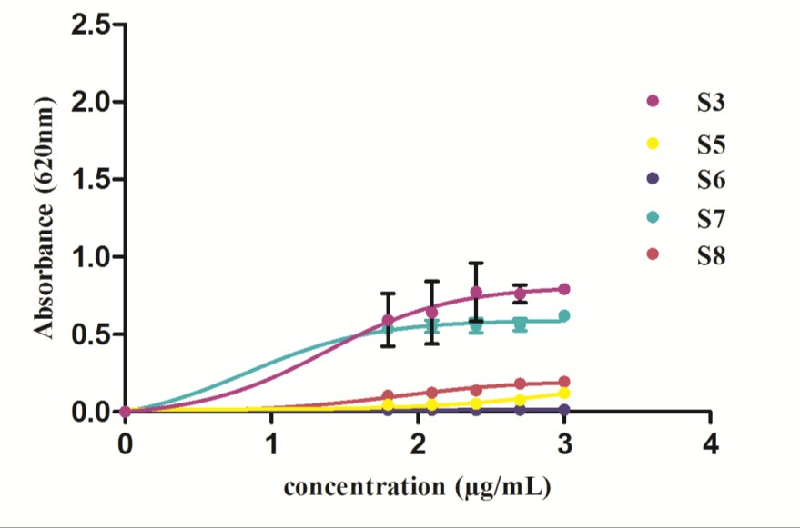

A

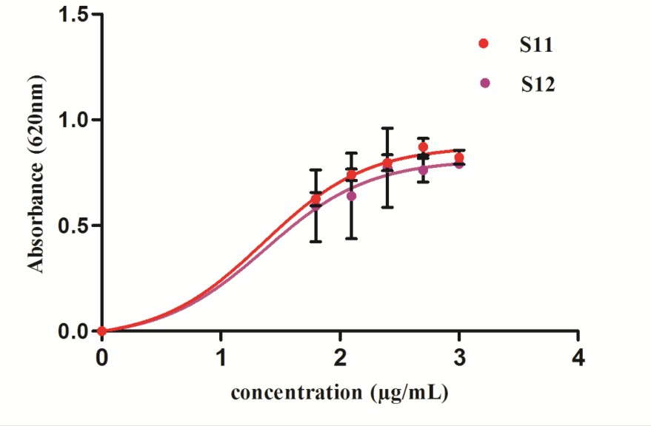

B

Figure 3.1. A graphical representation (30-1000 µg/mL) of *α-*amylase inhibition activity

(A) methanol extract for individual plant and (B) formulations prepared by the combination of individual plants selected for this study. Solid lines represent hyperbolic dose response curves, which were generated in Graphpad Prism. IC50 values were calculated from the curves and are shown in Table 3.1.

### Antiglycation Activity

In another series of experiments, antiglycation properties of individual plants and their formulations (S11 and S12) have been evaluated using spectroflourimeter. Fluorescence values were recorded for each sample, and plotted against log inhibitor concentration in graph pad prism to generate dose response curve using non-linear regression analysis. All experiments were performed in triplicate with positive and negative controls. Results are shown in Figure 3.2. Graphs showed that the activity was increased with increase in concentration. However, the best comparison was made on IC50 values like in case of pancreatic amylase. IC50 values were calculated from dose response curves and shown in Table 3.1. All the individual plants possess comparable activities to each other with IC50 value range from 27.8±0.27 to 309.8±0.15 µg/mL. Although, the least value was shown by *T. foenum-graecum*, but, this plant was found to be inactive in amylase inhibition as well as in antioxidant assays as shown by IC50 values in respective assays (Table 3.1). When the formulations S11 and S12 were compared both were equally effective for antiglycation activity with IC50 values of 33.4±0.24 µg/mL and 36.8±0.28 µg/mL, respectively. It is important to note that both formulations contained *C. intybus* as common ingredient, which individually showed highest IC50 value of 44.8±0.241 µg/mL however in formulations this effect is overwhelmed by other plants synergistically. The results were also comparable with positive control rutin which possess IC50 value of 18±0.98 µg/mL.

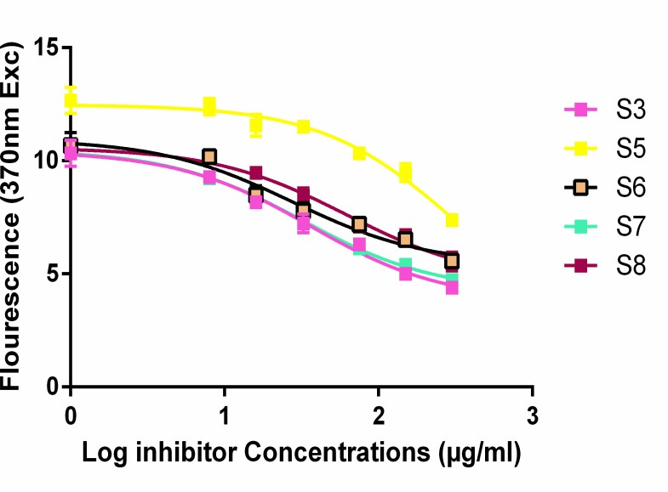

A

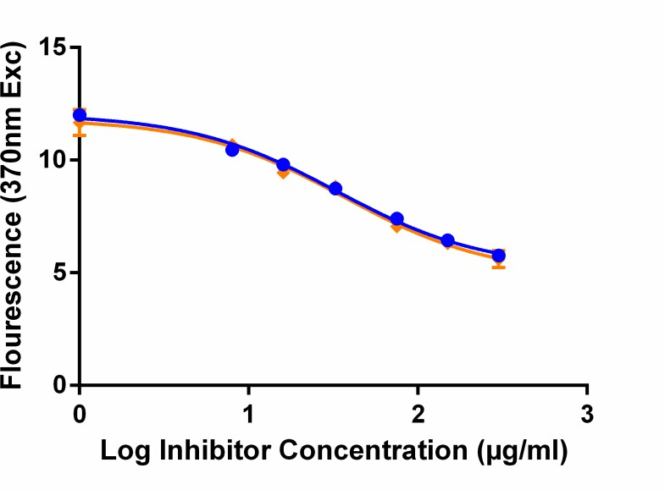

B

Figure 3. 2. A graphical representation (30-1000 µg/mL) of Antiglycation activity of (A) methanol extract of individual plants and (B) polyherbal formulations. Solid lines represent hyperbolic dose response curves generated in Graphpad Prism. IC50 values were calculated from the curves and are shown in Table 3.1.

### Antioxidant Activity

In continuation, antioxidant activities for all samples were evaluated using DPPH scavenging assay. A range of concentrations has been evaluated to generate a dose response curve. Activity was found to be increased with increase in concentration (Figure 3.3). The comparison was made on the basis of IC50 values. Results revealed a wide range of variability in IC50 values of individual plants that ranged from 63.38±0.03 µg/mL to 3891±0.23 µg/mL. In this case, the highest antioxidant activity is shown by *L. sativum* followed by *S. lappa* with IC50 values of 63.38±0.03 and 90.67±0.05 µg/mL, respectively. The least antioxidant activity was shown by *N. sativa* with IC50 value of 3891± 0.23 µg/mL. Moreover, *C. intybus* (IC50, 263.8±0.12 µg/mL) and (837.5 ±0.06 µg/mL) also gave high IC50 values thus less potent antioxidants. When the formulations were compared, both were found to be effective in scavenging free radicals as compared to their respective individual plants thus, again showing the synergistic effect of individuals. The IC50 values were found to be 331.6±0.20 µg/mL and 1697±0.89 µg/mL for S12 and S11 respectively. It has been observed again that S12 is more potent than S11. The standard used for antioxidant activity was ascorbic acid showed IC50 value 12.33±0.04 µg/mL.

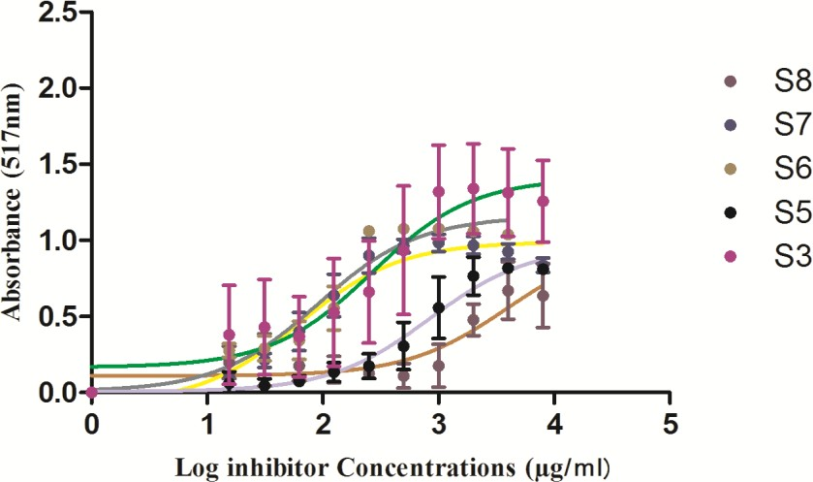

A

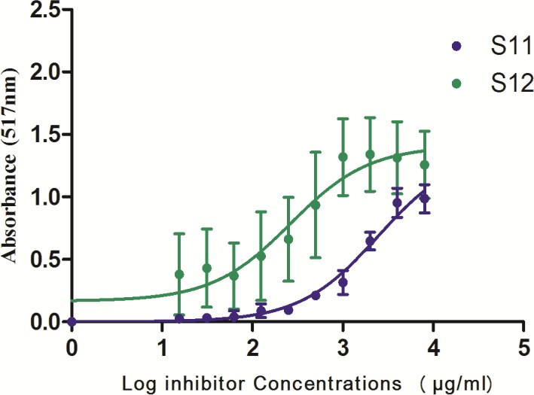

B

Figure 3.3. DPPH radical scavenging activity of (A) methanol extract of individual plants and (B) polyherbal formulations. Log inhibitor concentration vs absorbance was plotted in graphical form to generate dose response curve in graph pad prism. IC50 values were calculated from the curves and are shown in Table 3.1.

Table 3.6. IC50 values for *α-*amylase inhibition, antiglycation and antioxidant activities of individual plants and polyherbal formulations S11 and S12

|  |  |  |  |
| --- | --- | --- | --- |
| **Samples** | **Amylase inhibition**  **(µg/mL ± SE)** | **Antiglycation**  **(µg/mL ± SE)** | **Antioxidant**  **(µg/mL ± SE)** |
| *C. intybus* | 23.57±0.06 | 36.3±0.241 | 263.8±0.12 |
| *T. foenum-graecum* | 853.8±0.06 | 27.8±0.27 | 837.5±0.06 |
| *S. lappa* | 10.69± 0.04 | 309±0.15 | 90.67±0.05 |
| *L. sativum* | 6.814±0.02 | 32.5±0.25 | 63.38±0.03 |
| *N. sativa* | 72.64±0.01 | 61.8±0.23 | 3891±0.23 |
| S11 | 6.740±0.02 | 33.4±0.24 | 1697±0.89 |
| S12 | 11.1±0.05 | 36.8±0.28 | 331.6±0.20 |
| Reference standard* | 34.5±0.09 | 18±0.98 | 12.33±0.04 |

*Reference standard for *α-*amylase inhibition, antiglycation and antioxidant activities were acarbose, rutin and ascorbic acid, respectively

* + 1. ***α-*Amylase Inhibition Activity of *M. conica* (Mushroom)**

In this study, an edible/medicinal mushroom has also been evaluated for its antidiabetic potential. Crude methanol extract was evaluated at a concentration range of 30-1000 µg/mL. Initially this mushroom was screened for *α-*amylase inhibitory potential. The results are shown in Figure 3.4. Graph was plotted with log inhibitor concentrations on ordinate versus absorbance at 620 nm on abscissa. Line showed trend in activity and squares represent data points, which are mean of three independent experiments performed in duplicate. It has been observed from the curve that the activity of sample

was found to be increased with increase in concentration. The IC50 value was found to be 6.407± 0.029 which was 5 fold higher than the standard acarbose (Table 3.1). The data clearly indicating the potency of S10 against amylase.

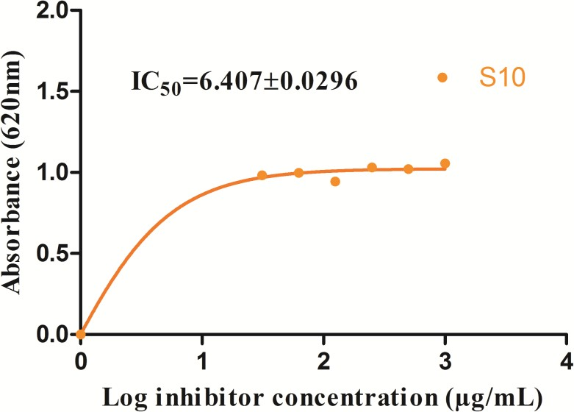

Figure 3.4. A graphical representation (30-1000 µg/mL) of *α-*amylase inhibition activity of methanol extract *M. conica*. Solid lines represent hyperbolic dose response curves, which were generated using non-linear regression analysis in graph pad prism.

* + 1. **Antiglycation Activity of *M. conica***

In the next series, antiglycation activity of *M. conica* (S10) was evaluated using different concentrations. Results are shown in Figure 3.5. Activity was also monitored in the absence of inhibitor as negative control and in the presence of rutin as positive control. Data indicated that *M. conica* showed positive correlation of activity with concentration. Moreover, the IC50 value was found to be IC50=24±1.99μg/mL. The comparison was made with rutin, which is a known reported antiglycating compound showed IC50 value of 18±0.98 µg/mL.

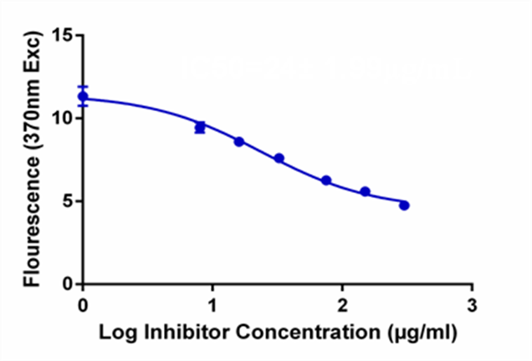

**IC50=24± 1.99μg/mL**

S10

Figure 3.5. A graphical representation (30-1000 µg/mL) of antiglycation activity of methanol extract of *M. conica*. Solid lines represent hyperbolic dose response curves*.*

* + 1. **Antioxidant Activity of *M. conica***

In the second step, antioxidant activity of *M. conica* (S10) was evaluated using different concentrations of methanol extract S10. The study was controlled using positive and negative controls. In this regard, ascorbic acid was used as standard and reaction mixture in the absence of inhibitor was used as negative control. Results are shown in Figure 3.6. Dose response curves indicated trend in activity. The data was compared on the basis of IC50 value which was found to be 77.74 ± 0.018 µg/mL for *M. conica*, which is an edible mushroom possessing high oxidative stress inhibitory potential.

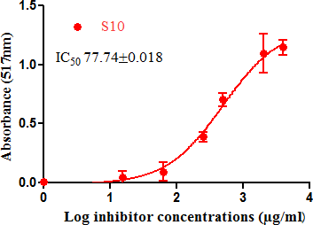

Figure 3.6. Antioxidant activity of methanol extract of *M. conica*. IC50 value is shown on the graph.

* + 1. **Glucosidase Inhibition Activity and Cytotoxic Properties of S10, S11, and S12** In final series of experiments, polyherbal formulations S11 and S12 were evaluated in intestinal glucosidase inhibition assay and cytotoxicity assays against CCRF CEM vcr 1000 overexpressing cell line. Results for intestinal glucosidase inhibition are shown in Figure 3.7. Composite graph showed that the activity of formulations increased with increase in concentrations. Data revealed the potent activity of both formulations against intestinal glucosidase with IC50 values of 319.0±5.47 µg/mL and 462±12.05 µg/mL, and S10 was found to be active with 268.6±912 µg/mL.

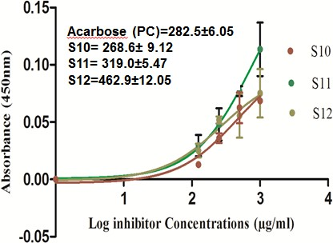1.

Figure 3.7. A graphical representation (30-1000 µg/mL) of glucosidase inhibition activity of S10 and polyherbal formulations; S11 and S12. Solid lines represent hyperbolic dose response curves, which were generated using non-linear regression analysis in graph pad prism. IC50 values were calculated from the dose response curves and are shown on graph.

Results of cytotoxicity assay for S10, S11 and S12 are shown in Figure 3.8. Dose response curve was generated with log inhibitor concentration on X-axis and absorbance on Y-axis. Again, IC50 values were calculated using non-linear regression analysis. Data revealed potent inhibition of CCRF CEM vcr 1000 overexpressing cells proliferation showing IC50 values of 2.862 ± 0.1128 µg/mL, 2.497±0.1258 µg/mL, and 2.279±0.3680 µg/mL for S10, S11, and S12 respectively. The overall picture of results indicated that formulations S11 and S12 are effective in multi antidiabetic assays.

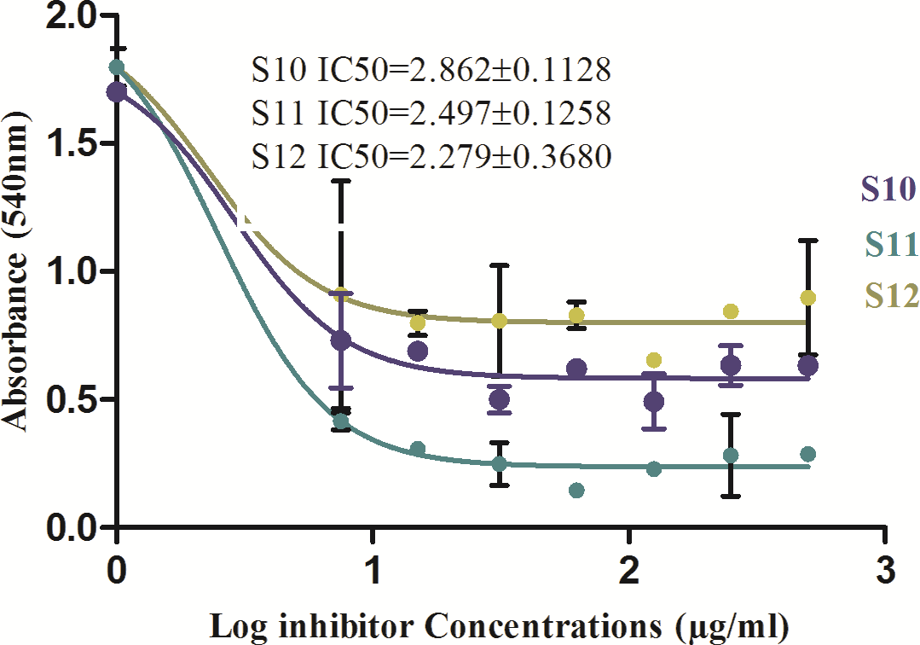

Figure 3.8. Cytotoxicity of polyherbal formulations (S11 and S12) and *M.conica* against ABCB1 overexpressing cell line using MTT. A concentration range of 7-500 µg/mL was used for both formulations. A dose response curve was generated in graph pad prism to calculate IC50 values for cell proliferation inhibition.

### Phytochemical Analysis

* + 1. **Determination of Phenolic and Flavonoid Contents**

All the assayed therapeutic properties were correlated with the major phytochemicals including phenols and flavonoids. Phenols were quantified using gallic acid as standard while flavonoids were determined using quercetin. The data (Table 3.2) indicated that flavonoids are found in higher concentrations as compared to phenols. Moreover, in comparison to individual plants formulations S11 and S12 contained much higher amounts of flavonoids. Flavonoidal content in S10 (*M. conica*), S11 and S12 were found

to be 487.0 ± 4.05 µg/mL, 1312 ± 29.3 µg/mL and 1450 ± 56.8 µg/mL, respectively

while total phenolic contents for S10, S11 and S12 were 461.0 ± 32.5 µg/mL, 575±83 µg/mL and 403±99.03 µg/mL, respectively.

Table 3.7. Flavonoid (quercetin equivalents, QE) and phenolic contents (gallic acid equivalent, GAE) in the analyzed medicinal plants and polyherbal formulations

|  |  |  |
| --- | --- | --- |
| **Plants selected** | **Flavonoids (QE)**  **µg/mL ± SD** | **Phenols (GAE)**  **µg/mL ± SD** |
| *C. intybus* | 687.8 ± 177.8 | 456.6 ± 4.5 |
| *T. foenum-graecum* | 826.6 ± 40.7 | 612.4 ± 65.7 |
| *S. lappa* | 1092 ± 37.6 | 342 ± 3.4 |
| *L. sativum* | 798 ± 10.9 | 461.2± 32.5 |
| *N. sativa* | 1037 ± 126.9 | 461 ± 32.5 |
| S11 | 1312 ± 29.3 | 575 ± 83.2 |
| S12 | 1450 ± 56.8 | 403 ± 99.3 |
| *M. conica* (Mushroom) | 487.0±4.05 | 461.0±32.5 |

### Phytochemical Profiling of Polyherbal Formulations and *M. conica* by LC- MS Analysis

From the results of therapeutic activities, it can be clearly seen that S10 (*M. conica*), S11 and S12 (polyherbal formulations) possess prominent antidiabetic potential. All the three samples controlled the hyperglycemic index. Therefore, to know which compounds could be considered responsible for the bioactivity of the subject samples, a liquid

chromatography-mass spectrometry (LC-MS) analysis was carried out. The LC

chromatograms (Figure 3.9) show the common peaks of S11 and S12 indicating that S11 contained almost the same compounds as that of S12. The positive and negative ESI spectra (Figure 3.10-3.17) of samples S11 and S12 obtained from LC-ESI-MS analysis, a molecular ion peak at *m/z* 311.5 [M±H]± (MW 312.05) could be assigned to caftaric acid (MW 312) present in *C. intybus*, or to dihydroxy-octadecadienoic acid (MW 312) reported from *N. sativa*, and/or sinapine (MW 310.16) found in *L. sativum* (Bahri *et al.,* 2012; Farag *et al.,* 2014; Oszmiański *et al.,* 2013). Additionally, a molecular ion peak MS[M-H]- at *m/z* 223.3 or a fragment ion MS–MS[M-H]- might be respectively given by sinapic acid (MW 224) or sinapoyl malic acid (MW 339) identified in *L. sativum* (Oszmiański *et al.,* 2013). Another molecular ion peak MS[M-H]- at *m/z* 148.9*,* corresponded to tartaric acid (MW 150.08) reported from *C. intybus* was also detected (Bahri *et al.,* 2012). The molecular ions MS MS[M±H]± at *m/z* 353.2 and 355.3 and a fragment ion MS–MS[M-H]- at *m/z* 171.2 in the chromatogram might be assigned to chlorogenic acid (MW 354.095085) or 3-caffeoylquinic acid (MW 354.41) reported from

*C. intybus* (Bergantin *et al.,* 2017). Furthermore, fragment ions peak detected at *m/z* 148.9, 309.1, 311.5 were assigned to chicoric acid (MW 474.0) as previously reported from *C. intybus* (Zhu *et al.,* 2015). Fragment ion peaks MS–MS[M-H]- at *m/z* 309.1 and

327.2 could also be considered for kaempferol-7-O-rhamnosyl-(1 2) glucoside (MW 594) as was reported for *Trigonella foenum-graecum* (Benayad *et al.,* 2014; Omezzine *et al.,* 2014). A molecular ion peak MS[M-H]- or fragment ion MS–MS[M-H]- at *m/z* 651.4 is assigned to luteolin 7-*O*-(2''dihydrogalloyl)-pentosyl-4'- *O*-(2''',6'''-malonyl-pentosyl)-

rhamnoside (MW 936) or kaempferol 3-*O*-b-glucosyl (1 2) (6-*O*-acetyl)-b-D-

galactoside (MW 652) present in *T. foenum-graecum*, respectively (Benayad *et al.,* 2014; Omezzine *et al.,* 2014). On further interpretation, a molecular ion peak MS[M-H]- observed at *m/z* 411.3 could be assigned to 13,14-seco-stigma-5(6),14(15)-diene-3 -ol (Zhu *et al.,* 2015). A fragment ion peak MS-MS[M-H]- at *m/z* 449.4 was assigned to cyanidin-3-*O*-glucoside (MW 484) in *C. intybus*, a molecular ion MS[M-H]- at *m/z* 489.3 was specified to kaempferol-7-*O*-(6´´-*O*-acetyl-glucoside (MW 490) in *C. intybus* or thymoquinol diglucoside (MW 490) reported from *N. sativa*, and a molecular ion peak MS[M-H]- at *m/z* 519.4 was given to isorhamnetin-7-*O*-(6´´-*O*-acetyl-glucoside) found in

*C. intybus* or a MS[M+H]+ for genistein 7- O-glucoside malonylated I (MW 518) in *N. sativa* (Muth *et al.,* 2008; Bergantin *et al.,* 2017; Farag *et al.,* 2014). A peak of 449.4 could also be given to 2′-Hydroxygenistein present in *T. foenum-graecum* (Muth *et al.,* 2008). Three more peaks were located in the extracted ion chromatogram at *m/z* 557, 233 and 487.5 representing dicaffeoyl–methoxyoxaloylquinic acid–CO2–H]+, a fragment formed by the loss of the second caffeoyl residue, and parent ion of caffeoyl- feruloyltartaric acid. A caffeoyl-feruloyltartaric acid produced a fragment peak at *m/z*

294.4 due to [caffeoyltartaricacid-H2O-H]+ (Jaiswal *et al.,* 2011). According to the literature (Keskes *et al.,* 2018), parent ion peaks at *m/z* 148.9 [M+H]+ and 449.4 and fragment ion peaks at *m/z* 353.2, and 327.2 could be corresponded to 4- Hydroxyisoleucine, vicenin-2 (MW 594.522), and isoorientin, respectively. A peak at *m/z*

329.5 [M-H]- is designated as of trihydroxy octadecenoic acid (in *N. sativa*) reported by Farag et al. (2014). Fragment ion peaks at 251 and 301 MS-MS[M-H]- could be assigned

to sinapine and quercetin-sinapoyl-di-hexosepentose present in *L. sativum* (Oszmiański *et al.,* 2013).

Regarding the LC-MS analysis, there is no previous report available on this investigation of *M. conica*. The LC chromatogram is given in Figure 3.9, whereas its ESI-MS spectra in positive and negative mode are given in Figures 3.18-3.21. Some of the compounds in the mass spectra obtained for S10 were identified with the help of Willey 8, NIST library. The compounds are given in Table 3.3.

Intens. x108

3.0

2.5

2.0

1.5

1.0

0.5

0.0

2 4 6 8 10 12 14 16 Time [min]

S 12_GA4_01_5879.d: BPC +All MS S 11_GA3_01_5877.d: BPC +All MS S 10_GA2_01_5875.d: BPC +All MS

Figure 3.4. Overlay chromatographic profiles of samples S10, S11, and S12

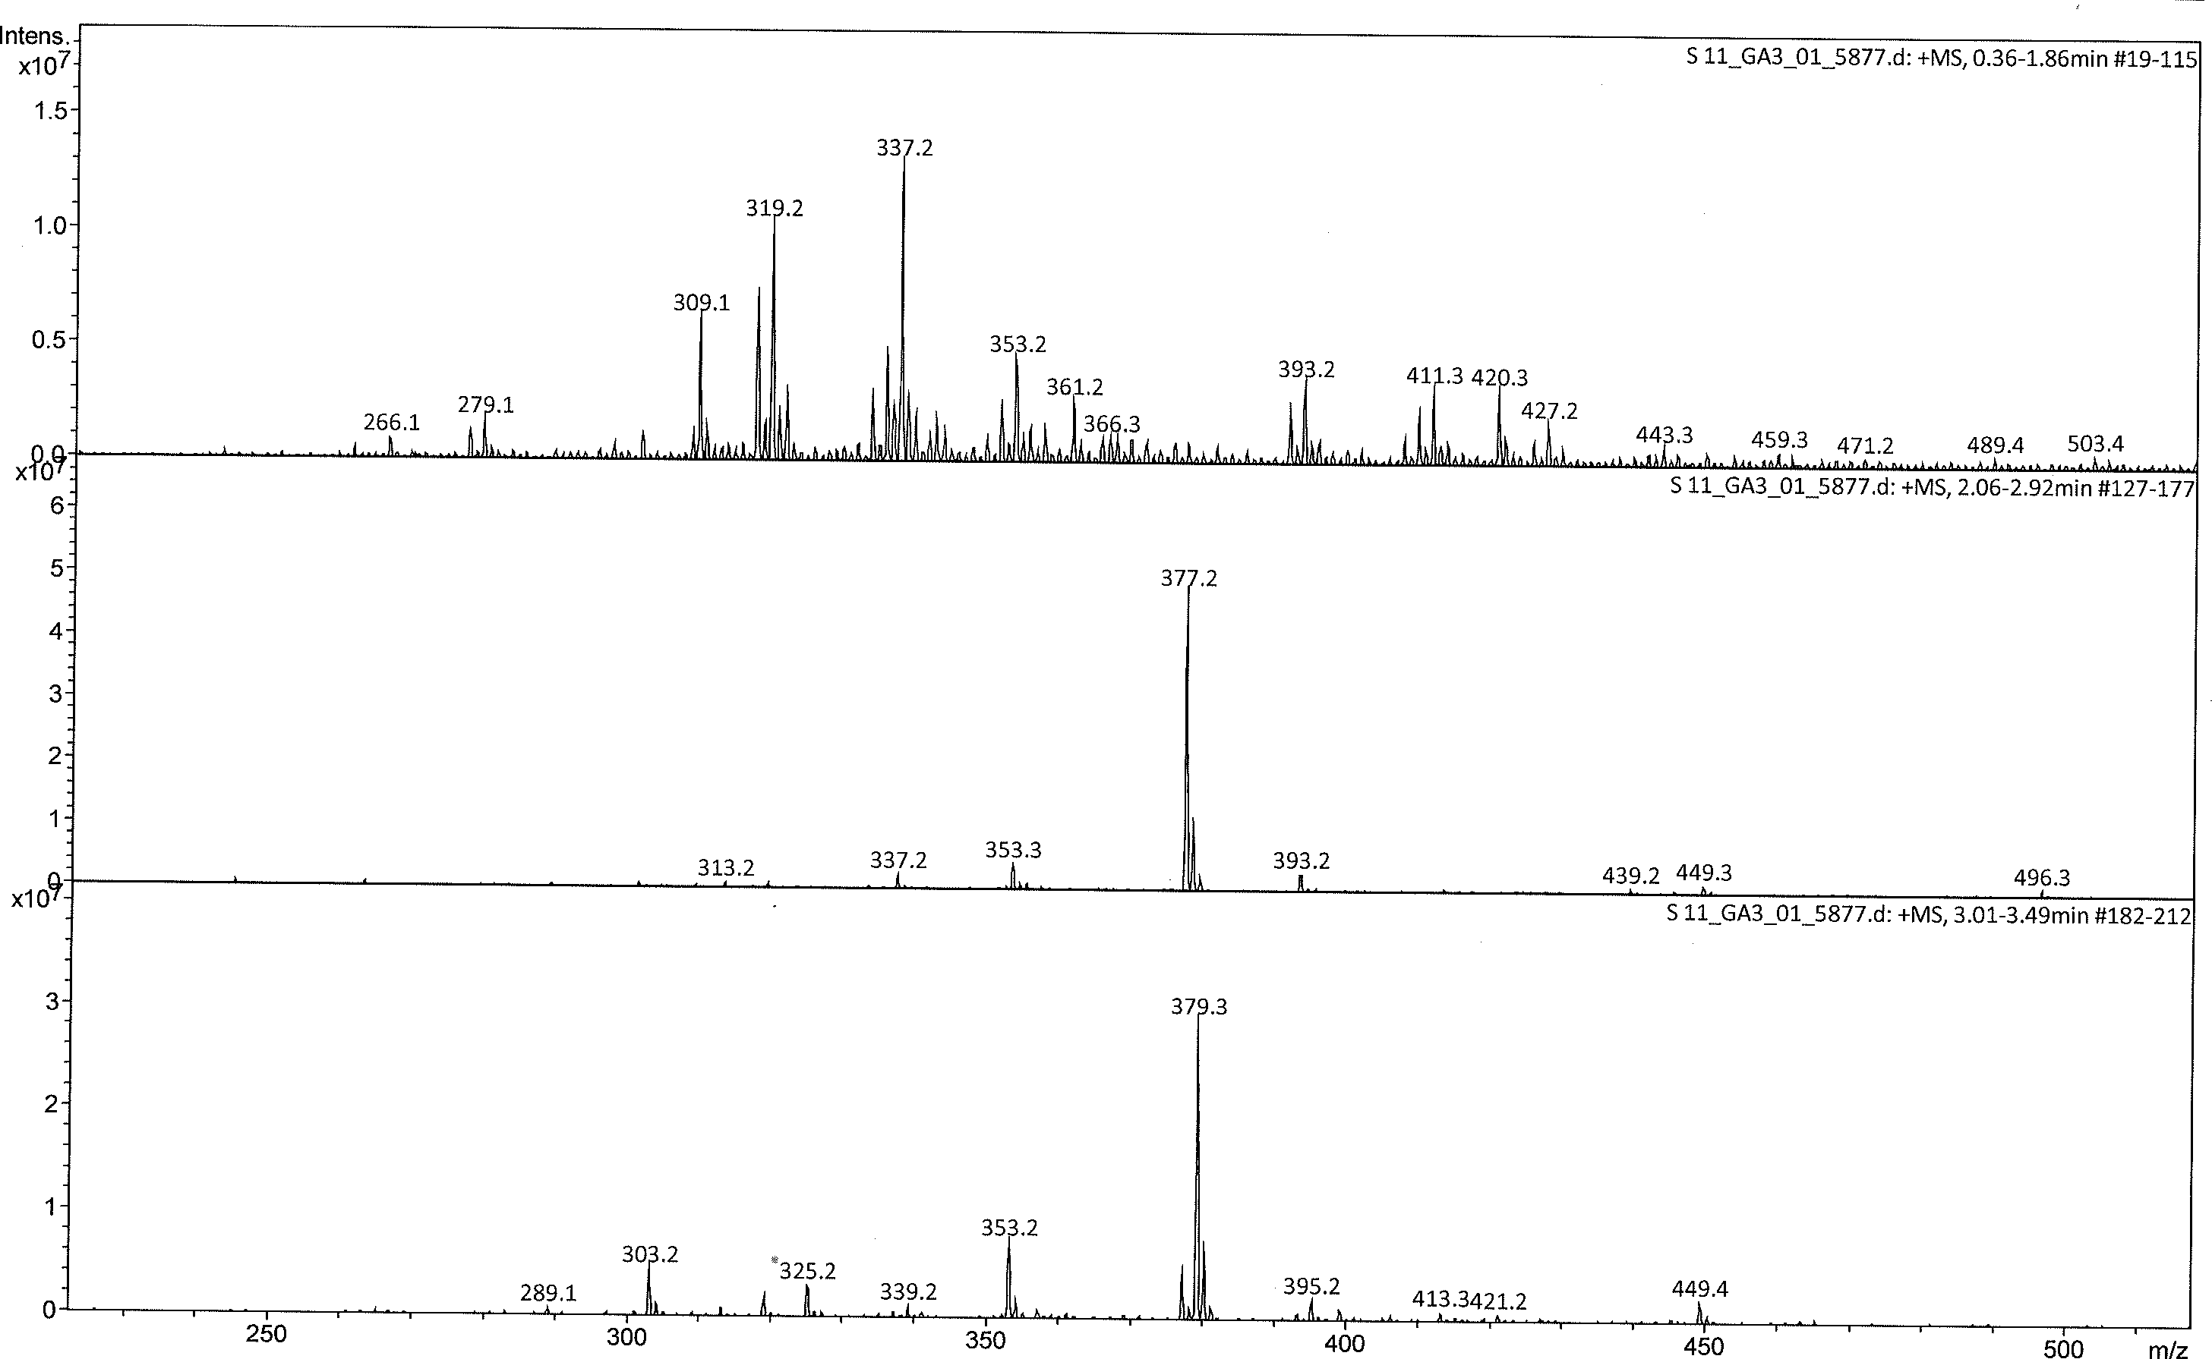

Figure 3.5. ESI mass spectrum (+MS) of S11 at 0.36-1.86, 2.06-2.92, and 3.01-3.49 min

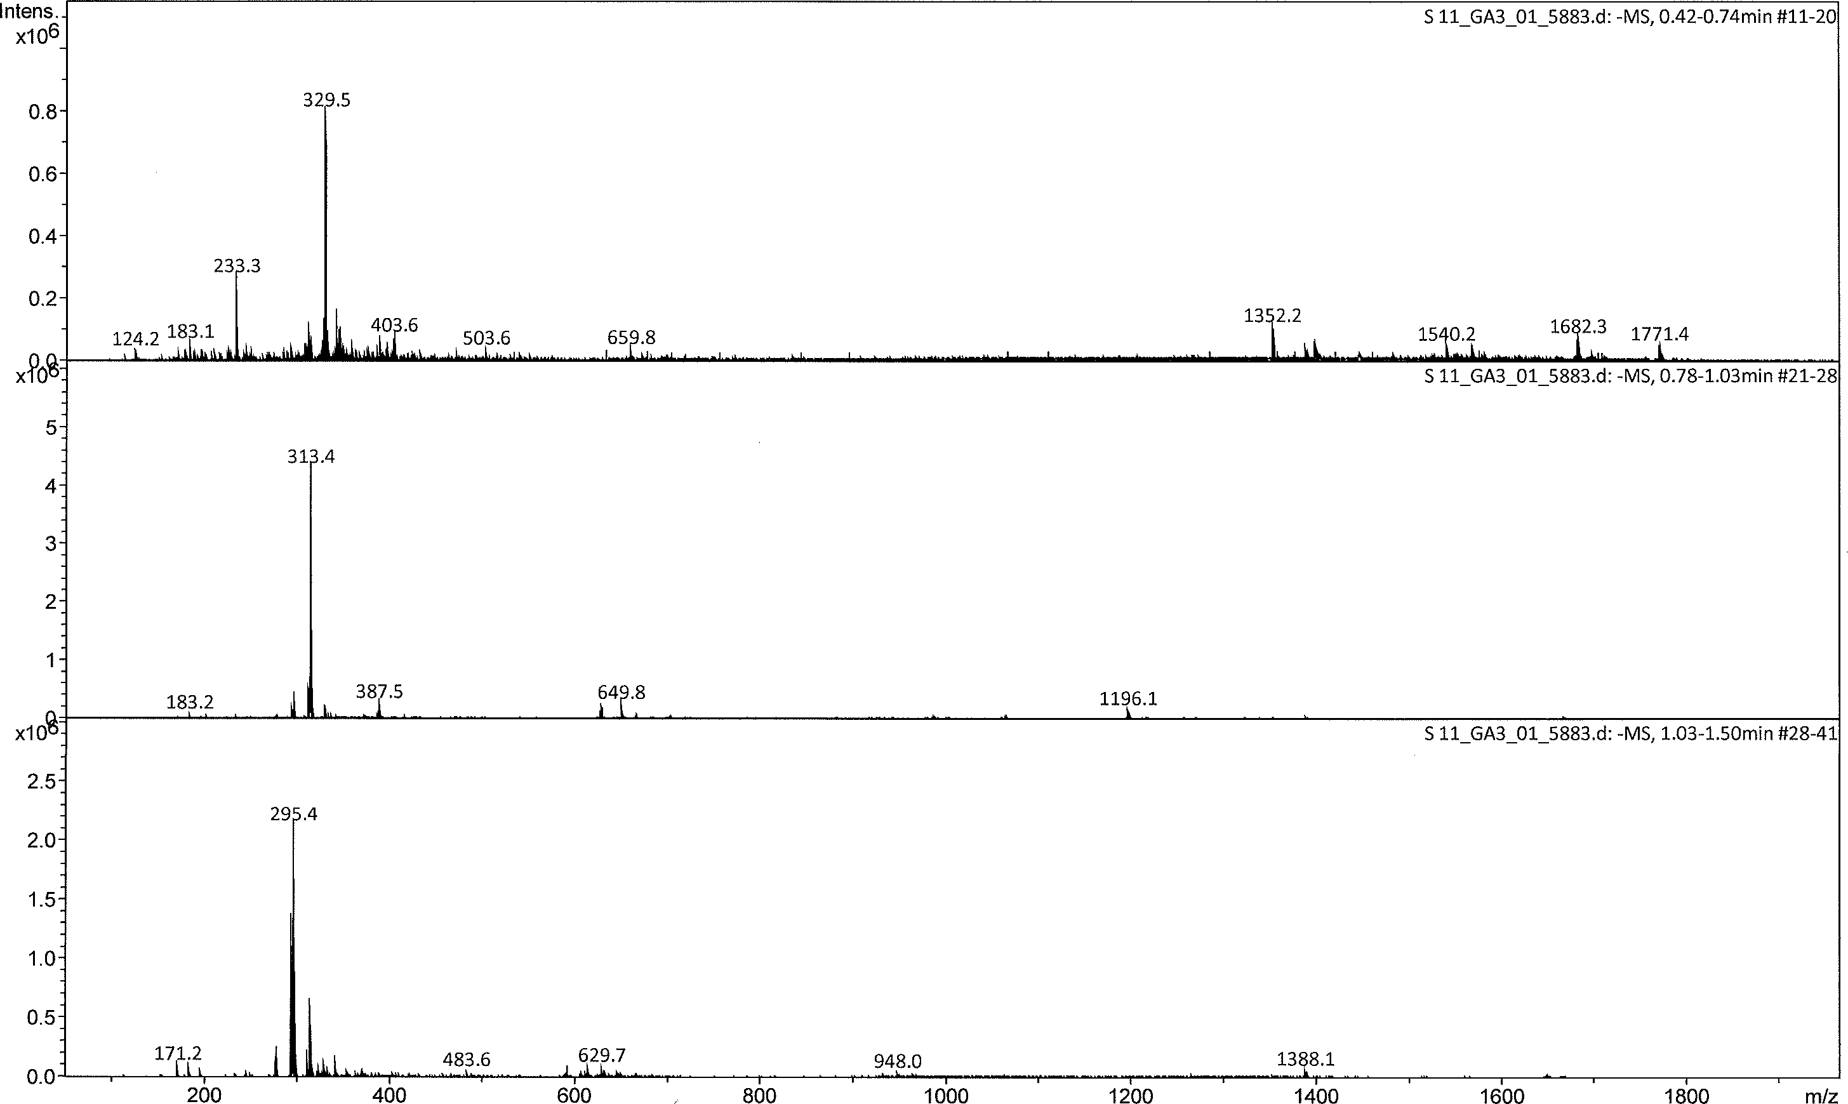

Figure 3.6. ESI mass spectrum (+MS) of S11 at 0.42-0.74, 0.78-1.03, and 1.03-1.50 min

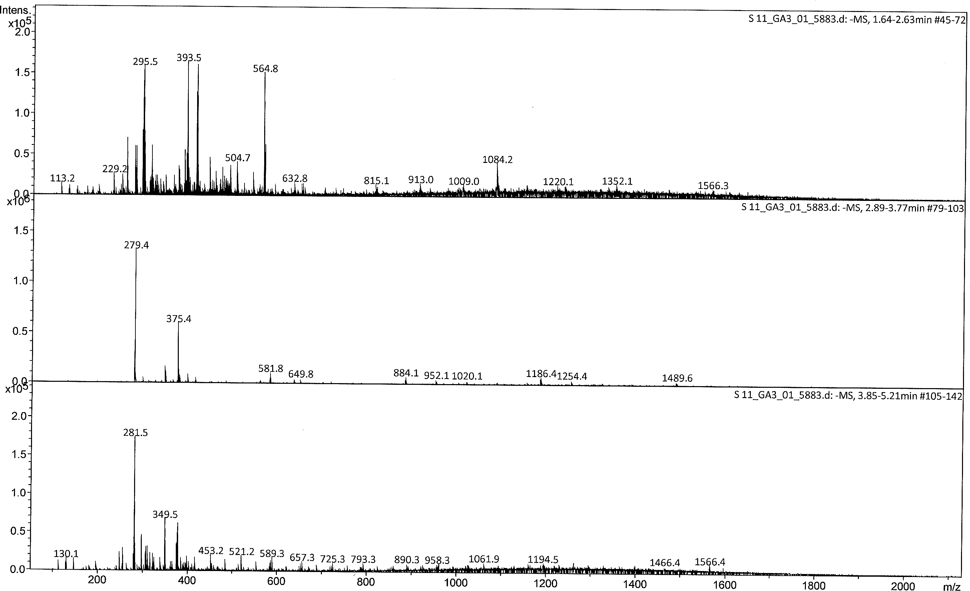

Figure 3.7. ESI mass spectrum (-MS) of S11 at 1.64-2.63, 2.89-3.77, and 3.85-5.21 min

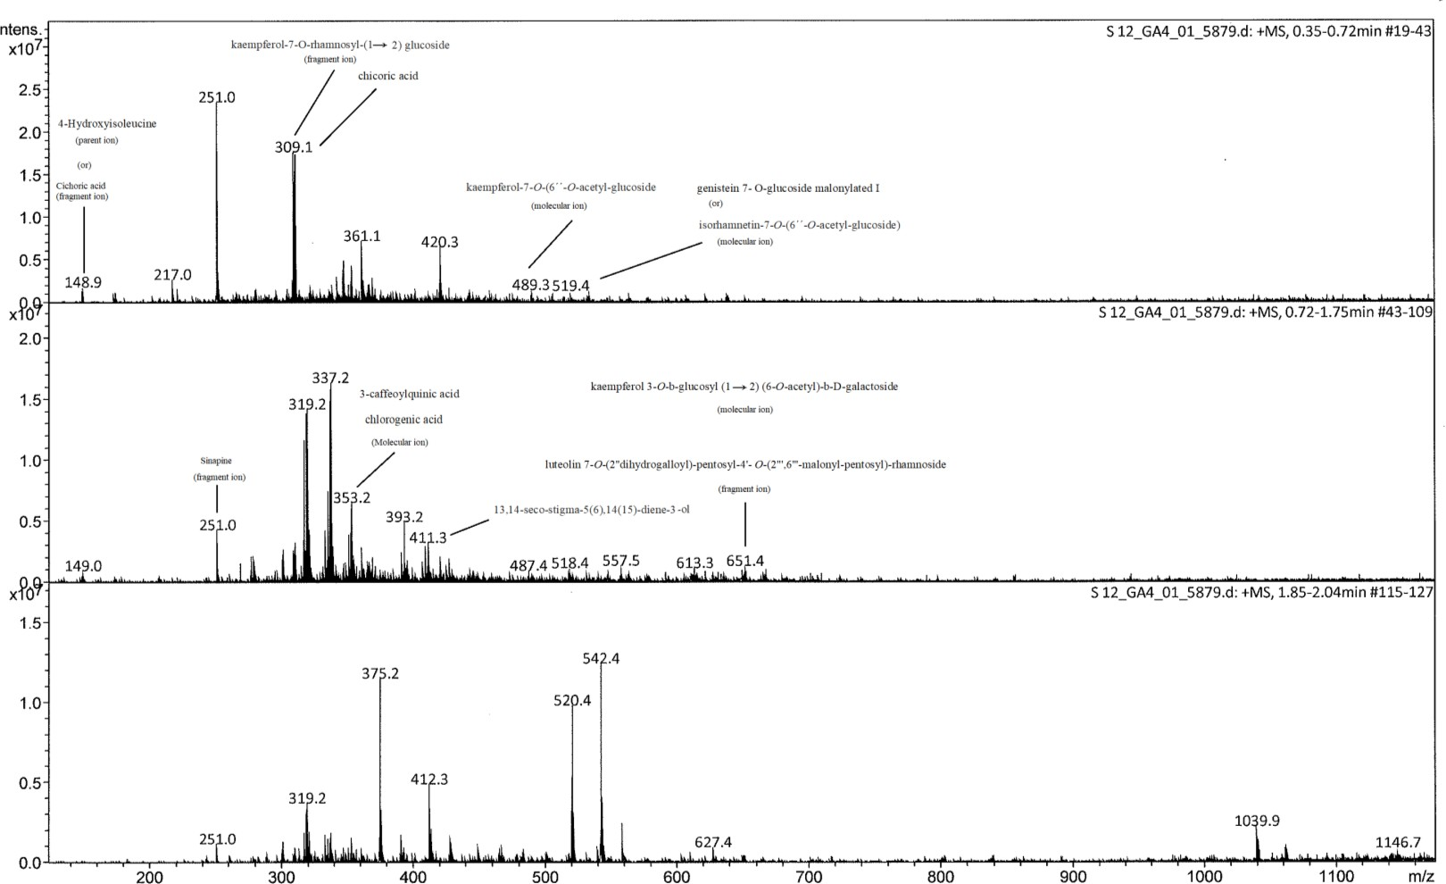

Figure 3.8. ESI mass spectrum (+MS) of S12 at 0.35-1.75 and 1.85-2.04 min

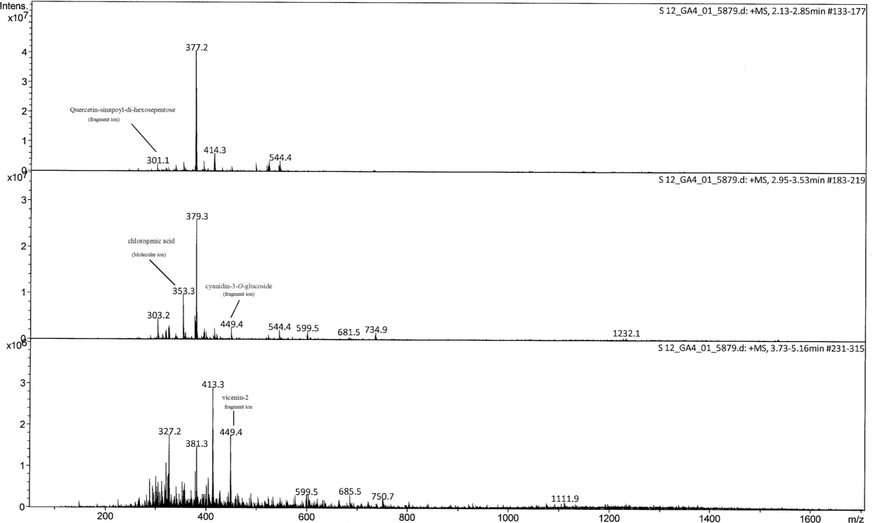

Figure 3.9. ESI mass spectrum (+MS) of S12 at 2.13-2.85, 2.95-3.53, and 3.73-5.16 min

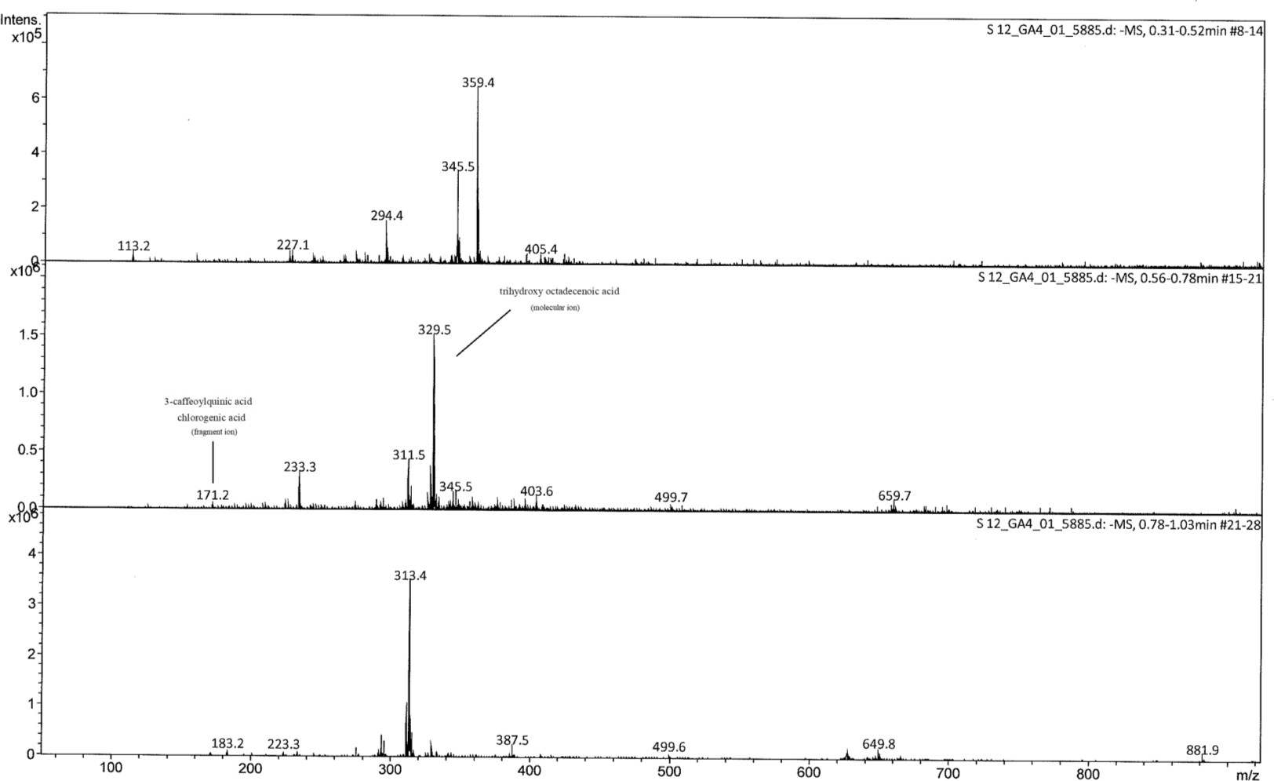

Figure 3.10. ESI mass spectrum (-MS) of S12 at 0.31-0.52, and 0.56-1.03 min

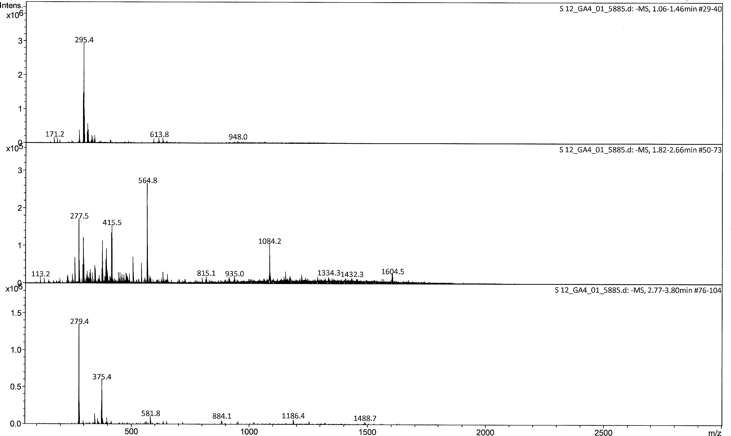

Figure 3.11. ESI mass spectrum (-MS) of S12 at 1.06-1.46, 1.82-2.66, and 2.77-3.80 min

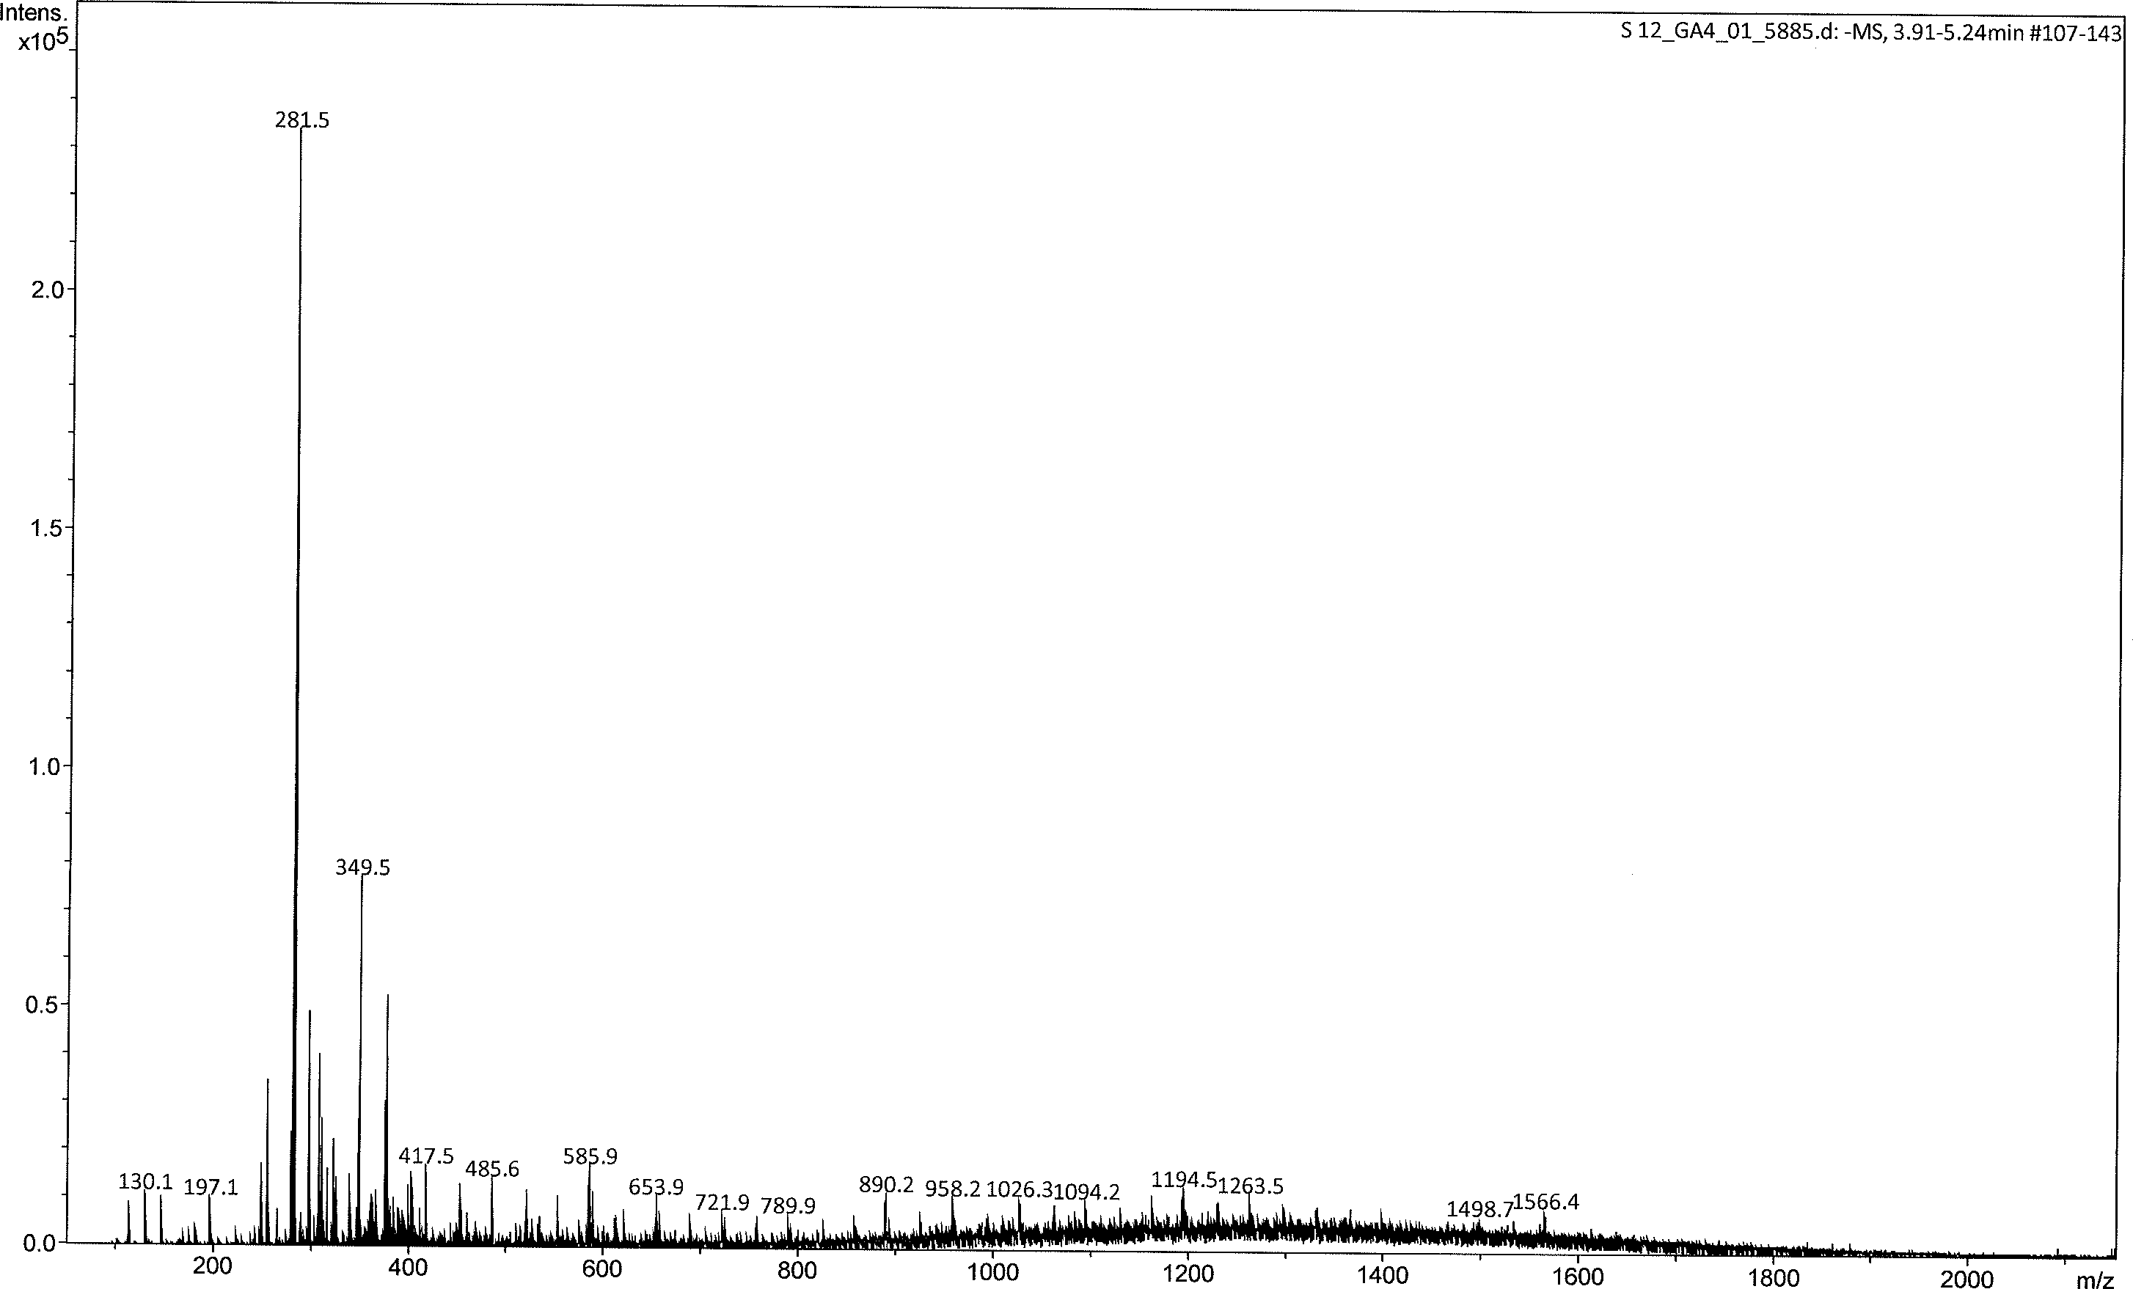

Figure 3.12. ESI mass spectrum (-MS) of S12 at 3.91-5.24 min

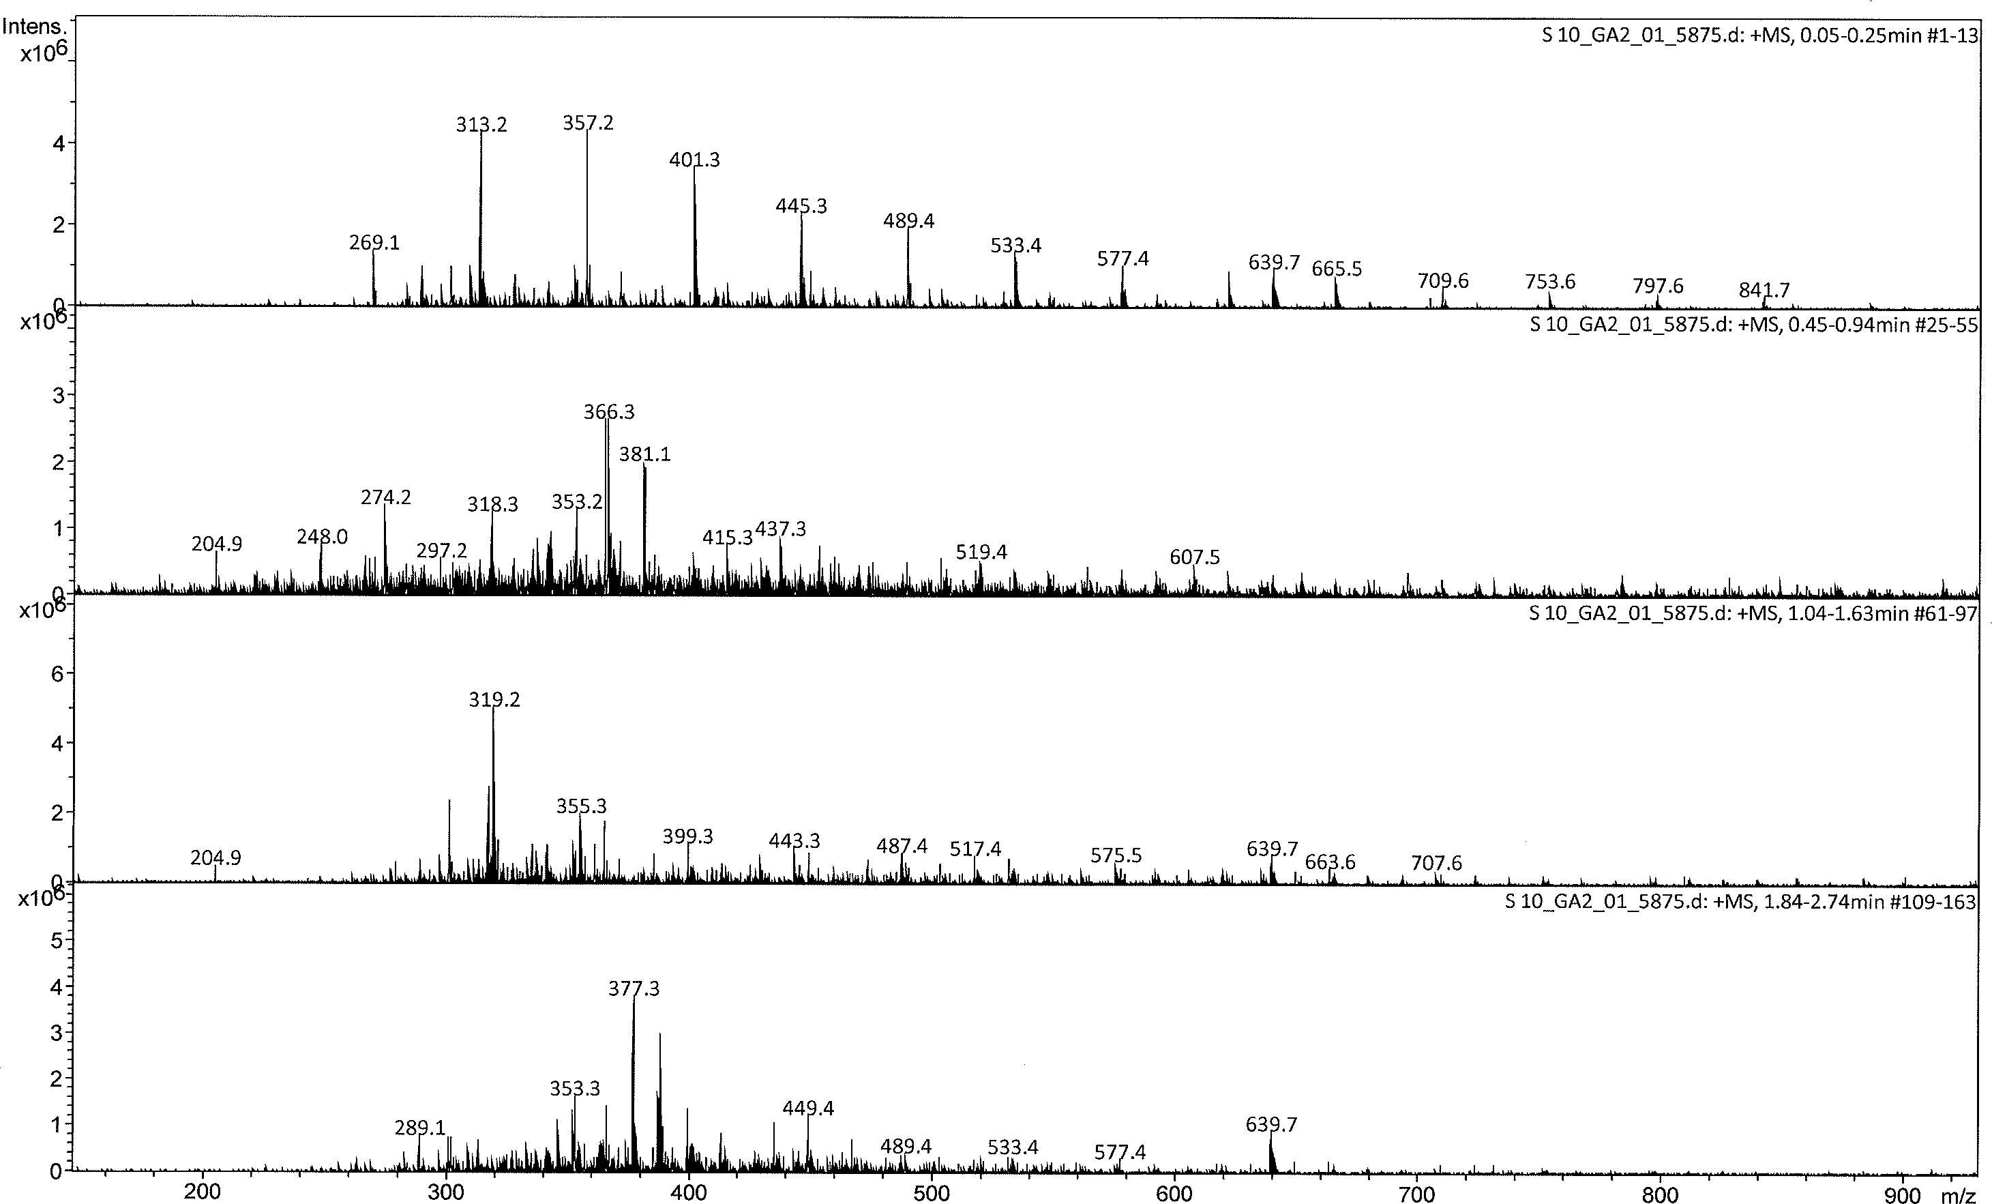

Figure 3.13. ESI mass spectrum (+MS) of S10 at 0.05-0.25, 0.45-0.94, 1.04-1.63, and 1.84-2.74 min

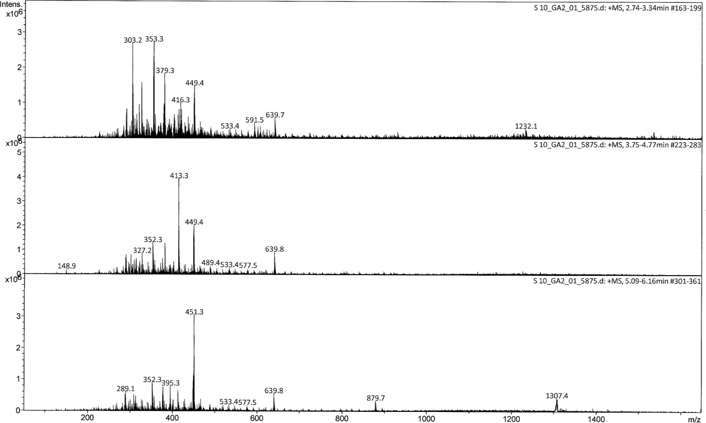

Figure 3.14. ESI mass spectrum (+MS) of S10 at 2.74-3.34, 3.75-4.77, and 5.09-6.16 min

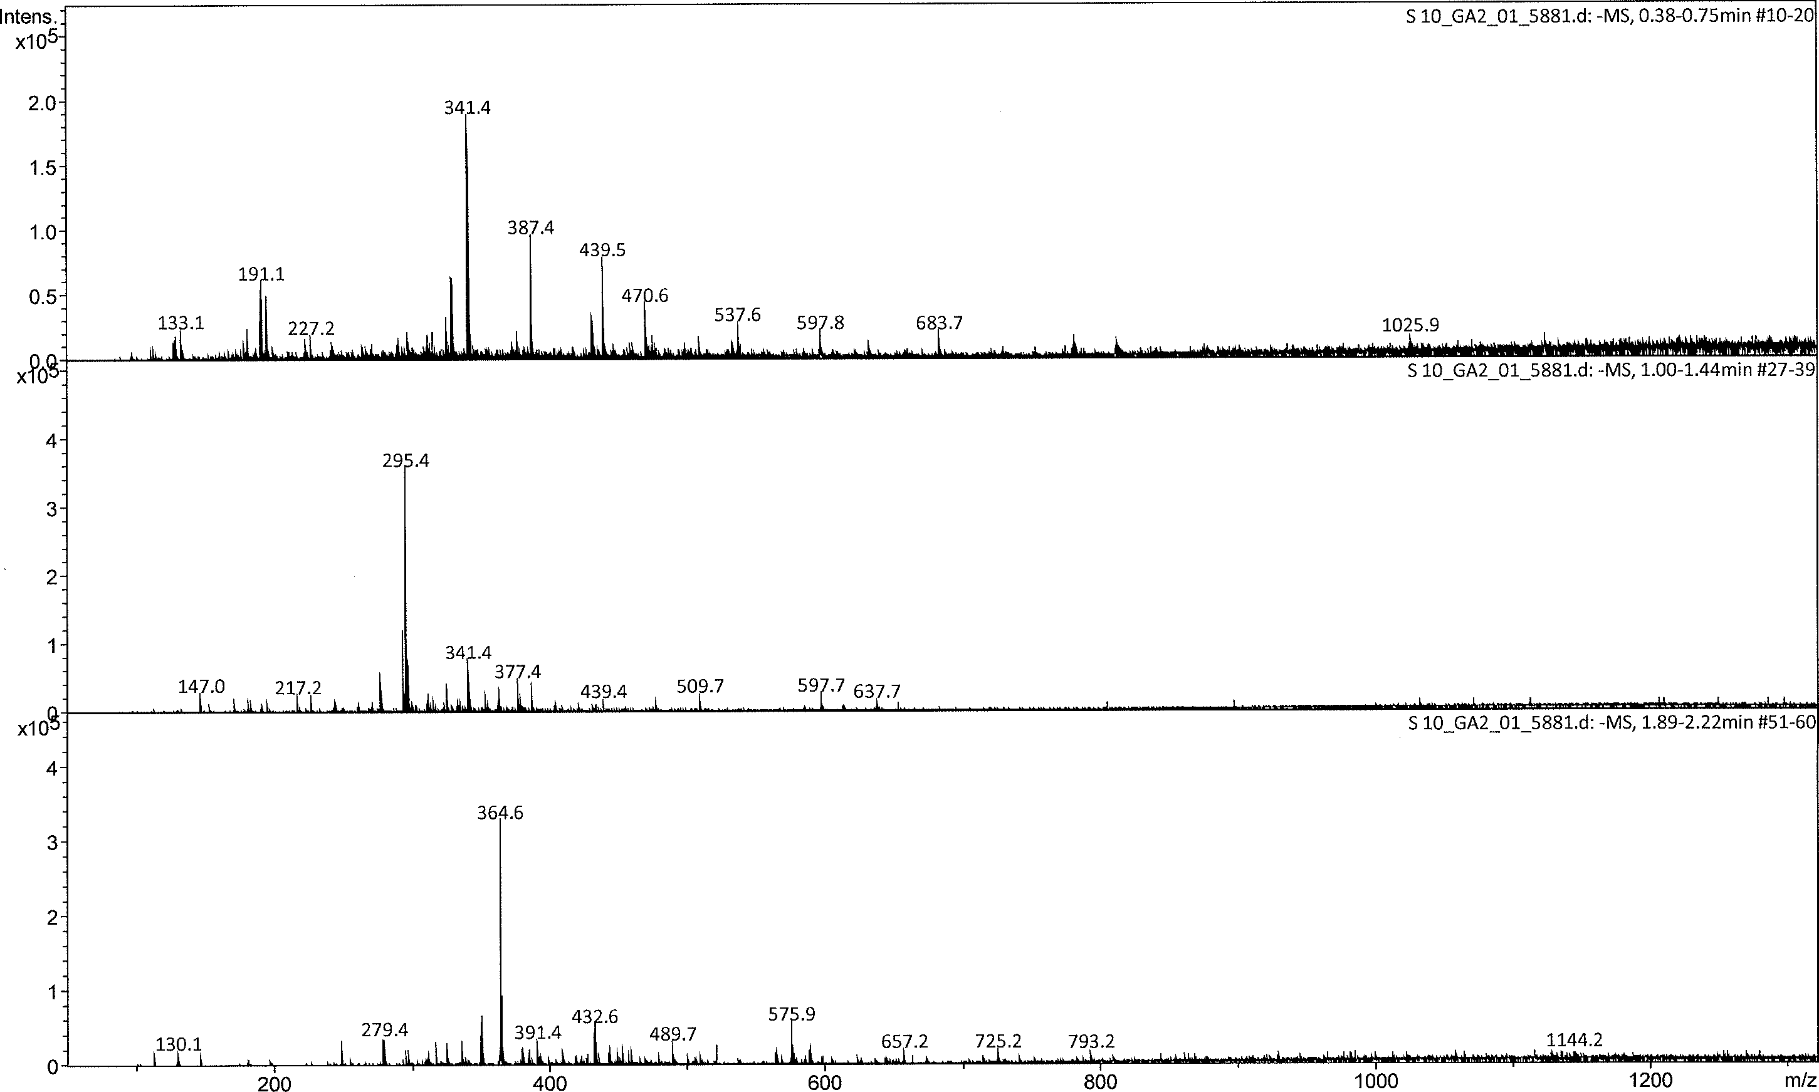

Figure 3.15. ESI mass spectrum (-MS) of S10 at 0.38-0.75, 1.00-1.44, and 1.89-2.22 min

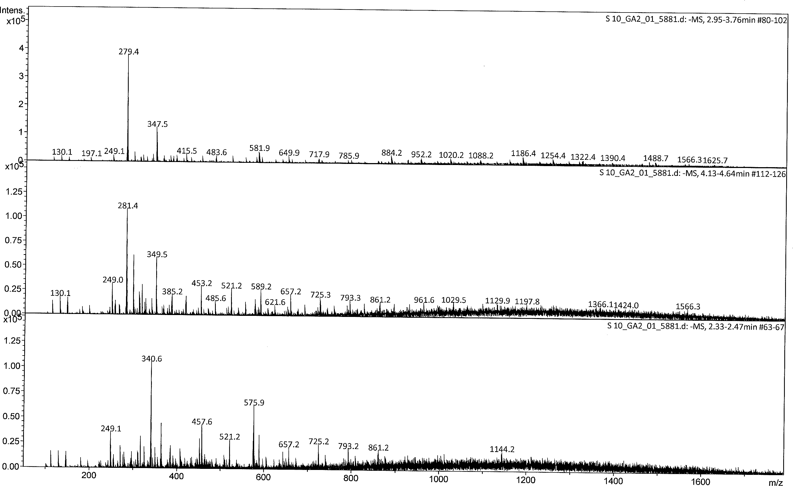

Figure 3. 16. ESI mass spectrum (-MS) of S10 at 2.95-3.76, 4.13-4.64, and 2.33-2.47 min

Table 3.8. Compounds in S10 identified by NIST library

|  |  |  |  |  |  |
| --- | --- | --- | --- | --- | --- |
| S. No. | Compounds | Molecular weight | Molecular ion Peak | Fragment ion peak | Spectrum type |
| 1 | Diethofencarb | 267 | 289 | 226 | [M+Na]+ |
| 2 | Glycylprolyllysine | 300 | 301 | --- | [M+H]+ |
| 3 | Enterodiol | 302 | 303 | --- | [M+H]+ |
| 4 | S-Nitroso-L- glutathione | 336 | 359 | --- | [M+Na]+ |
| 5 | Acenocoumarol | 353 | 352 | --- | [M-H] |
| 6 | Lagochiline | 356 | 357 | --- | [M+H]+ |
| 7 | 16,16-  Dimethylprostaglan din A1 | 364 | 365 |  | [M+H]+ |
| 8 | Quercetin 3,5,7,3',4'-  pentamethyl ether | 372 | 373 | --- | [M+H]+ |

### Proximate analysis

* + 1. **Nutritional Composition of the Selected Medicinal Plants**

Since, many of the plants and herbal products are used orally; carrying out proximate and nutrient analysis of these products and raw material used therein plays a crucial role in assessing nutritional significance and health effects (Howell *et al.*, 2006; Pandey, 2006; Taiga *et al.*, 2009). The proximate composition analysis showed (Table 3.3) presence of dry mass 90.90±0.34% to 96.65±0.23%, crude proteins from 5.87±0.80% to 33.27±0.80%, crude lipids from 0.97±0.20% to 39.68±0.30%, crude fiber from 8.05±0.12% to 16.70±0.20% and ash from 4.25±0.75% to 13.39±0.75%. Therefore, they reveal much about the nutritional value of these medicinal plants.

Table 3.9. Proximate composition of selected medicinal plants and polyherbal formulations

|  |  |  |  |  |  |
| --- | --- | --- | --- | --- | --- |
| **Sample No.** | **DM %** | **Ash %** | **CP %** | **Fat %** | **Fiber %** |
| S3 | 94.44 | 8.66 | 23.08 | 8.42 | 15.42 |
| S5 | 91.26 | 4.25 | 24.35 | 5.69 | 8.05 |
| S6 | 92.73 | 5.79 | 5.87 | 0.97 | 15.10 |
| S7 | 93.38 | 8.52 | 28.06 | 24.29 | --- |
| S8 | 96.65 | 4.95 | 20.4 | 39.68 | 11.01 |
| S10 | 90.90 | 13.39 | 33.27 | 2.48 | 9.64 |
| S11 | 96.20 | 6.29 | 21.21 | 32.17 | 16.70 |
| S12 | 93.84 | 5.47 | 19.14 | 17.26 | --- |

As far as medicinal plants and herbal drug’s standardization is concerned, WHO has also emphasized on the need and importance of determining proximate and micronutrients

analysis. Among minerals, the essential trace elements including zinc, cobalt, copper, selenium, chromium and nickel are the critical components of biological structures, but they can also be toxic at concentrations beyond certain limits (N. Khan, Jeong*, et al.*, 2014).

In macro and micro elements analysis (Table 3.4), the concentrations (µg/g) on dry weight basis of samples represented that Ca, K, Na and P were present at high levels, where as Mg, S, and Fe were present at second. Among the macro elements, Na showed the highest concentration (19403.7µg/g) in S8, whereas S was found to have the lowest level (81.5µg/g) in S10. Specifying the contents to the samples, S7 was highly enriched with Al (662.3 µg/g) and S3 with Ca (9277.9 µg/g).

In micro-elements analysis (Table 3.4), the mean concentration of Ni was found high in S7 with a value of 6.36 µg/g followed S1 (5.1µg/g). The contents of Cu were high in with a value of 6.03 µg/g in S7 following by S3 with 6.01 µg/g. Zn and V contents were high in with the levels of 30.2µg/g and 4.79µg/g in S7 and S3 respectively. From ANOVA statistical test, Ni content in S7 and S1, Cu in S7 and S3, Zn in S7, V in S3 and S1 have close values. V was present in high concentration in S3 with the value 4.79 µg/g.

Table 3.10. Content (µg/g) of macro and micro-elements in selected medicinal plants

|  |  |  |  |  |  |  |
| --- | --- | --- | --- | --- | --- | --- |
| **Elements** | **S3** | **S5** | **S6** | **S7** | **S8** | **S10** |
| Al | 187.7±53.1 | 293.8±10.5 | 377.9±10.4 | 662.3±123.7 | 510.8±11.5 | 198.8±15.9 |
| Ca | 9277.9±193.0 | 2084.9±78.4 | 3014.7±50.3 | 8205.8±1.49.8 | 1375.9±317.9 | 792.6±27.8 |
| Fe | 381.9±38.5 | 99.4±3.75 | 87.6±1.78 | 519.2±53.7 | 943.8±51.1 | 81.5±3.89 |
| K | 1049.3±99.4 | 9910.5±301.5 | 1037.7±205.4 | 12973.4±492.7 | 19403.7±729.5 | 2964.8±120.6 |
| Mg | 1502.7±84.2 | 1205.6±77.5 | 938.8±81.9 | 2067.2±137.3 | 2169.3±184.7 | 1029.4±72.5 |
| Na | 521.6±51.3 | 92.5±4.78 | 228.4±19.8 | 729.7±39.2 | 810.5±71.4 | 147.3±9.30 |
| P | 591.7±41.8 | 2015.8±148.3 | 1739.2±107.8 | 2302.4±102.4 | 3029.5±174.5 | 392.4±0.33.8 |
| S | 330.2±10.5 | 241.7±14.9 | 158.3±39.9 | 428.7±37.5 | 521.7±19.7 | 491.7±10.9 |
| Micro elements | | | | | | |
| Ni | 3.72±0.009 | 5.02±0.129 | 3.01±0.278 | 6.36±0.613 | 3.04±0.059 | 2.05±0.008 |
| Cu | 6.01±0.130 | 5.38±0.210 | 2.01±0.137 | 6.03±0.007 | 5.01±0.118 | 4.16±0.007 |
| Zn | 14.9±0.417 | 19.5±0.185 | 7.38±1.32 | 30.2±0.917 | 21.9±0.1.03 | 9.91±0.615 |
| V | 4.79±0.195 | 2.18±0.019 | 1.13±0.007 | 3.20±0.819 | 1.93±0.037 | 0.916±0.008 |

# DISCUSSION

Although, several synthetic antidiabetic drug target-inhibitors are available but still there is a need of new potent multi-targeted inhibitors from natural source in order to overcome the adverse effects of existing drugs. In current study, two polyherbal formulations (S11 and S12) were prepared and characterized for their inhibitory potential against amylase, glucosidase, AGEs, ROS to find potential multi-targeted inhibitors. Samples were also assessed for their cytotoxic properties. In control, five individual plants have also been evaluated in certain assays. An edible mushroom *M. conica* was also assessed in all assays for its therapeutic importance with reference to Diabetes mellitus. Results revealed potent activity of both S11 and S12 against α amylase (6.704 ± 0.02 µg/mL and 11.1± 0.09 µg/mL) and intestinal glucosidase (947±0.07 µg/mL and 522±0.03 µg/mL). In antiglycation assays, both S11 and S12 showed comparable activity with IC50 value of 33.4±0.24 and 36.8±0.28 µg/mL respectively. Moreover, rutin as positive control showed IC50 value of 18±0.98 µg/mL. The data demonstrated higher potency of S12 in glucosidase inhibition assays and antioxidant assays as compared to S11. In antiglycation assays, both formulations were found to be equally effective. When the overall data was compared with individual plants it has been noticed that certain plants became inactive in different assays individually however when mixed in formulation the effect was masked down synergistically by other ingredients of formulations. When the data was considered for

*M. conica* it is noticed that this mushroom was also found effective in multiple assays.

In case of CCRF-CEMvcr1000 cells both polyherbal formulations (S11 and S12) and

*M. conia* showed potent activity in low micromolar range indicating that these formulations-controlled cell proliferations of CCRF-CEMvcr1000cells. When the data was compared for phenols and flavonoids contents both these formulations possessed

higher amount of flavonoids as compared to phenols. Moreover, the concentrations were found to be higher than individual plants. *M. conica* also possess higher amounts of flavonoids and phenols. Therefore, these formulations and *M. conica* can be considered as multi-targeted inhibitors for antidiabetic drug development process and the activity might be due to flavonoids which are found in higher amounts.

As far as herbal drug’s standardization is concerned, WHO has also emphasized on the need and importance of determining proximate and micronutrients analysis. Furthermore, the World Health Organization (WHO) expert committee (WHO, 2006) recommended the thorough study of medicinal plants dealing with diabetic mellitus. Among minerals, the essential trace elements including zinc, cobalt, copper, selenium, chromium and nickel are the critical components of biological structures, but they can also be toxic at concentrations beyond certain limits (N. Khan, Jeong*, et al.*, 2014).

Moreover, different minerals are playing variable roles in body. Zn and Cu are required in growth and proliferation of normal cells so there presence may be correlated with its anticancer property. Low concentration of plasma Zn in cancer patients is believed that the increased requirement of Zn by cancer tissues whereas Cu concentration increases because of the fact that tumor cells have high rate of DNA synthesis and most of the enzymes involved in the nucleic acid synthesis are Zn dependent (Gupte *et al.*, 2009). Iron is a structural component of hemoglobin, myoglobin and other heme proteins, many of which are enzymes of the Krebs cycle. Significant amounts of nickel are found in DNA and RNA. Nickel may act as a stabilizer of these nucleic acids (Shirin *et al.*, 2010)

The selected plants investigated in current study were *C. intybus*, *T. foenum-graecum*,

*S. lappa*, *L. sativum*, and *N. sativa*. In addition, an edible mushroom, *M. conica,* was also evaluated. The analysis displayed variable concentrations of the different trace

elements including Zn, Ni, V and Cu in the plants. Moreover, the levels of major elements, such as Mg, Ca, K, Na, and Al, and heavy metals, such as Fe, Cu and Ni were determined and found to be in the permissible limit defined by WHO. It is also depicted that K, Na and Ca are the main nutritional elements present in all samples. The nutritional minerals, micro and trace elements were present in noticeable concentrations. Cu and Zn are responsible for the secretion of insulin from the beta cells of the islets of Langerhans and are involved in potentiating insulin action (Anderson *et al.*, 1997; Kimura *et al.*, 1996; Mertz, 1969; Scott *et al.*, 1938; Toepfer, 1974). From Table 3.4, it is clear that, zinc has highest concentration (30.2±0.917g/g) in S7. Zinc complex is the store house of insulin secreted from pancreas (Kar *et al.*, 1999), which plays an important role in normal glucose metabolism. Normal potassium levels are required for optimal secretion of insulin (Underwood, 2012). Potassium found to be 19403.7 ± 729.5 g/g in S8. Conforming to the beneficial effects of supplemental Zn and K, in the management of DM, our results show that, the analyzed medicinal plants can be considered as valuable sources of essential trace elements for treatment of DM.

Most of these plants are rich in one or more individual elements, there by acting as a source of supplementation to the patients of DM, who are diagnosed to be deficient in corresponding elements. The present data in elemental concentrations in these medicinal plants will be useful to set new standards for prescribing dosage and duration of administration of these herbal medicines to the patients of DM. The mineral elements analyzed also revealed that medicinal plants studied contained micronutrients such as copper, zinc iron and Ni in quantities within the acceptable range were below the maximum permissible limits of 10 mg/kg according to WHO (2006).

How these results of bioassays are correlated with literature? Local populations have already realized the medicinal importance of these rare plants and have been using them for treatment of medical ailments for past many centuries. Plants used in this study were selected on the basis of ethno medicinal approach and formulations were also made accordingly by combination of S3, S5, S6, S7, S8 plants. These plants are very well studied in literature by different groups for their antidiabetic potential individually however data on formulations of these plants is still lacking. Data revealed the more potency of PHF1 hot water extract in porcine pancreatic alpha amylase inhibition assay as compared to individual plants and standard acarbose. Our results are consistent with this study as we also reported two formulations both were found to be more active in amylase as well as glucosidase assay as compared to acarbose, which was used as positive control. Moreover, both formulations were also found to be active in antiglycation assays as well. Our results were also found to be consistent with Duraiswamy et al. (2016) who prepared a polyherbal formulation ADJ6 and evaluated its amylase and glucosidase inhibitory potential (Duraiswamy *et**al.*, 2016). Their data reported the potency of formulation as compared to individual plants with IC50 value of 410µg/mL and 510µg/mL against amylase and glucosidase respectively. However, our both formulations were found to be much more active with IC50 values of 6.740±0.02 µg/mL and 11.1±0.05 µg/mL in alpha amylase inhibition assays for S11 and S12, respectively. However, for intestinal glucosidase our formulation S12 was found to be more active as compared to S11 with IC50 value of 522±0.03 µg/mL. When the data was compared for antiglycation activity the IC50 values were again found to be lower thus indicating the efficacy of S11 and S12 against selected diabetic drug targets. Lui *et al.,* 2014 studied the combined effect of acarbose with polyphenols against alpha glucosidase and amylase (M. Liu *et al.*,

2014). Their results showed the synergistic effect of compounds with acarbose towards amylase and glucosidase inhibition. Our results are also in line with this study by showing the synergistic effect of selected medicinal plants against amylase and glucosidase in polyherbal formulations (S11 and S12). Moreover, our study also showed the synergistic behavior of this formulation towards AGEs and oxidative stress indicating that this formulation without addition of any synthetic compounds can directly control diabetes by inhibiting carbohydrate hydrolyzing enzymes and can also address the problem of diabetic complications by controlling AGEs and reactive oxygen species.

When the data of cytotoxicity was compared with literature it had been notced that CCRF-CEMvcr1000 is a cancerous cell line that overexpressed P-glycoprotien which is involved in export of certain drugs including anticancerour and antidiabetic drugs and is strongly correlated with the development of pathological changes in different organ systems. (Bae *et al.*, 2005; H. J. Kim *et al.*, 2006; J.-w. Kim *et al.*, 2006). Several antidiabetic drugs including glibenclamide are substrates of P-glycoprotein. Lilja conducted a study on effects of P-gp inhibitor clathromycin on pharmacokinetics of glibenclamide (Lilja *et al.*, 2007). The data indicated that glibenclamide absorption was increased in the presence of P-gp inhibitor clathromycin (Y.-H. Lee *et al.*, 2012). In our study, we also screened our formulations (S11 and S12) and *M.conica* as inhibitor for P-gp in cell culture system using CCRF-CEMvcr1000, which is P-gp overexpressing cell line. Both formulations were found potent inhibitor for this cell line with IC50 value of 2.497 ±0.1258 µg/mL and 2.279±0.3680 µg/mL for S11 and S12, respectively.

These activities can be correlated with phytochemicals including flavonoids and phenols. It had already been reported in literature that flavonoids are mostly the

polyphenols, which provide a major contribution towards bioactivity due to the presence of several hydroxyl groups. Flavonoids gained much attention since the discovery of French paradox. According to which the French people got less chances of heart attack due to increased use of red wine, which contained higher amount of flavonoids. Several groups have already studied the flavonoids contents in polyherbal formulation but lack the data related to bioactivity of those flavonoids. Aslam et al. (2016) studied the phytochemical evaluation of polyherbal formulation of *C. nutans* and *E.scaber* and found out higher contents of flavonoids in *C. nutans* and formulation of two plants as compared to individual plant *E. scaber* (Aslam *et al.*, 2016). Our results are found to be consistent with this study by reporting the higher contents of flavonoids in polyherbal formulations as compared to simple phenols as well as individual plants. Our results are also consistent with (Kamtekar *et al.*, 2014). Kamtekar et al. (2014) who reported the higher contents of flavonoids in marketed polyherbal formulation as compared to phenols. Moreover, the study also linked the higher contents of flavonoids with antioxidant and alpha amylase inhibition activity. The polyherbal formulations reported in the current study contained much higher amounts of flavonoids as compared to one reported by Kamtekar group. Additionally, the current polyherbal formulation showed synergistic effect in glucosidase inhibition assay as well as antioxidant assays. When the literature was considered for mushroom, *M. conica* (Morchellaceae family), it is noticed that several studies are reporting the medicinal importance of various mushrooms. In case of Morchellaceae family most of the literature is available on *M. esculenta.* Heleno et al. (2013) conducted a comparative study on antioxidant, antimicrobial and chemical composition of *M. esculenta* (morel) from Portugal and Serbia region (Heleno *et al.*, 2013). Both samples were rich in carbohydrates, proteins and contained higher

amounts of phenolic compound and tocopherols. Both samples showed higher radical scavenging activity and were equally effective in antimicrobial assays. Chao et al (2016) reported the antitumor and antiproliferating activity of *M. esculenta* (C. Liu *et**al.*, 2016). Our study was found consistent with these by showing potent activity of *M. conica* in various anitdiabetic assays including α amylase, glucosidase antiglycation and antioxidant assays.

# Chapter 4

**Inhibition of Protein Tyrosine Phosphatase 1B using Polyherbal Formulation and *Morchella conica***

Protein tyrosine phosphatase 1B is a non-transmembranous protein which played an important role in insulin signaling pathways as a major negative regulator thus mediating insulin resistance. There are several studies reporting the strong correlation of PTP1B expression and insulin resistance state. According to Klaman *et al.,* 2000 insulin stimulated glucose disposal was significantly improved in PTP1B deficient mice thus decrease in overexpression of PTP1B may enhance insulin signaling pathway. Therefore, it is expected that a PTP1B inhibitor would demonstrate anti-diabetic effects by enhancing insulin sensitivity in T2DM (Nguyen *et al.*, 2015; Tiganis, 2013). In this chapter effect of polyherbal formulations S11 and S12 on PTP1B inhibition is discussed. In addition *M.conica* has also been evaluated for *invitro* and *invivo* inhibitory potential on PTP1B.

## *In-vitro* PTP1B Inhibitory Potential of Polyherbal Formulations

In first series of experiments, crude methanolic extracts for polyherbal formulations S11 and S12 were evaluated for PTP1B inhibitory potential. In addition, five individual plants were also evaluated for PTP1B inhibitory potential to take the best comparison of formulations as compared to individual plants. Firstly, polyherbal formulation S11 (S3:S8) and its control plants *C. intybus* (S3) and *N. sativa* (S8) were screened in PTP1B inhibition assay. Absorbance was recorded using 405 nm filter of ELISA followed by calculation of percentage inhibition at respective concentration of sample. Dose response curves were plotted using log inhibitor concentration on X- axis and percentage inhibition on Y-axis. Results for these series of samples are shown in Figure 4.1A. Zero data point was recorded as maximum enzyme activity due

to the absence of inhibitor, which actually indicated that enzyme showed 100% activity resulting in the catalysis of substrate p-nitrophenyl pyranoside thus generated yellow coloration. Variation was observed in percentage inhibition among all the samples. Oleanolic acid, which was known best inhibitor of PTP1B, was used as positive control. From the curve, it had been noticed that this inhibitor showed percentage inhibition in the range of 82%-88%. When the IC50 value (Figure 4.2) was calculated on the basis of dose response curve in graph pad prism, the value was found to be 36.2±2.42 µg/mL. When the samples S3 and S8 were compared, *C. intibus* (S3) showed percentage inhibition of more than 90-93% thus found much more potent than *N. sativa* (S8) having percentage inhibition of 76-83%. The IC50 values (Figure 4.2) were found to be 34.5±1.62 µg/mL and 28.1±2.19 µg/mL for *N. sativa* and *C. intybus*, respectively. Moreover, *C. intybus* was even more potent than positive control, oleanolic acid, and the difference was found to be significant. *N. sativa* (S8) showed comparable activity to that of positive control. In the second series the polyherbal formulation (Figure 4.1B), S11, which was developed by mixing a specified ratio of S3 and S8, was evaluated for its PTP1B inhibitory potential it had been noticed that the formulation also showed high potency by showing a percentage inhibition of more than 90-94%, which is far more than the positive control. The IC50 value (Figure 4.2) for S11 was found to be 24.6±3.47 µg/mL, which indicated that this formulation is highly potent against PTP1B even more than positive control. The data clearly demonstrate the importance of *C. intybus* alone or in combination of *N. sativa* against PTP1B which is renowned molecular target for diabetes. In addition *C. intybus* may resume the activity of *N. sativa* which was found less active alone showing percentage inhibition in the range of 80% individually. Polyherbal formulation, S12 was than characterized for its PTP1B inhibitory potential to see if

this is more potent than individual plants as well as S11. It is seen from the graph that the formulation S12 showed a percentage inhibition in the range of 83%-90%. At highest concentration of 1mg/mL, S12 inhibited enzyme by 90%. The best comparison for two formulations S11 and S12 was made on the basis of IC50 values (Figure 4.2) which were found to be 24.5±3.47 µg/mL and 26.5±2.12 µg/mL respectively. The data clearly demonstrate higher potency of S11 as compared to S12. Both formulations S11 and S12 were evaluated in *in vivo* streptozotocin induced diabetic mice model for their effect on protein tyrosine phosphatase 1B expression.

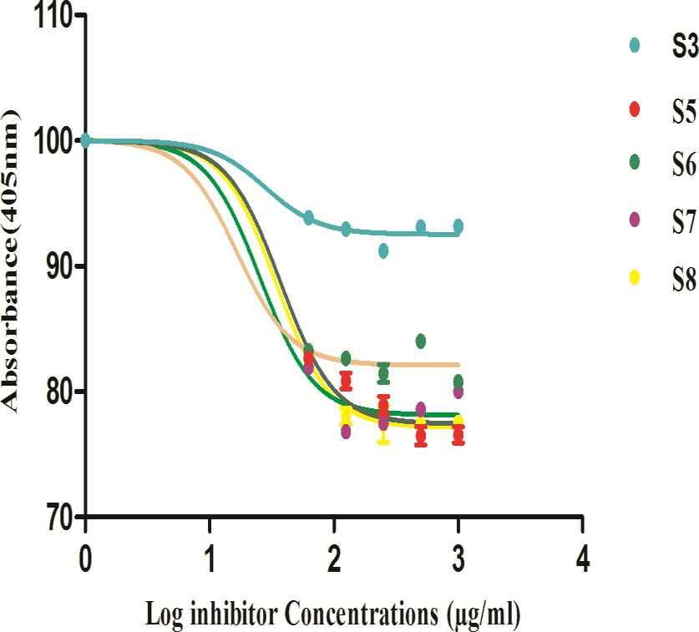

A

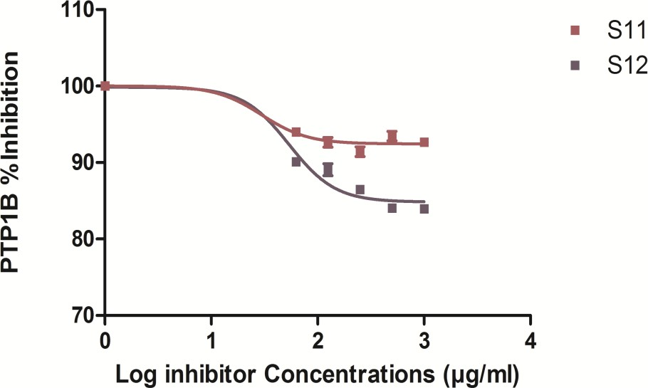

B

Figure 4.14. PTP1B inhibition activity of (A) individual plants S3, S5, S6, S7 and S8 and (B) polyherbal formulations S11 and S12

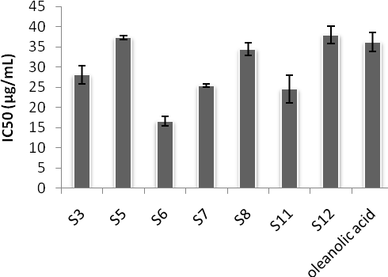

Figure 4.15. Comparison of IC50 values for individual plants and polyherbal formulation S11 and S12 for PTP1B inhibition

* 1. ***In-vitro* PTP1B Inhibitory Potential of *M. conica***

A concentration range (30-1000µg/mL) of methanol extract of *M.conica* was assessed in the inhibition experiment. Absorbance was recorded using 405 nm filter of ELISA followed by calculation of percentage inhibition at respective concentration of sample. Dose response curves were plotted using log inhibitor concentration on X-

axis and percentage inhibition on Y-axis. Results are shown in Figure 4.3. Zero data point was recorded as maximum enzyme activity. IC50 values were calculated from dose response curve using non-linear regression analysis in graph pad prism. Data indicated upto 80% decrease in PTP1B activity in the presence of *M. conica*, which is comparable to positive control (oleanolic acid) used in this study. The IC50 values was found to be 26.455 ± 1.478.

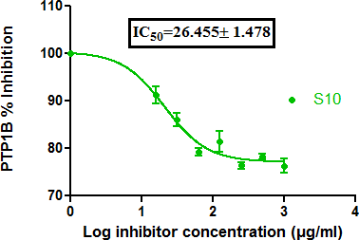

Figure 4.16. Dose response curve for PTP1B inhibition activity by *M. conica*. IC50 values was calculated from the curve and is shown on the graph

* 1. ***In vivo* Study**

### Effect of Formulations on Body Weight and Hyperglycemic Index

Initially, body weight of animals from all groups including normal, diabetic control, diabetic treated with glibenclamide, diabetic treated with crude methanolic extract of polyherbal formulations S11 and S12, was recorded. It had been noticed that under diabetic conditions the body weight was decreased from normal mice. The values were found to be 34 ± 3.59 gm and 26.9 ± 4.52 gm, respectively. For glibenclamide, S11 and S12 treated groups, the average body weights were found to be 33.1 ± 1.82 g, 32.2± 3.21 g and 30.1 ± 1.90 g, respectively.

Methanol extract of polyherbal formulations S11 and S12 were administered intraperitnoeally to diabetic mice to see the effect of treatment (*n*=6). Initially, dose

response curve was generated to determine the toxicity level and to optimize effective dose. Results are shown in Figure 4.4, it had been noticed that S11 controlled hyperglycemic index at dose of 100 mg/kg where glucose level drop by 63%. The diabetic mice showed the hyperglycemic index of 201 mg/dl. However, in S11 treated mice the glucose level was dropped to 128 mg/dl. Same has been recorded for S12, where dose optimization data indicated a decrease in glucose level to 148 mg/dl from 284 mg/dl at concentration of 100 mg/kg. In another series of experiments (Figure 4.5), the hyperglycemic index was recorded on weekly basis up to 4 weeks for normal mice, diabetic mice, diabetic mice treated with S11, diabetic mice treated with S12 and diabetic mice treated with glibenclamide. Results revealed after 1st week the glycemic index was found to be 263 ± 69 mg/dl for S11 and 279 ± 67 mg/dl for S12 treated group. The glycemic index was gradually decreased to 121± 22.4 mg/dl and 134± 25.7 mg/dl after 4th week for S11 and S12 treated groups respectively. The data was also recorded for glibenclamide treated group which was used as positive control. Data after 1st week showed the hyperglycemic index of 242 ± 31 mg/dl and after 4th week it was decreased to 109 ± 26 mg/dl.

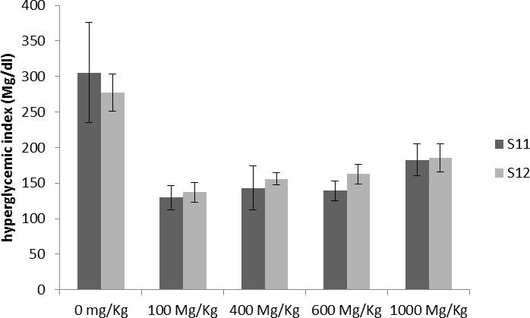

Figure 4.17. A bar graph showing dose optimization for S11 and S12 to select a final effective dose to be administered. The effective dose was found to be 100mg/Kg for both samples as it controlled hyperglycemic index comparable to normal levels.

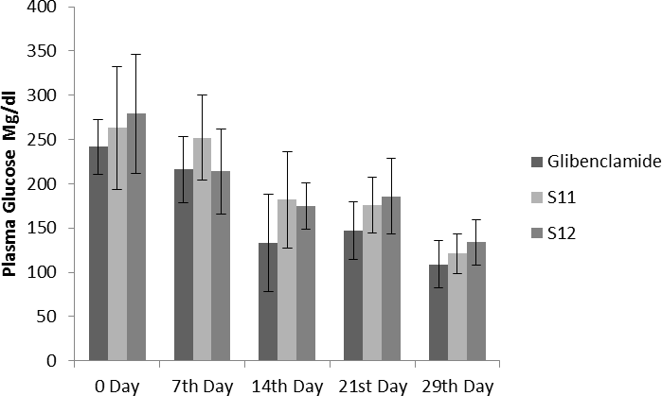

Figure 4.18. Effect of S11 and S12 on hyperglycemic index compared with glibenclamide treated group**.** Controlled plasma glucose levels were found on 29th day showing that both samples S11 and S12 lowers the glucose levels to normal levels.

### Effect of *M. conica* on Body Weight and Hyperglycemic Index

The body weight of animals from all groups including normal, diabetic control, diabetic treated with glibenclamide were recorded. In this section body weights of animals (*n*=5) treated with *M. conica* was evaluated. It had been noticed that under diabetic conditions, the body weight was decreased from normal mice. The values were found to be 34±3.59 g and 26.9±4.52 g for diabetic and normal group, respectively. For glibenclamide and *M. conica* treated groups the average body weights were found to be 33.1±1.82 g and 32.6±3.42 g, respectively. Methanol extract of *M. conica* was also evaluated for its effect on hyperglycemic index of treated group. Dose response curve was initially generated to optimize the dose. Results are shown in Figure 4.6. Four different concentrations were given to diabetic mice including 100 mg/Kg, 400 mg/Kg, 600 mg/Kg and 1000 mg/Kg. It had been noticed that the *M. conica* extract controlled the hyperglycemic index from 448 mg/dl to 148 mg/dl at a concentration of 100 mg/kg. Therefore, this dose has been selected for further analysis. The treated group was administered 100 mg/kg of *M. conica* extract intraperitonealy upto four weeks. Hyperglycemic index was recorded at zero day, 7th day, 14th day, 21st day and 29th day. In another series of experiments (Figure 4.7), the hyperglycemic index was recorded on weekly basis upto 4 weeks for normal mice, diabetic mice and diabetic mice treated with *M. conica*. At zero day the hyperglycemic index was recorded as 346±11.5 mg/dl. Results revealed after 1st week (7th day) the glycemic index were found to be 281±23.2 mg/dl for *M. conica* and 216±37.8 mg/dl for glibenclamide treated group. The glycemic index was gradually decreased to 132±3.51 mg/dl and 110 ±26.6 mg/dl after 4th week for *M. conica* and glibenclamide treated groups, respectively.

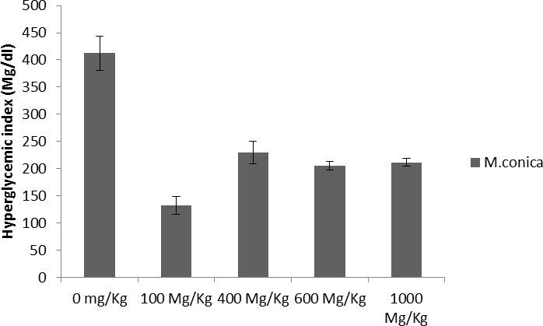

Figure 4.19. Dose optimization for *M. conica* to select a final effective dose to be administered. 100 mg/Kg was found to be the most efficient concentration for controlling hyperglycemic index that dropped the glucose level to almost 150 mg/dl.

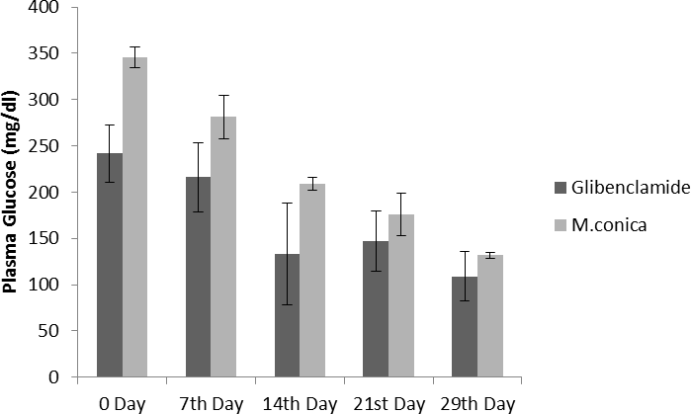

Figure 4.20. Effect of *M. conica* on hyperglycemic index compared with glibenclamide treated group. Controlled plasma glucose levels were found on 29th daya showing that *M.conica* lowers the glucose levels to normal levels.

### Effect of Polyherbal Formulations on Lipid Profile of Treated Mice

After 4th week, all mice were killed, the organs were collected for histopathological analysis and blood was collected for serum chemistry analysis. This was done to see if

the proposed formulations also affect the levels of total cholesterol (J.-w. Kim *et al.*), triglycerides (TG), high density lipoprotein (HDL), low density lipoprotein (LDL), serum creatinine and urea. These are all the parameters correlated with diabetes. Under diseased condition, it had been noticed that total cholesterol was increased in diabetic mice as compared to normal mice. The values were found to be 108 mg/dl for normal mice and 198 mg/dl for diabetic mice, where HDL and LDL levels were 28 mg/dl and 108 mg/dl, respectively for normal group. However, in diabetic group HDL was found to be 19.46 mg/ dl and LDL value obtained was 105 mg/dl. In case of S11 and S12 treated groups, it had been noticed that both HDL and LDL were positively controlled, which also reflect in total cholesterol levels. S11 treated group showed total cholesterol level of 137 mg/dl where HDL and LDL values were found to be 25 mg/dl and 117 mg/dl, respectively. The other diabetic treated group which administered by S12 also possess controlled total cholesterol (150 mg/dl) having HDL of 24 mg/dl and LDL of 128 mg/dl. When the triglycerides profile was compared among all samples, it had been noticed that there is an increase level of triglycerides in diabetic mice (190 mg/dl) as compared to normal (92 mg/dl) and treated groups with S11 (195 mg/dl) and S12 (183 mg/dl). In glibenclamide treated groups, triglycerides were found to be 188 mg/dl.

### Effect of *M. conica* on Lipid Profile of Treated Mice

After 4th week, all mice were killed and organs were collected for histopathological analysis and blood was collected for serum chemistry analysis including total cholesterol, triglycerides, HDL, LDL, serum creatinine and urea. Results of *in vivo* study revealed increase in total cholesterol in diabetic mice (198 mg/dl) as compared to normal mice (108 mg/dl) where HDL level was 28 mg/dl and LDL was 108 mg/dl for normal group. However, in diabetic group, HDL was found to be 19.46 mg/ dl and

LDL value was 105 mg/dl. In case of *M. conica* treated group, the values for total cholesterol was found to be 141.5±6.36 mg/dl. The HDL and LDL values were found to be 20±1.41 mg/dl and 71.5±4.95 mg/dl, respectively. When the triglycerides profile was compared, it had been noticed that there is an increase level of triglycerides in diabetic mice (190 mg/dl) as compared to normal (92 mg/dl). The *M. conica* treated group possessed triglyceride level of 187.6 ± 3.67 mg/dl, and the positive control glibenclamide treated groups triglycerides were found to be 188 mg/dl.

### Effect of Polyherbal Formulations on Liver and Kidney Damage

Diabetes is a severe condition to body that leads to liver and kidney damage therefore, the effect of polyherbal formulations, S11 and S12, developed in current study were evaluated on liver and kidney. The most common tests used for assessment of liver include serum glutamic pyruvic transaminase test (SGPT) also known as alanine aminotransferase (ALT), serum glutamic oxaloacetate test (SGOT) also known as aspartate aminotransferase test (ASP) and alkaline phosphatase test (ALP). If liver may become damaged, it leads to increased level of SGP, SGO and ALP in blood stream due to leakage from liver. Moreover, increased levels of ALP may also refer to abnormalities associated with kidneys, gallbladder and pancreas. In the present study, increased levels of SGP and SGO were found in blood stream of diabetic mice. The values were found to be 77 U/l and 79 U/L as compared to normal mice having SGP and SGO values of 45 U/l and 44 U/l, respectively. When the diabetic treated group with S11 was assessed, it had been noticed that the SGP and SGO levels were slightly decreased as compared to diabetic group having levels of 63 U/l and 61 U/l for SGP and SGO respectively. Levels were also measured in S12 diabetic treated group and as a control glibenclamide treated groups were also assessed. In case of S12 treated groups, SGP and SGO levels were found to be 52 U/l and 60 U/l, respectively. For

glibenclamide treated groups SGP and SGO were 50 U/land 59 U/l, respectively. In conclusion, SGP and SGO were lessened in treated groups as compared to diabetic group. ALP is another parameter for measurement of liver and kidney damage these levels were also monitored in different groups. In diabetic group without any treatment, ALP levels were found to be 268 U/l while in normal control group the ALP level was found to be 98 U/l thus indicated that in diabetic group there is a damage in either liver, kidney or pancreas that leads to elevated level of alkaline phosphatase. When the treated groups were monitored, the ALP was found to be 201,

225 and 223 U/l for glibenclamide, S11, and S12 treated groups, respectively indicating slightly lower ALP levels as compared to diabetic control group.

For kidney damage evaluation, the most commonly used parameters include urea and creatinine levels. As a result of protein metabolism, there is formation of ammonia in liver which may enter into urea cycle results in production of urea which released into blood stream and kidney may filtered blood nitrogen in the form of urea. If there are elevated levels of urea in blood stream it is an indication that kidney are somehow damaged and may not working properly. In addition to this, kidney may also filter creatinine from blood stream therefore, if creatinine levels are high in blood this may become another indication for kidney damage. Therefore, to see the effect of polyherbal formulations on kidney damage both urea and creatinine were assessed in normal control group, diabetic control group, diabetic treated groups with glibenclamide, S11 and S12. Results are shown in Table 4.1. The data revealed increased level of urea and creatinine in diabetic control group without any treatment having values of 70 mg/dl and 1.7 mg/dl as compared to normal group having levels of 33 mg/dl and 0.8 mg/dl for urea and creatinine, respectively. There is slight decrease in urea and creatinine levels in glibenclamide (54 mg/dl and 0.3 mg/dl), S11

(50 mg/dl and 1.2 mg/dl) and S12 (48 mg/dl and 0.4 mg/dl) treated groups for urea and creatinine, respectively.

Table 4.2. Levels of TG, TC, HDL and LDL in the normal, diabetic control, and glibenclamide and samples treated mice group

|  |  |  |  |  |  |  |  |  |  |  |
| --- | --- | --- | --- | --- | --- | --- | --- | --- | --- | --- |
| **Sample** | **Body Weight** | **TG**  **(mg/dl)** | **TC**  **(mg/dl)** | **HDL**  **(mg/dl)** | **LDL**  **(mg/dl)** | **ALP**  **U/L** | **SGPT**  **U/L** | **SGOT**  **U/L** | **Creatinin (mg/dl)** | **Urea (mg/dl)** |
| Diabetic | 33.8±3.6 | 190±3.3 | 198±5.  0 | 19.5±4.3 | 105±5.0 | 268±0.  8 | 77±5.2 | 79±4.2 | 1.7±3.4 | 70±2.1 |
| Normal | 26.9±4.5 | 92±4.6 | 108±4.  1 | 28±5.9 | 108±5.9 | 98±1.7 | 17±0.3 | 44±3.3 | 0.8±2.2 | 33±2.9 |
| Glibencla  mide treated | 33.1±1.8 | 188±3.9 | 139±3.  5 | 21±2.4 | 100±4.1 | 201±3.  2 | 50±3.9 | 59±6.8 | 0.3±0.9 | 54±2.1 |
| S 10  treated | 32.6±3.4 | 187±3.7 | 141±6.  4 | 20±1.4 | 71±4.9 | 225±4.  6 | 65±3.5 | 58±3.5 | 0.3±0.1 | 48±2.8 |
| S11 treated | 32.2±3.2 | 195±5.2 | 137±4.  3 | 25±3.9 | 117±5.2 | 225±6.  5 | 63±5.3 | 61±5.3 | 1.2±2.9 | 50±7.1 |
| S12 treated | 30.1±1.9 | 183±4.3 | 150±3.  3 | 24±5.3 | 128±4.2 | 223±3.  8 | 52±3.4 | 60±4.3 | 0.2±4.3 | 48±6.5 |

* + 1. **Effect of *M. conica* on Liver and Kidney Damage**

Diabetes leads to liver and kidney damage therefore the effect of *M. conica* was also evaluated on liver and kidney. It is noticed that both SGP and SGO levels were increased in blood stream of diabetic mice. The values were found to be 77 U/l and 79 U/L as compared to normal mice having SGP and SGO values of 45 U/l and 44 U/l respectively. When the diabetic treated group with *M. conica* was evaluated it had been noticed that the SGP and SGO levels were found to be 65.5±3.53 mg/dl and 58.5±3.53 mg/dl respectively which were slightly less than that of diabetic group. For glibenclamide treated groups SGP and SGO were 50 U/l and 59 U/l respectively. When the ALP levels were compared, these were found to be 225 U/l in *M. conica* treated group which were less than that of diabetic group having ALP levels of 268

U/l while in normal control group the ALP level was found to be 98 U/l thus indicated that in diabetic group there is a damage in either liver, kidney or pancreas that leads to elevate level of alkaline phosphatase. In addition, serum creatinine and urea levels were also monitored to see effect of *M. conica* on kidneys. It had been noticed that urea and creatinine were found lower than that of diabetic control sample (without any treatment). The values were recorded as 48±2.82 mg/dl and 0.30±0.07 mg/dl for serum urea and creatinine respectively. When compared with diabetic control having serum urea of 70 mg/dl and creatinine of 1.7 mg/dl, it had been noticed that *M. conica* controlled serum urea and creatinine to approximately normal levels.

### Effect of Polyherbal Formulation on PTP1B Expression in Liver and Pancreas

In the next series of experiments, the effect of polyherbal formulations S11 and S12 was observed on protein tyrosine phosphatase 1B expression in liver and pancreas of diabetic treated mice and was thus compared with normal mice, diabetic control mice and glibenclamide treated mice. The expression was assessed using ELISA kit as mentioned in material and method section. Results are shown in Figure 4.8. PTP1B, a negative regulator of insulin signaling mechanism may become overexpress in diabetic liver, and it is reported in literature that its expression may become decreased in diabetic condition in pancreas. Therefore, pancreatic PTP1B deficiency may lead to impaired glucose stimulated insulin secretion thus leads to insulin resistance state. The data in present study indicated that streptozotocin induced diabetic mice model showed higher expression of liver PTP1B as shown in Figure 4.8, diabetic mice treated with glibenclamide may control the expression of PTP1B to almost to normal levels. Interestingly, the polyherbal formulation developed in current study also control PTP1B expression to normal levels. The percentage of PTP1B proteins were

calculated relative to normal PTP1B expression found in normal control mice group. In diabetic liver, protein expression was almost doubled (188.7±19.3%) to that of normal which was taken as 100 %. For treated group, the percent protein was found to be 69.4±0.42% and 100.2±3.11% for S11 and S12 treated groups, respectively indicated that protein expression was resumed to normal levels.

All the groups were also compared for pancreatic PTP1B expression. It had been observed that in diabetic control group pancreatic PTP1B expression was decreased as compared to normal mice (Figure 4.9). Normal pancreatic PTP1B expression was considered 100%. For other groups, relative expressions to normal were calculated for better comparison. In this regard, streptozotocin induced diabetic group without any treatment showed protein expression of 52.75±17.6%. However, there is a resume in protein PTP1B expression in pancreas of glibenclamide treated group with a percentage of 114± 10.1%. When the polyherbal formultions (S11 and S12) treated groups were killed and pancreatic PTP1B expressions were evaluated, interestingly, both formulations enhanced the expression of pancreatic PTP1B with 311±16.7% and 256±8.55% for S11 and S12, respectively.

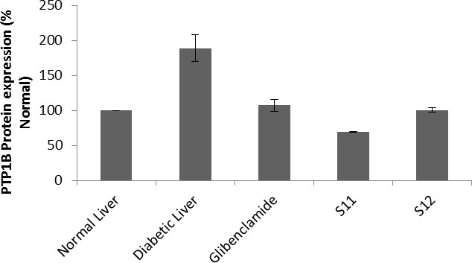

Figure 4. 21. Comparison of PTP1B expression in liver tissue of normal mice, diabetic mice and diabetic treated groups with glibenclamide S11 and S12. Both S11 and S12 inhibit PTP1B expression to normal levels. Relative expressions to normal are plotted on Y-axis.

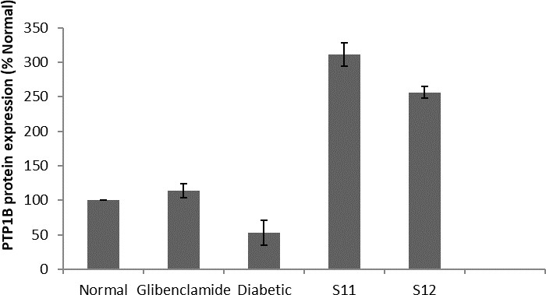

Figure 4.22. Comparison of PTP1B expression in pancreas of normal mice, diabetic mice and diabetic treated groups with glibenclamide S11 and S12. Diabetic treated mice with S11 and S12 showed increased expression of PTP1B in pancreas.

### Effect of *M. conica* on PTP1B Expression in Liver and Pancreas

*M. conica* extract was also evaluated for its potential to alter the PTP1B expression *in vivo*. The expression was assessed using ELISA kit. Under diabetic condition, PTP1B may become overexpressed in liver resulting in permanent switch off mechanism of insulin thus leads to hyperglycemic index. Therefore, it was important to assess the effect of *M. conica* extract on expression profiling of PTP1B in liver and pancreas. The percentage of PTP1B proteins were calculated relative to normal PTP1B expression found in normal control mice group. In diabetic liver, protein expression was almost doubled (188.7±19.3%) to that of normal which was taken as 100%. For

*M. conica* treated group, the percent protein was found to be 64.9±7.35% indicated that *M. conica* down regulated the expression of PTP1B as compared to diabetic mice.

Therefore, the hyperglycemic index was also found controlled in treated groups. The treated groups was also evaluated for pancreatic PTP1B expression. It had been observed that in diabetic control group pancreatic PTP1B expression was decreased as compared to normal mice where normal pancreatic PTP1B protein expression was considered as 100%. For other groups relative expressions to normal were calculated for better comparison. In this regard streptozotocin induced diabetic group without any treatment showed protein expression of 52.75±17.6%. However, there is a resume in protein PTP1B expression in pancreas of glibenclamide treated group and *M. conica* treated group with a percentage of 87.4±12.4%, respectively. Results for liver and pancreatic PTP1B protein expression are shown in Figures 4.10 and 4.11, respectively.

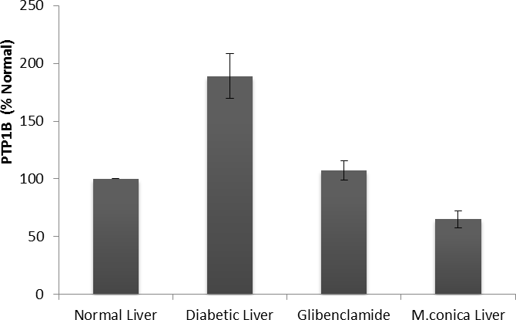

Figure 4.23. Comparison of PTP1B expression in liver tissue of normal mice, diabetic mice and diabetic treated groups with glibenclamide and *M. conica.* Diabetic mice showed overexpression of PTP1B in liver which is statistically significant than the normal mice. *M. conica* inhibit PTP1B expression to normal levels.

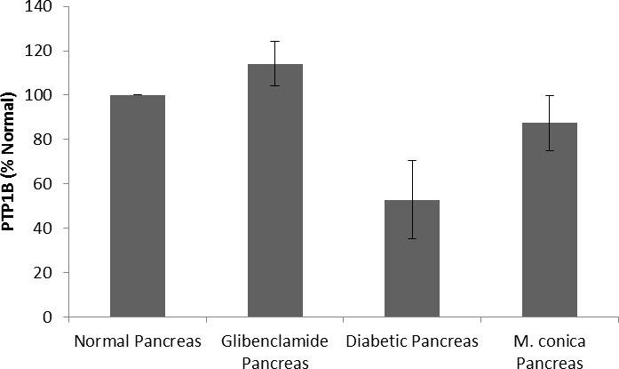

Figure 4.24. Comparison of PTP1B expression in pancreas tissue of normal mice, diabetic mice and diabetic treated groups with glibenclamide and *M. conica.* Diabetic treated mice with S11 and S12 showed increased expression of PTP1B in pancreas which is statistically significant than the diabetic mice.

### Histopatholgoical Analysis for Liver and Pancreas and Kidneys

In final series of analysis collected organs including liver and pancreas from normal, diabetic and treated groups were sectioned for histopathology analysis. Results are shown in figure 4.12. In normal liver, normal histological changes of liver section of normal mouse including central vein, blood sinuses, hepatic cells and kuffer cells were observed. When compared with diabetic liver it had been noticed that under diabetic condition prominent necrotic changes is present with severe degenerated parenchymal cells in the liver diabetic mice. There is also infiltration and inflammation in hepatic cells and kuffer cells significantly present. Deformed liver histology was due to inflammation. Shapes change is also seen in hepatocytes, central vein with dilated of sunsidus. When the histopathological results for liver of glibenclamide treated mice were evaluated it had been noticed that necrotic change is present in the liver diabetic mice. There is also infiltration and inflammation significantly present. Deformed liver histology was also observed due to inflammation. Shapes change is also seen in hepatocytes, central vein with dilated of sunsidus. While in case of polyherbal formulations (S11 and S12) and *M. conica* treated groups, minimal necrotic changes were observed in the liver as compared to diabetic control and glibenclamide treated groups. There is also minimal infiltration and inflammation present. Parenchymal cells were also restored. Most interstingly hepatic cells were also found similar to normal control groups.

Histopathological analysis for pancreas of normal control group, diabetic control group, glibenclamide, S11, S12 and *M.conica* treated groups are shown in Figure

4.13. Results showed that normal mice shows number of Islet per X10 field=02.

Moreover pancreas shows normal Islet of Langharhans surrounded by normal exocrine portion and with normal acinus and normal interlobular duct. When the

pancreas for diabetic mice was observed histopathologically it had been noticed that diabetic pancreas shows necrotic changes. There is also infiltration of inflammatory cells with atrophic changes (morphological changes). Severe destruction and distortion of exocrine cells and abundant number of β-cells along with degenerative changes in β-cells were observed. Numbers of Islet cells per X10 field were found to be 04. Treated groups with S11, S12 and *M. conica* showed recovery and regeneration of cells of pancreas with minimal necrotic changes. There is also infiltration of inflammatory cells with atrophic changes (morphological changes) i.e., restoration of normal cellular population with abundant number of β-cells and morphologically similar to normal mouse pancreas. Pancreatic tissues of treated mice for 29 days showed minimal necrosis significantly.

Normal Liver

Normal central vein & blood

Normal liver parenchyma

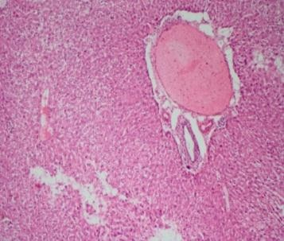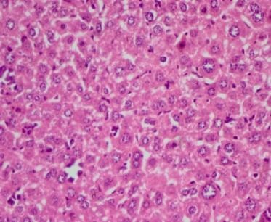

Diabetic Liver

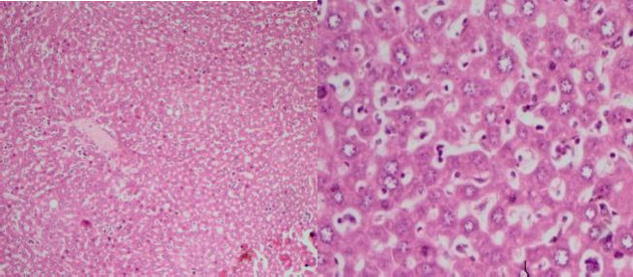

Diabetic induced changes

* Inflammation in hepatic\kuffer cells
* Prominent necrotic changes
* Severe degenerated pranenchymal cells
* Deformed the liver histology due to inflammation

Glibenclamide treated

Portal vein\portal

* Necrotic changes
* Infiltration of inflammatory cells
* Deformed liver histology

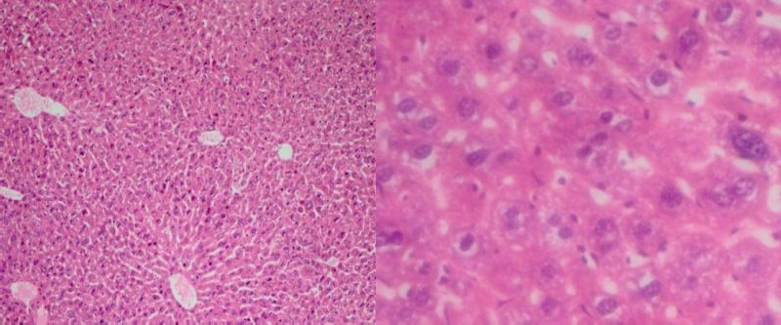

S11 and S12 treated liver

* Minimal Necrotic changes
* Minimal Inflammation
* Praenchymal cells were restored

Portal Vein\Portal

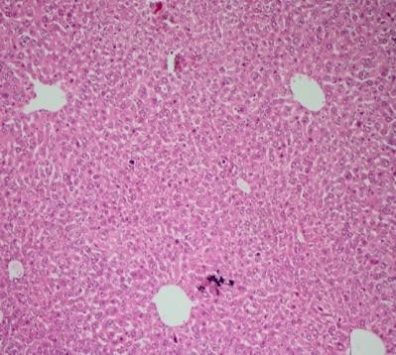 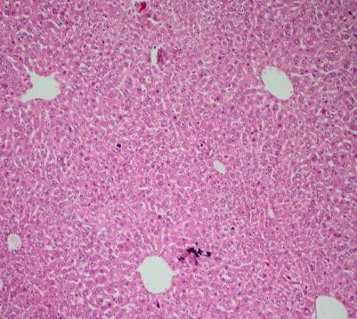

*M. conica* treated Liver

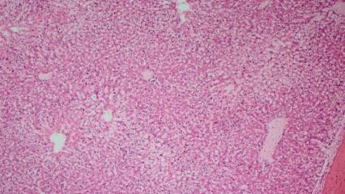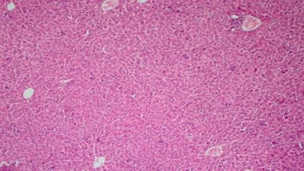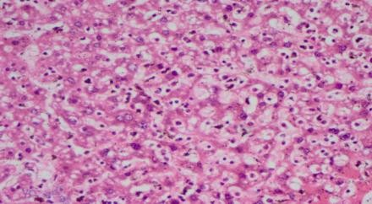

Figure 4.25. Comparison of morphological changes in liver of diabetic mice with normal, glibenlamide treated, polyherbal formulations (S11 and S12) and *M. conica* treated mice. Representative images are shown at resolution of 10X and 40X.

Normal Pancreas

* Normal Islets.
* Normal acinus.
* Normal interlobular duct.

Islets

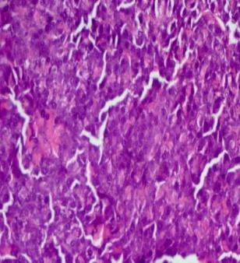

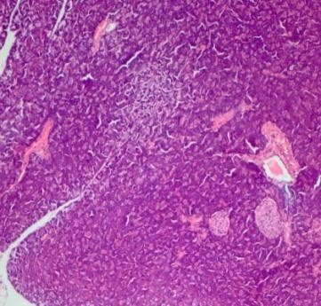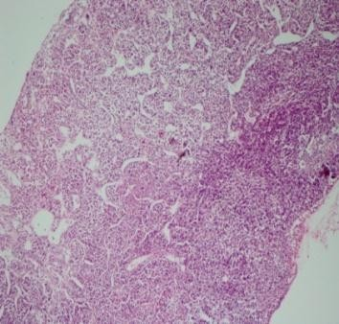

Number of Islet per X10

Diabetic pancreas

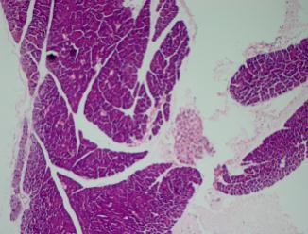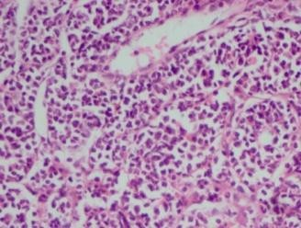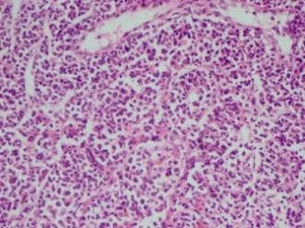

* Necrotic Changes.
* Infiltration of inflammatory cells.
* Atrophic changes.
* Severe destruction & distortion of exocrine cells
* Degenerative changes in β-cells.

Glibenclamide treated pancreas

Infiltration of inflammatory cells. Necrotic changes.

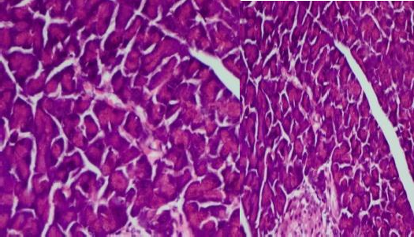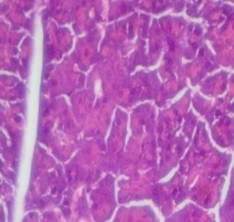

➢

➢

➢

Degenerative changes.

* + Recovery &regeneration of pancreas cells.
  + Minimal necrotic changes.
  + Infiltration of inflammatory cells.
  + Atrophic changes.
  + Restoration of normal cellular population with abundant number of β-cells.

S11 and S12 treated pancreas

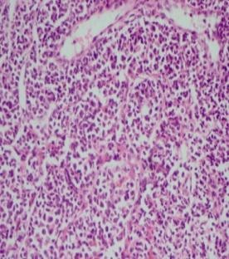 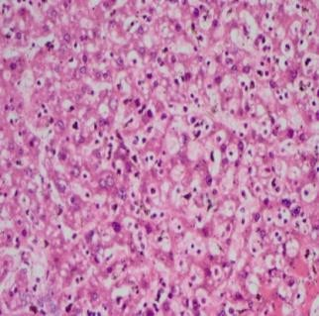

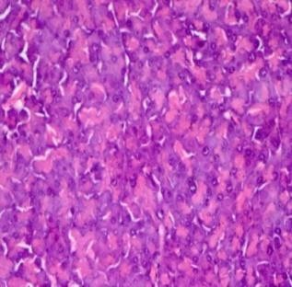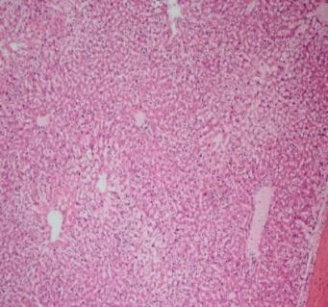

*M.conica* treated Pancreas

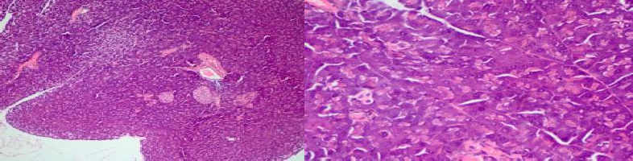

Figure 4. 26. Comparison of morphological changes in pancreas of diabetic mice with normal, glibenlamide treated, polyherbal formulations (S11 and S12) and *M. conica* treated mice. Representative images are shown at resolution of 10X and 40X.

### DISCUSSION

**[**

A recent known molecular target to treat diabetes is protein tyrosine phosphatase 1B which played a significant role in negative feedback mechanism of insulin signaling. There are several studies already reported the inhibition of PTP1B and strongly correlate it with improvement in diabetes reversal. Recently, various synthetic PTP 1B inhibitors with sub-micro molar scale or nanomolar actions have been discovered by high-throughput screening and structure-based design (Combs, 2009; Combs *et al.*, 2006). These compounds in spite of the fact that have great potential but yet experience limitation of the low cell permeability and low bioavailability which distressed their development as active candidate drugs (Lee *et al.*, 2007; S. Zhang *et**al.*, 2007). The real explanation for this is the vicinity of very adversely negatively charged residue (containing diﬂuoromethylphosphonates, carboxymethylsalicylic acids, and oxalyl amino benzoic acids) which impersonate the phosphate group in IRS (Combs, 2009; Combs *et al.*, 2006). Most of the work has been done with small molecular weight compounds to inhibit PTP1B. These inhibitors can be divided into competitive and non-competitive inhibitors. Where most of the competitive inhibitors can control phosphorylated tyrosine of Insulin receptor and non-competitive inhibitors can do the oxidation at catalytic cysteine cys215 of PTP1B. However till date none of these small molecular weight compounds are found to be success full in clinical trials and also in *in-vivo* studies. Therefore, there is still a need of new inhibitors of PTP1B that may act better in inhibition studies. In this regard, natural product can be used as best anti-diabetic drug source by controlling protein tyrosine phosphatase 1B overexpression.

In the present study, five selected medicinal plants: *Chicorium intibus* (S3), *Trigonella foenumgraceum* (S5), *Saussarea lappa* (S6), *Lipidium sativum* (S7) and *Nigella sativa* (S8) have been evaluated individually and in combination in the form

of two polyherbal formulations (S11 and S12) for their PTP1B inhibitory potential. These plants were selected on the basis of ethnomedicinal approach. A lot of literature is already available on medicinal properties and more importantly antidiabetic potential of these plants. However, very limited studies are available on their PTP1B inhibitory potential. Therefore in the present study these plants were used *firstly,* to evaluate PTP1B inhibitory potential of crude methanol extracts of these plants individually, *Secondly*, to develop polyherbal formulations of these plants and then to characterize these formulations against PTP1B. To the best of my knowledge this is first ever study reporting the PTP1B inhibition activity of these polyherbal formulations S11 and S12 comprising of *C. intibus* (S3), *T. foenumgraceum* (S5), *S. lappa* (S6), *L. sativum* (S7) and *N. sativum* (S8). In addition, *M. conica* (edible mushroom) has also been assessed in PTP1B inhibition. The purpose was to find a potent natural product sample that may better inhibit PTP1B at low concentration.

The data indicated that individually *C. intybus* showed potent PTP1B inhibition which is found to be in the range of 90-93% indicating it a potent PTP1B inhibitor. However, other four samples including S5, S6, S7 and S8 showed inhibition in the range of 75-83%. The formulation prepared by combination of S3 and S8 interestingly showed the highest PTP1B inhibition that is approximately 90-95%. Moreover, S12 formulation, which is combination of S3:S5:S6:S7:S8 also showed comparatively higher activity (83-90%) as compared to individual plants. Therefore, the current study was focused on the polyherbal formulations, which were found to be more active as compared to individual plants. *M. conica* was also found active against PTP1B by showing a percentage inhibition range of 73-80%. Moreover, when the in-vivo data was considered both polyherbal formulations (S11 and S12) and *M. conica* controlled the hyperglycemic index to normal levels at a dose of 100 mg/Kg.

PTP1B expression was found to be downregulated in liver of treated group. However, in pancreas there is an upregulation of PTP1B as compared to diabetic mice. In literature role of liver PTP1B has been extensively studied and a detailed mechanism is known however in case of pancreas PTP1B still very limited studies are available explaining its proper mechanism of action. Whole-body PTP1B knockout (KO) mice exhibit enhanced glucose tolerance and improved insulin sensitivity (Xi *et al.*, 2015). Tissue-specific PTP1B deletion helped define the functions of this phosphatase in many tissues including muscle, liver and brain. In addition, several studies also reported involvement of PTP1B in pancreas function. A compound knocks out mouse model demonstrates that PTP1B global deficiency decreased the severe diabetes caused by insulin receptor substrate 2 deletion. Mice with pancreatic PTP1B deficiency leads to impaired glucose tolerance and improper glucose stimulated insulin secretion (GSIS) (Dsouza *et al.*, 2015).

In recent few years, it had been noticed that in many Asian countries including Pakistan polyherbal formulations are used traditionally without having scientifically controlled studies. One of the formulations POL4 comprises of *C. intybus, T. foenumgraceium, N. sativa* and *G. sylvestre* is used to treat caridometabolic diseases including diabetes and hypertension. In the present study, polyherbal formulations S11comprising of *C. intibus* (S3) and *N. sativa* (S8) and S12 comprising of *C. intybus+T. foenum-graecum+S. lappa+L. sativum+N. sativa* showed much more activity as compared to positive control oleanolic acid in in vitro assays. Moreover, both formulations also showed potent in vivo antidiabetic potential by controlling hyperglycemic index in streptozotocin induced diabetic mice model at a concentration of 100 mg/Kg. Both formulations also lower the PTP1B protein expression in liver of treated mice, which was over expressed in diabetic mice model. However, in case of

pancreatic PTP1B which was decreased in diabetic mice model there seems upregulation in treated mice. The same have also been observed for *M. conica* treated mice. In another study Galhena et al. (2012) assessed the anti-inflammatory activity of polyherbal decoction which contained *N. sativa* as an ingredient with two other plants including *Hemidesmus indicus*, and *Smilax glabra* (Galhena *et al.*, 2012) The anti- inflammatory mechanism was studied by measuring effect on nitric oxide inhibitory activity, membrane stabilization and by inhibition of leukocyte migration. The group reported that the anti-inflammatory activity of the decoction can be one of the mechanisms of mediating hepatocarcinogenic effects. The polyherbalformulations S11 and S12 used in present study also contained *N. sativa* as an ingredient in addition to *C. intybus* and shows strong PTP1B inhibitory potential. Moreover, polyherbal formulations S11 and S12 was also studied *in vivo* and showed controlled PTP1B expression in liver tissue. In addition, PTP1B expression in pancreas was elevated which was found decreased in diabetic mice. In addition third sample S10 (*M. conica*) was also proven to be effective in controlling diabetes and also effecting PTP1B protein expression in positive way.

Muthusamy *et al.,* 2010 reported PTP1B inhibition using*C.intybus*. Crude methanol extract (Yilmaz *et al.*) was prepared and proceeded for bioactivity guided extraction and purification. Results revealed the additive effect of cholorogenic acid (CGA) with caffiec acid derivative. CME and CGA inhibit PTP1B with an IC50 value of 21.2ng and 3.12 µg respectively which actually indicated that crude methanol extract is more active than purified compound. The in vivo model showed improvement in insulin sensitivity after giving crude methanolic extract and chlorogenic acid derivative. In our study formulation S11 (*C.intybus* and *N.sativa*)and S12 (*C. intybus+T. foenum- graecum+S. lappa+L. sativum+N. sativa*)containing *C.intybus* and *N.sativa* showed

strong PTP1B inhibitory potential as seen from IC50 values which were found to be 24.5µg/mL and 26.5 µg/mL respectively. The same were also evaluated in in-vivo experiments and controlled PTP1B expression to normal levels were found as compared to diabetic mice. Moreover LC-MS analysis of present study also reveals presence of chlorogenic acid, caffetaric acid, kaempferolglucoside and galactoside in S11 and S12.

Very recently PTP1B inhibition was studied using methanol extract of fruit of *Paulownia tomentosa*. The extract showed potent inhibition of both PTP1B and glucosidase. The compound purification of extract results in isolation and purification of eight different flavonoids identified as dihydroflavonols and flavonols. IC50 values for PTP1B were found in the range of 1.9-8.2µM. Inhibitory potencies of these compounds varied accordingly, but most of the compounds were highly effective against PTP1B than a-glucosidase.All the three samples S10 (*Morchellaconica*), S11 and S12 (Polyherbal formulations) evaluated in current study also showed potent PTP1B inhibition in vitro and controlled hyperglycemic index in in vivo experiments. In addition PTP1B expression was also inhibited in diabetic treated mice with which was overexpressed in streptozotocin induced diabetic mice (Results are shown in chapter 4)Yeong *et al.,* 2017).

Ming *et al.,* 2011 reported PTP1B as a negative regulator of insulin signaling pathway. The group studied the effect of PTP1B inhibitor CCF06240 on lipid metabolic abnormalities andinsulin sensitivity in vitro and in vivo. The insulin resistant (Reuter *et al.*) mouse model was induced by high fat diet. Total cholesterol and triglycerides were measured. As a result due to the presence of inhibitor of PTP1B insulin resistance was improved. TG, TC and body weight were also found

reduced. These results demonstrated that CCF06240 (PTP1B inhibitor) could increase insulin sensitivity through the regulation of insulin signaling pathway.

Shrikrishna *et al.,* 2000 investigated the cellular mechanism(s) of insulin resistance associated with non-insulin dependent diabetes mellitus (NIDDM) using skeletal muscles isolated from Goto-Kakizaki (GK) rats (genetic rat model for type II diabetes). It is noticed that as compared to control mice GK mice showed insulin stimulated insulin receptor autophosphorylation and insulin receptor substrate-1 tyrosine phosphorylation were prominently inhibited in GK skeletal muscles. This may be due to increased dephosphorylation by a protein tyrosine phosphatase (PTPase). It was noticed that PTPase 1B activity was increased in diabetic rats (GK rats).The increase in PTPase 1Bactivity in diabetic GK rats was associated with an increased expression of the PTPase 1B protein. Therefore it was concluded that enhanced PTP1B activity leads to impaired glucose tolerance and enhanced insulin resistance. In present three samples including *Morchellaconica* (S10) and polyherbal formulations (S11 and S12) were screened for PTP1B inhibitory potential. Data indicated that all the three samples inhibited PTP1B activity at a concentration of low micro molar range. In addition iv vivo data also revealed decreased PTP1B expression in liver by these samples which leads to controlled hyperglycemic index which indicated that hyperglycemia in diabetic mice was due to overexpression of PTP1B which causes insulin resistance thus elevated levels of plasma glucose.

Wang *et al.,* 2012 reported antidiabetic potential of *Ganodermalucidum*. The group previously reported Fudan-Yueyang-Ganodermalucidum (FYGL) from *G. lucidum* as a novel PTP1B inhibitor with IC50 value of 5.12 mg/mL. It had been noticed that Oral administration of FYGL for 4 weeks significantly decreased plasma glucose in streptozotocininduced diabetic mice. FYGL also controlled the biochemistry indices

relative to T2DM-accompanied lipidaemic disorders. It was concluded that decrease in plasma glucose was due to the inhibition of PTP1B expression and activity. Our results werefound consistent with this study as all the three samples used in present study S10 (*Morchellaconica*), S11 and S12 (Polyherbal formulations) controlled hyperglycemic index as well as PTP1B expression. Inin streptozotocin induced diabetic mice PTP1B protein was overexpressed and in diabetic mice treated with S10, S11 and S12 respectively the protein expression was decreased to normal levels. Therefore it might be possible that decrease in hyperglycemic index is due to the inhibition of PTP1B.

# Chapter 5

**CONCLUSION AND FUTURE RECOMMENDATION**

Following conclusions have been drawn from this study***.*** Firstly, *Morchella conica* (S10) and polyherbal formulations S11 (S3:S8) and S12 (S3:S5:S6:S7:S8) reported in this study comprising of *Chicorium intibus* (S3), *Trigonella foenum graceum* (S5), *Saussarea lappa* (S6), *Lipidium sativum* (S7) and *Nigella sativum* (S8) can be used as multi targeted inhibitor to treat Diabetes mellitus as these became active in in vitro antidiabetic assays including α-amylase, glucosidase and protein tyrosine phosphatase 1B inhibition assays, antiglycation and antioxidant assays as well. All the three samples *M.conica*, S11 and S12 were also found to be active in in vivo experiments. Secondly, the basic mechanism by which these samples controlled hyperglycemic index is alteration of protein tyrosine phosphatase 1B protein expression in liver and pancreas which was found to be overexpressed in case of diabetic mice liver and decreased in diabetic mice pancreas. However, in all the three treated groups by S10, S11 and S12 controlled expressions were found for PTP1B. Therefore, it can be concluded that both polyherbal formulations developed and characterized in current study possess antidiabetic potential. In addtition, *M.conica* which is an edible mushroom can also be used as antidiabetic drug source. To the best of my knowledge this is the very first study reporting antidiabetic potential of *M. conica* and two polyherbal formulations S11 and S12 developed and characterized in this study. Exploration of novel targets like glucagon-like peptide-1 (GLP-1), sodium-glucose co-transporter 2 (SGLT-2) and dipeptidyl peptidase 4 (DPP-4) for antidiabetic drugs and medicinal plants with emphasis on site specific effectiveness and overcoming

problems of resistance, side effects, prolonged usage and high cost, are being investigated for future research.

This work will significantly contribute towards pharmaceutical industries for drug development specifically as antidiabetic candidate. However, in future, further clinical trials are required to be done with these samples (S10, S11, and S12). Moreover, collaboration with pharmaceutical industries will be helpful to further evaluate drug

Xi, Y., Liu, S., Bettaieb, A., Matsuo, K., Matsuo, I., Hosein, E., . . . Zhang, Z.-Y. 2015. Pancreatic T cell protein–tyrosine phosphatase deficiency affects beta cell function in mice. *Diabetologia,* 58(1): 122-131.

Xiao, Z., Storms, R., & Tsang, A. 2006. A quantitative starch? Iodine method for measuring alpha-amylase and glucoamylase activities. *Analytical biochemistry,* 351(1): 146-148.

Yazdanparast, R., & Ardestani, A. 2007. In vitro antioxidant and free radical scavenging activity of Cyperus rotundus. *Journal of medicinal food,* 10(4): 667-674.

Yazdanparast, R., Bahramikia, S., & Ardestani, A. 2008. Nasturtium officinale reduces oxidative stress and enhances antioxidant capacity in hypercholesterolaemic rats. *Chemico-Biological Interactions,* 172(3): 176-

184.

Yilmaz, N., Solmaz, M., Türkekul, İ., & Elmastaş, M. 2006. Fatty acid composition in some wild edible mushrooms growing in the middle Black Sea region of Turkey. *Food Chemistry,* 99(1): 168-174.

Young, S. W., Bishop, L. D., & Conway, A. 2012. Interventions performed by community pharmacists in one Canadian province: a cross-sectional study. *Therapeutics and clinical risk management,* 8: 415.

Zhang, S., & Zhang, Z.-Y. 2007. PTP1B as a drug target: recent developments in PTP1B inhibitor discovery. *Drug discovery today,* 12(9-10): 373-381.

Zhang, Y., Li, C., Sun, X., Kuang, X., & Ruan, X. 2012. High glucose decreases expression and activity of p-glycoprotein in cultured human retinal pigment epithelium possibly through iNOS induction. *PLoS ONE,* 7(2): e31631.

Zheng, W., & Wang, S. Y. 2001. Antioxidant activity and phenolic compounds in selected herbs. *Journal of Agricultural and Food chemistry,* 49(11): 5165- 5170.

Zimmet, P. 1999. Diabetes epidemiology as a tool to trigger diabetes research and care. *Diabetologia,* 42(5): 499-518.